Mr. Sabado, Algebra 1 Week 19 Friday, January 23, 2015

Homework

Due Today:
Assignment #74:
Chapter 1 Final Review
Opener Packet

Due 1/26:
Assignment #75:
Final Review Study Guide

Due 1/27:
Final Exam Extra Credit

Agenda

- Warm-Up
- Turn in Opener Packet

- Class Work: Math Sprint

- Homework

- Return Graded Work

Warm-Up

Solve
- 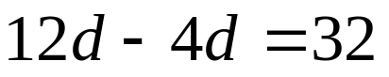
- 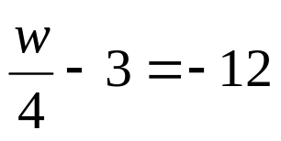
`whs.saba.do


“It is never too late to be what you might have been.”
- G. Eliot

