Mr. Sabado, Algebra 2 Week 19 Wednesday, January 21, 2015

Homework

Due Today:
- Assignment #70
Graphing Polynomial Review Worksheet #1-10

Due 1/22:
- Assignment #71
Function Families

Unit 4 Test Today!!!
Scientific Calculator ONLY!!!

Agenda

- Warm-Up
- HW Questions

- Unit 4 Test: Polynomial Operations

- Homework

- Extra Credit

- Return Graded Work

Warm-Up

1.Take out last night’s homework if you have any questions

2. Write “Unit 4 Test” in your warm-up box.


`whs.saba.do

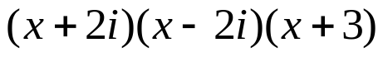

“It is never too late to be what you might have been.”
- G. Eliot

