Mr. Sabado, Algebra 2 Week 19 Thursday, January 22, 2015

Homework

Due Today:
- Assignment #71
Function Families

Due 1/23:
Unfinished Class Work
Opener Packet

Due 1/28:
Final Exam Extra Credit

Agenda

- Warm-Up

- Class Work: The Cost of a Zero

- Homework

- Extra Credit

- Return Graded Work

Warm-Up
- Is the following a function?

Input Output
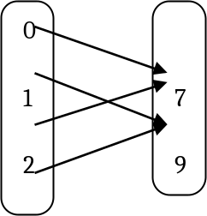


`whs.saba.do

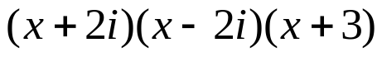

“It is never too late to be what you might have been.”
- G. Eliot

