Mr. Sabado, Algebra 2 Week 19 Friday, January 23, 2015

Homework

Due Today:
Opener Packet

Due 1/26:
Unit 1 & 2 Study Guide

Due 1/28:
Final Exam Extra Credit


Agenda

- Warm-Up

- Finish Class Work: The Cost of a Zero

- Turn in Opener Packet

- Unit 1 & 2 Study Guide

- Return Graded Work

Warm-Up
Let f(x) = 4x and g(x) = x² + 3

- 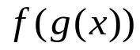

- 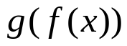

Solve

`whs.saba.do

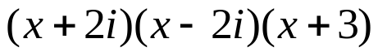

“It is never too late to be what you might have been.”
- G. Eliot

