Mr. Sabado, Algebra 2 Week 8 Monday, October 12, 2015

Homework

Due Today:
- Assignment #31
p. 456: 23-31, 33, 75-80

Due 10/13:
- Assignment #32
Quiz Review Worksheet

Quiz postponed to Tuesday!!!


Agenda

- Warm-Up

- Review: Solving Equations with Rational Exponents

- Class Work

- Homework

- Return Graded Work

Warm-Up

Solve
- 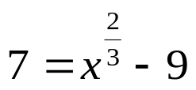

- 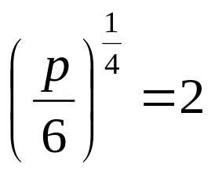

- 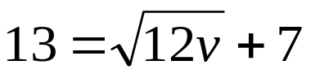

Algebra 2 Online Textbook: 2606518-10
classzone.com

whs.saba.do

yes

“It is never too late to be what you might have been.”
- G. Eliot

