Mr. Sabado, Algebra 2 Week 7 Tuesday, October 6, 2015

Homework

Due Today:
- Assignment #28
Simplifying Radical Expressions

Due 10/7:
- Assignment #29
Simplifying Radical Expressions 2

Quiz of Friday!!!

Agenda

- Turn in Test Corrections
- Warm-Up
- HW Questions

- Review: Solving and Radical Expressions

- Class Work

- Homework


Warm-Up

Simplify the Expression

- 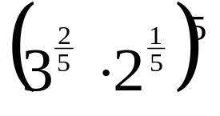

Solve
- 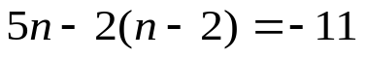
Solve for s.
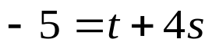

Algebra 2 Online Textbook: 2606518-10
classzone.com

whs.saba.do

“It is never too late to be what you might have been.”
- G. Eliot

