Mr. Sabado, Algebra 2 Week 5 Wednesday, September 23, 2015

Homework

Due Today:
- No Homework

Due 9/24:
- Assignment #20
p. 21 (21-72 mult. of 3)
and
p. 45 (27-57 mult. of 3, 34, 35)

Agenda

- Warm-Up

- Review: Solving Equations and Inequalities

- Silent Group Game

- Homework

Warm-Up

Solve the Following

- -4(3k + 5) = -2(5 – k)

- 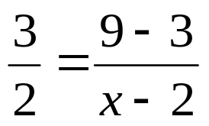

Algebra 2 Online Textbook: 2606518-10
classzone.com

whs.saba.do



“It is never too late to be what you might have been.”
- G. Eliot

