Mr. Sabado, Algebra 2 Week 5 Thursday, September 24, 2015

Homework

Due Today:
Due 9/24:
- Assignment #20
p. 21 (21-72 mult. of 3)
and
p. 45 (27-57 mult. of 3, 34, 35)

Due 9/25:
- Assignment #21
1.3: Literal Equations Worksheet

Agenda

- Warm-Up
- HW Questions

- Group Exploration: Using Literal Equations

- Homework

Warm-Up

Solve the Following

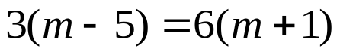
- 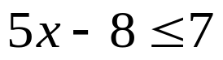

Algebra 2 Online Textbook: 2606518-10
classzone.com

whs.saba.do



“It is never too late to be what you might have been.”
- G. Eliot

