Mr. Sabado, Algebra 2 Week 5 Friday, September 25, 2015

Homework

Due Today:
Due 9/25:
- Assignment #21
1.3: Literal Equations Worksheet

Due 9/28:
- Assignment #22
1.7: Absolute Value Worksheet

Agenda

- Warm-Up
- HW Questions
- Turn in Opener Packet

- Lesson: Solving Absolute Values

- Class Work

- Homework

Warm-Up

Solve the Following
- 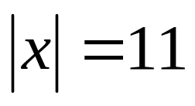
- 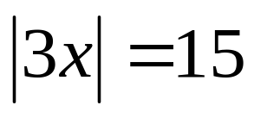

- 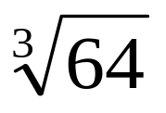

Algebra 2 Online Textbook: 2606518-10
classzone.com

whs.saba.do



“It is never too late to be what you might have been.”
- G. Eliot

