Mr. Sabado, Algebra 1 Week 6 Friday, October 10, 2014

Homework

Due Today:
- Assignment #24:
P. 51: 19-36, 41-47, 54

Due 10/14:
- Assignment #25:
Activity 15 Worksheet

Bring your Textbook every day!!!
Quiz Today!!!
Chapter 1 Test on Wednesday (10/15)

Agenda

- Warm-Up
- HW Questions
- Turn in Opener Packet

- Quiz: Simplifying Expressions

- Quiet Activity
- Homework
- Kahn Academy



Warm-Up

Simplify
- 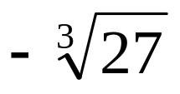

- 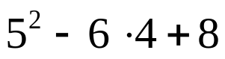

- 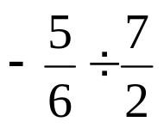

whs.saba.do

“It is never too late to be what you might have been.”
- G. Eliot
Nb

