Mr. Sabado, Accounting Week 15 Thursday, November 30, 2017

Homework

Due Today:
A59: Chapter 6-1 Vocab

Due 12/1:
A60: OYO 6-1

Chapter 6 Test on Wednesday, 12/13
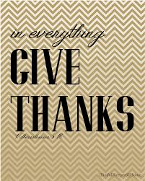

Agenda

- Warm-Up

-Read 6-1

Class Notes: Work Together 6-1

Homework

- Return Graded Work



- Return Ch. 1 Study Guide

- Return Chapter 1 Test

Warm-Up

- What is written on the Three-Line heading on a work sheet?


“It is never too late to be what you might have been.”
- G. Eliot

