Mr. Sabado, Accounting Week 17 Friday, December 15, 2017

Homework

Due Today:
A65: Vocab 7.2 and OYO 7.2

Due 12/18
A66: Drill 7-D1

Chapter 7 Test on Thursday, 12/21


Agenda

- Warm-Up

- Turn in Opener Packet

Class Work: Cool Careers

Homework:
Drill 7-D1: Preparing an Income Statement

- Return Graded Work



- Return Ch. 1 Study Guide

- Return Chapter 1 Test

Warm-Up

Write the following fractions as percentages rounded to the nearest tenth.

1) 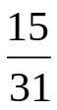 2) 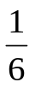

3) 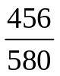 4) 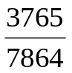



“It is never too late to be what you might have been.”
- G. Eliot

