Mr. Sabado, Algebra 1 Week 17 Monday, January 5, 2015

Homework

Due Today:
No HW

Due 1/6:
Assignment #65:
Solving Inequalities Worksheet Review

Quiz on Friday!!!


Agenda

- Seating Chart
- Opener Sheet
- Warm-Up

- Return Quiz: One-Step Inequalities

- Class Work: Choose Your Fate

- Homework
- Return Graded Work

Warm-Up

Graph the following
- 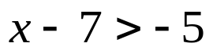

- 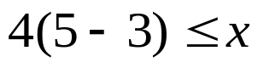

Solve
- 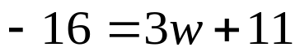

`whs.saba.do

“It is never too late to be what you might have been.”
- G. Eliot

