Mr. Sabado, Algebra 1 Week 16 Tuesday, December 16, 2014

Homework

Due Today:
Assignment #61:
Page 139: 2-18 all, 19-33 odd

Due 12/17:
Assignment #62:
Inequalities Worksheet pg. 5

Quiz on Friday!!!


Agenda

- Warm-Up
- HW Questions

- Lesson Continued: Intro in Inequalities

- Class work

- Homework

- Return Graded Work

Warm-Up

Solve.
- 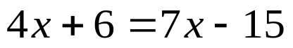
Graph
- 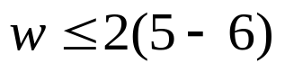

whs.saba.do

“It is never too late to be what you might have been.”
- G. Eliot

