Mr. Sabado, Algebra 1 Week 16 Wednesday, December 17, 2014

Homework

Due Today:
Assignment #62:
Inequalities Worksheet pg. 5

Due 12/18:
Assignment #63:
Page 145: 7-29

Quiz on Friday!!!


Agenda

- Warm-Up
- HW Questions

- Lesson: One-Step+ Inequalities

- Class work

- Homework

- Return Graded Work

Warm-Up

Write an inequality for the following.
- The temperature must be at least -10 degrees.
Solve
- 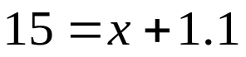

whs.saba.do

“It is never too late to be what you might have been.”
- G. Eliot

