Mr. Sabado, Algebra 1 Week 16 Thursday, December 18, 2014

Homework

Due Today:
Assignment #63:
Page 145: 7-29

Due 12/19:
Assignment #64:
Solving Inequalities Worksheet pg. 13

Quiz on Friday!!!


Agenda

- Warm-Up
- HW Questions

- Lesson Continued: One-Step+ Inequalities

- Class work

- Homework

- Return Graded Work

Warm-Up

Graph the following
- 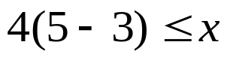

Solve
- 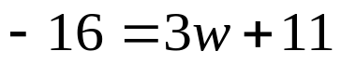

whs.saba.do

“It is never too late to be what you might have been.”
- G. Eliot

