Mr. Sabado, Algebra 2 Week 18 Wednesday, January 6, 2016

Homework

Due Today:
- Assignment 78:
p. 390 (3-17 odd)

Due 1/7:
- Assignment 79:
Unit 4 Review

Unit Test (1/7)



Agenda

- Warm-Up

- Review: Polynomial Unit Review Functions

- Class Work

- Homework

- Return Graded Work

Warm-Up

Factor the polynomial completely
- 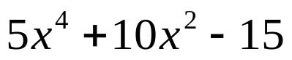
` Evaluate the following

- 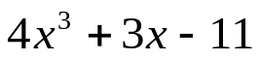 when x = - 2
`

yes

“It is never too late to be what you might have been.”
- G. Eliot

