Mr. Sabado, Algebra 2 Monday, September 22, 2014

Homework

Due Today:
- Assignment #8:
Graphing Calculator: Domain/Range

Due 9/23:
- Assignment #9:
Function Families: State all of the intercepts.

Quiz on Friday!!!

Agenda

- Pick up Opener Sheet
- Warm-Up

- Lesson: Finding the Intercepts

- Independent Classwork

- Homework

- Return Quiz



Warm-Up
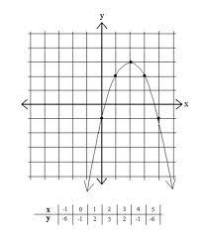
- What is the domain?
- What is the range?
- What is the y-int?

whs.saba.do

Algebra 2 Online Textbook: 2606518-10
classzone.com

“It is never too late to be what you might have been.”
- G. Eliot

