Mr. Sabado, Algebra 1 Week 4 Friday, September 26, 2014

Homework

Due Today:
- Assignment #15:
Page 20-21: Review Worksheet
Opener Packet

Due 9/29:
- Assignment #16:
Activity 14 Worksheet
Bring your Textbook every day!!!
Quiz Today!!!

Agenda

- Warm-Up
- HW Questions
- Turn in Packet

- Review:
- Math Sprint

- Homework

- Quiz #2



Warm-Up

Translate the following
- 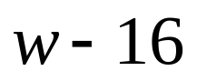

Evaluate the following

- 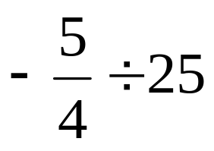

whs.saba.do

“It is never too late to be what you might have been.”
- G. Eliot
Nb

