Mr. Sabado, Algebra 1 Week 11 Monday, November 10, 2014

Homework

Due Today:
- Assignment #44:
-Solving Equations Handout pg. 26

Due 11/12:
- Assignment #45:
-Proportions Handout

Quiz Friday!!!



Agenda

- Pick up Opener Sheet
- Warm-Up

- Lesson: Solving Proportions Section 2.5

- Class Work
- Homework
- Return Graded Work

Warm-Up

Solve
- 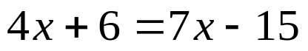
- 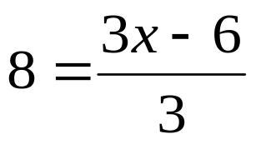



whs.saba.do

“It is never too late to be what you might have been.”
- G. Eliot

