Mr. Sabado, Algebra 1 Week 10 Friday, November 7, 2014

Homework

Due Today:
- Assignment #43:
-Quiz Review Handout

Due 11/10:
- Assignment #44:
-Solving Equations Handout pg. 26

Quiz Friday!!!

Agenda

- Warm-Up
- HW Questions

- Quiz: Solving Equations

- Homework
- Return Graded Work



Warm-Up

Solve
- 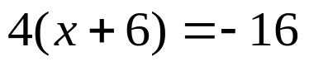

- 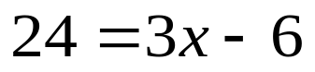



whs.saba.do

“It is never too late to be what you might have been.”
- G. Eliot

