Mr. Sabado, Algebra 2 Week 11 Monday November 10, 2014

Homework

Due Today:
- Assignment #38
p. 255: 3-23 odd and
p. 263: 3-31 odd

Due 11/12:
- Assignment #39
p. 256: 31-51 odd, 61, 67 and
p. 263: 33-45 odd, 51-56 odd, 63

Agenda

- Pick up Opener
- Warm-Up

- Lesson: Solve by Factoring

- Class Work

- Homework
- Return Graded Work



Warm-Up

Factor
1. 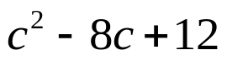

2. 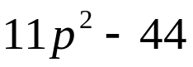

whs.saba.do



“It is never too late to be what you might have been.”
- G. Eliot

