Mr. Sabado, Algebra 1 Week 20 Monday, January 26, 2015

Homework

Due Today:
Assignment #75:
Final Review Study Guide
Opener Packet

Due 1/27:
Opener Packet
Final Exam Extra Credit

Agenda

- Opener Sheet
- Warm-Up

- Class Work: Final Review

- Homework

- Return Graded Work

Warm-Up

Solve
1. 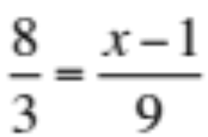

2. 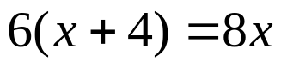
`whs.saba.do


“It is never too late to be what you might have been.”
- G. Eliot

