Mr. Sabado, Algebra 1A Week 20 Tuesday, January 27, 2015

Home Practice

Due Today:
-Semester 1 Final Packet (Week 20)



Agenda

- Turn In Semester 1 Final Packet

- Final Exam

- Class Participation Form

- Return Graded Work

Warm-Up

Place all of your bags/binders/belongings in the front of the class room by the white board.

Cell Phones too!!!


4) 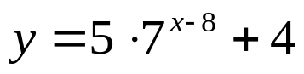

`whs.saba.do

“It is never too late to be what you might have been.”
- G. Eliot

