Mr. Sabado, Algebra 1 Week 1 Tuesday, February 3, 2015

Home Practice

Due Today:
- No HW

Due 2/4:
Who Am I?



Agenda

- Seating Chart
- Opener Sheet
- Warm-Up

- Class Syllabus and Expectations

- Pledge Form

- Class Work: Learning Styles

- Homework

Warm-Up

- Evaluate when a = 3, b = -5, and c = 2 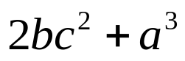

- Graph the following ordered pairs.
A(5, -2), B(0, -3), C(-3, 6)

`whs.saba.do

“It is never too late to be what you might have been.”
- G. Eliot

