Mr. Sabado, Algebra 1 Week 1 Thursday, February 5, 2015

Home Practice

Due Today:
Assignment #1:
Page EP2: 1-22, 27-36
(in the back of the book)

Due 2/6:
Assignment #2:
Page EP3: 53-65 odd, 84-106 even
(in the back of the book)



Agenda

- Opener Sheet
- Warm-Up

- Lesson:
Function Into

- Class Work:
Let’s Get Hopping

- Homework

Warm-Up

Simplify the following
- 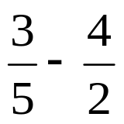

- 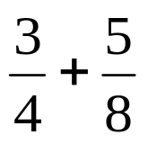
`whs.saba.do

“It is never too late to be what you might have been.”
- G. Eliot

