Mr. Sabado, Algebra 1 Week 1 Friday, February 6, 2015

Home Practice

Due Today:
Assignment #2:
Page EP3: 53-65 odd, 84-106 even
(in the back of the book)
Opener Packet

Due 2/9:
Assignment #3:
Week 1 Review Packet



Agenda

- Warm-Up
- HW Questions
- Turn in Packet

- Skills Quiz #1

- Class Work:
Word Search

- Homework

- Clock Buddies

Warm-Up

Simplify the following
- 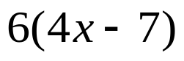

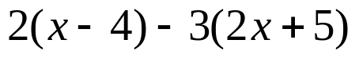
`whs.saba.do

“It is never too late to be what you might have been.”
- G. Eliot

