Mr. Sabado, Algebra 1 Week 2 Friday, February 9, 2015

Home Practice

Due Today:
Assignment #3:
Week 1 Review Packet

Due 2/10:
Assignment #4:
Simplifying Expressions Worksheet



Agenda

- Opener Sheet
- Warm-Up
- HW Questions

- Concept Check List

- Return: Skills Quiz #1

- Class Work:
Choose your Fate

- Homework

- Clock Buddies

Warm-Up

Simplify the following when x = 3 and y = -2
- 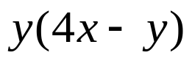
- 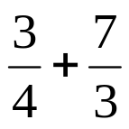

`whs.saba.do

“It is never too late to be what you might have been.”
- G. Eliot

