Mr. Sabado, Algebra 2 Week 20 Monday, January 26, 2015

Homework

Due Today:
Unit 1 & 2 Study Guide

Due 1/28:
Opener Packet
Final Exam Extra Credit


Agenda

- Opener Sheet
- Warm-Up

- Class Work: 5 in a Row

- Unit 3 & 4 Study Guide

- Return Graded Work

Warm-Up

Simplify
- 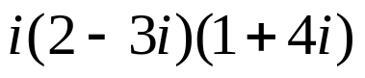
Solve

Find the inverse of
- 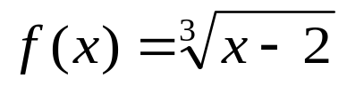

`whs.saba.do

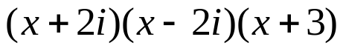

“It is never too late to be what you might have been.”
- G. Eliot

