Mr. Sabado, Algebra 2 Week 1 Wednesday, February 4, 2015

Home Practice

Due Today:
Who Am I?

Due 2/5:
Assignment #1:
A View to a Function



Agenda

- Warm-Up

- Lesson: Rational Function Intro

- Class Work: Data Collection

- Homework

Warm-Up

- Graph the Parent Function 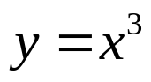

- Graph the function 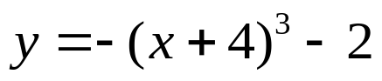 by translating.

`whs.saba.do

“It is never too late to be what you might have been.”
- G. Eliot

