Mr. Sabado, Algebra 2 Week 1 Thursday, February 5, 2015

Home Practice

Due Today:
Assignment #1:
A View to a Function

Due 2/6:
Assignment #2:
p. 561: 11-25 odd



Agenda

- Warm-Up

- Lesson: Rational Function Parent Graph

- Class Work:

- Exit Ticket

- Homework

Warm-Up

- Graph the Parent Function 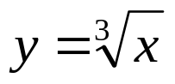

- Graph the function 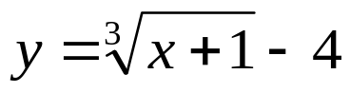 by translating.

- Determine the domain and range of #2.
`whs.saba.do

“It is never too late to be what you might have been.”
- G. Eliot

