Mr. Sabado, Algebra 2 Week 1 Friday, February 6, 2015

Home Practice

Due Today:
Assignment #2:
p. 561: 11-25 odd

Due 2/9:
Assignment #3:
p. 562: 27-34, 43-48



Agenda

- Warm-Up
- Turn in Packet

- Lesson: Equivalent Forms of Functions

- Class Work: Week 1 Review

- Homework

- Clock Buddies

Warm-Up

Divide

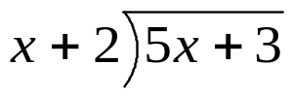

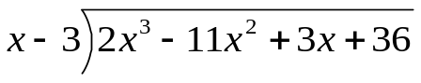
`whs.saba.do

“It is never too late to be what you might have been.”
- G. Eliot

