Mr. Sabado, Algebra 2 Week 2 Monday, February 9, 2015

Home Practice

Due Today:
Assignment #3:
p. 562: 27-34, 43-48

Due 2/10:
Assignment #4:
Graphing Rational Functions Worksheet #1-12



Agenda

- Opener Sheet
- Warm-Up

- Lesson Continued: Equivalent Forms of Functions

- Clock Buddies
- Class Work: Week 1 Review

- Homework

- Clock Buddies

Warm-Up

Write an Equivalent Expression

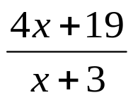

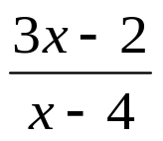
`whs.saba.do

“It is never too late to be what you might have been.”
- G. Eliot

