Mr. Sabado, Algebra 1 Week 5 Thursday, October 2, 2014

Homework

Due Today:
- Assignment #19:
P 35: 23-30, 36-40, 52, 66-75

Due 10/3:
- Assignment #20:
P. 36&37: Exponents and Roots Worksheet

Bring your Textbook every day!!!
Quiz Friday!!!

Agenda

- Warm-Up
- HW Questions

- Review: Roots

- Class Work

- Homework



Warm-Up

Simplify
- 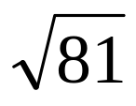

- 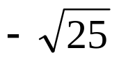

- 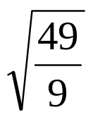

whs.saba.do

“It is never too late to be what you might have been.”
- G. Eliot
Nb

