**Open Event Server**

Integration of various Payment Gateways and enhancement of Admin Panel and Account functionalities

**GSoC 2019 Project Proposal**

# **Personal Details:**

* **Name**: Saicharan Reddy
* **Email**: [saicharan.reddy1@gmail.com](mailto:saicharan.reddy1@gmail.com), [bim2016002@iiita.ac.in](mailto:bim2016002@iiita.ac.in)
* **Mobile**: +91-9849065497
* **Institute**: Indian Institute of Information Technology, Allahabad [IIIT-A [➚](https://www.iiita.ac.in/)]
* **Current Address**: Allahabad, India
* **Course**: Bachelor of Technology (III Year)
* **Specialization**: Information Technology
* **GitHub**: [@mrsaicharan1](https://github.com/mrsaicharan1)
* **TimeZone**: (Asia/Kolkata) +0530

# **Abstract:**

* Implementation of payment gateways of **Sofort Pay and AliPay** using Stripe Sources
* Integrate an **admin view of payment statuses for various roles** in Sales section e.g. Marketing/Superuser/Normal User
* Automating **Payment Reminders** and integrating custom reminder templates with custom frequencies and related features.
* Implementing the feature of adding **NGO/Open Source events** with zero fees.
* **Limit account features of organizers** depending on their platform invoice payment.
* Implement **marketing ownership of events** in Admin UI Sales tab
* Integration of views for **Sales/Marketing analytics** for Admin/Organizer Monitoring.
* Implement features for **email customization for different users** through Admin UI
* Improve **exception handling and error message customization**
* Implement **security tests and automated reports** to decrease the vulnerability against attacks
* Maintaining **compatibility between legacy version and the new version** by writing scripts for migration of data.
* Implement **missing server endpoints** to check the presence of various components
* Improving the **security for tickets** by limiting access based on account status and unique IDs.

# **Potential Mentors:**

Areeb Jamal, Niranjan Rajendran, Saptak Sengupta, Abhinav K, Dilpreet Singh, Mario Behling

# **Contribution History:**

I’ve been a regular contributor to open source projects and have been associated with it for a considerable period of time. Some of the organizations to which I have contributed include **FOSSASIA[**[**➚**](http://github.com/FOSSASIA)**], Plone[**[**➚**](https://github.com/systers)**] and Freeflo[**[**➚**](https://github.com/coala/coala)**]** in which my **major contributions were with FOSSASIA**.

*Contributed to:*

|  |  |  |  |
| --- | --- | --- | --- |
| **Organization** | **Project** | **Merged PRs / Contributions** | **Major contributions/ What I did?** |
| FOSSASIA | [Open-Event Server](https://github.com/fossasia/open-event-server) (Flask) | 34 Contributions  2 PRs under review  [(link to all PRs)](https://github.com/fossasia/open-event-server/pulls?q=is%3Apr+author%3Amrsaicharan1+is%3Aclosed) | * Added crucial tests, bug fixes, notified priority issues, error handling, fixed blocking issues, existing modules and added features |
| FOSSASIA | [Open-Event FrontEnd](https://github.com/fossasia/open-event-frontend)  (EmberJS) | 4 contributions  1 PR under review  [(link to all PRs)](https://github.com/fossasia/open-event-frontend/pulls?utf8=%E2%9C%93&q=is%3Apr+is%3Aclosed+author%3Amrsaicharan1) | * Added acceptance tests for routes and fixed admin functionalities |
| Plone | [Plone](https://github.com/Plone) (Python) | 2 contributions  [(link to PRs)](https://github.com/plone/Products.CMFPlone/pulls?utf8=%E2%9C%93&q=is%3Apr+author%3Amrsaicharan1+) | * Fixed minor bugs and opened several website issues. |
| Freeflo | Axizoun | 60 contributions  [(link to contributions)](https://github.com/FreeFlowOrg/Axizoun/commits?after=d0f7d34f62c33789642739da5896d780257609d6+34&author=mrsaicharan1) | * Developed features for resume info extraction, hiring modules and payment features. |
| Freeflo | ResearchFLO | 45 contributions  [(link to contributions)](https://github.com/FreeFlowOrg/researchflo/commits?after=75f22360b8d69bd4c24ae00e0b79734f7c3fab11+34&author=mrsaicharan1) | * Implemented views and features for subscribers, publishers and reviewers |

**Design Mockups and Implementation :**

*Implementation of the Sofort Pay and AliPay will be through Stripe Sources. The workflow is attached below*

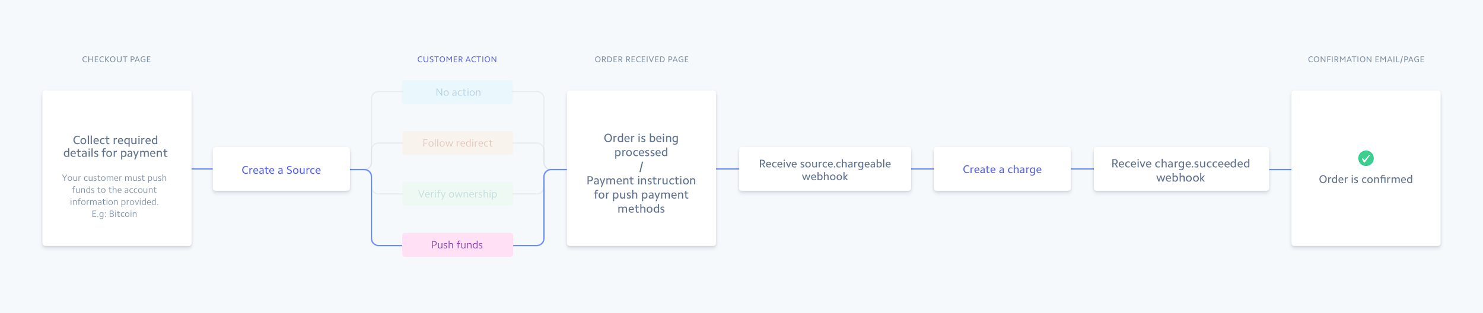

1. Sofort Pay integration

Sofort Pay can be integrated into the application using **Sources,** a single integration path for creating payments from customers in Europe. During the payment process, a Source API object is created and your customer is redirected to AliPay for authorization.

1. Payment Flow
   1. Create a Source Object with the parameters *currency, amount redirect_url, amount, country and other optional parameters.*
   2. Create a page for *completion of customer authorization* by specifying the redirect_url.
   3. Change the source status from *pending* to *chargeable.*
   4. Confirm the payment by redirecting to the confirmation page and process the refund for any unsuccessful payments(if deducted)

2. AliPay integration

AliPay can be integrated into the application using **Sources,** a single integration path for creating payments from customers in China. During the payment process, a Source API object is created and your customer is redirected to AliPay for authorization.

1. Payment Flow
   1. Create a Source Object with the parameters *currency, redirect_url and amount*.
   2. Create a page for *completion of customer authorization* by specifying the redirect_url.
   3. Change the source status from *pending* to *chargeable.*
   4. Confirm the payment by redirecting to the confirmation page and process the refund for any unsuccessful payments(if deducted)

3. Donations Feature(Pay-As-You-Want)

* Implementing donations as a part of the pre-existing PayPal integration.
  + Donations can be split into 2 types
    - Recurring
      * Adding the option of recurring donations for ease of payments on a monthly/yearly basis
    - Non-Recurring
      * Donating a specified amount(one-time amount)

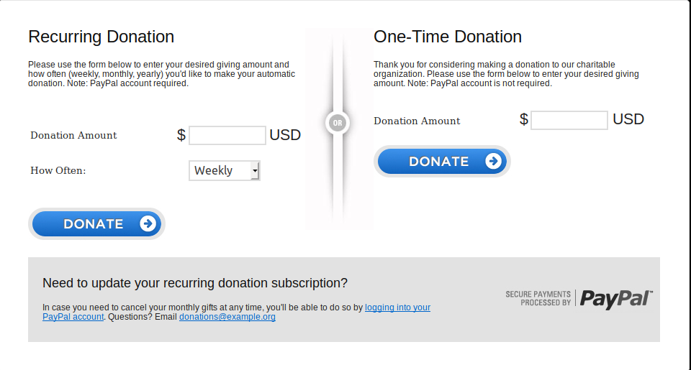

4. Payments Reminder/Customization

* A payment reminder module is to be prepared to remind the organizers to pay the invoice to the platform.
* Customizable fields such as email body, email subject, the frequency of emails, date and time will also be integrated as a part of this.

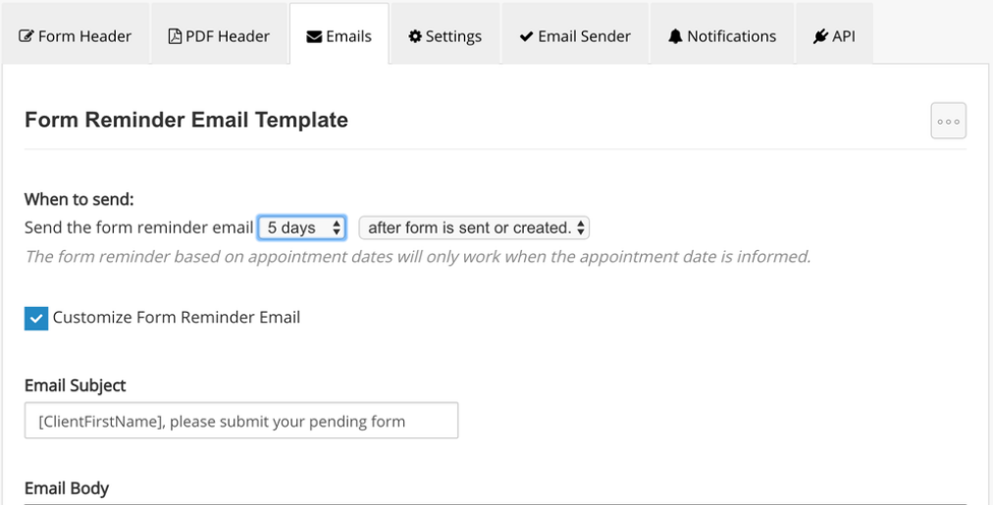

5. Migration of data from Legacy to New:

* In the legacy version of *eventyay*, there were no database relationships present in between the tables. Hence everything has been stored in a raw CSV format in the database.
* Therefore, scripts to make sure it is compatible with the new system are of utmost importance during this period.

6. Sales and Marketing Analytics for Admin/Organizers:

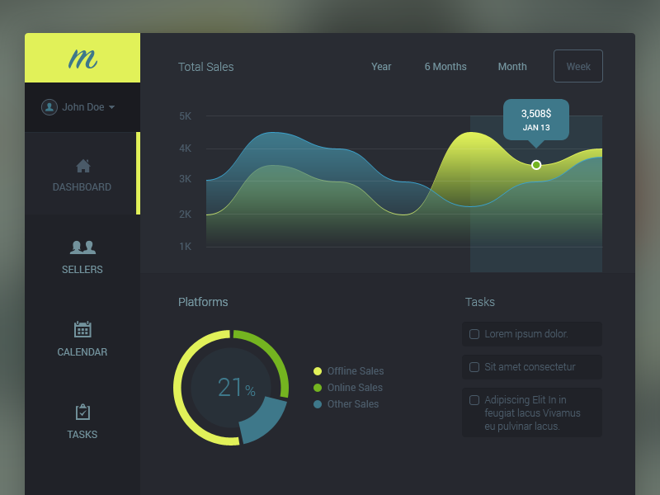

# For proper monitoring of sales and marketing analytics, a visual interface would be fruitful for this process.

1. Integrating an analytics dashboard for the Admin so that they can track the remuneration received and finance flow of the platform
2. Integrating a Sales and Marketing statistics panel so that the organizer can effectively track their customer outreach and business development.

# 

# **Timeline**

|  |  |  |  |
| --- | --- | --- | --- |
| **Time Frame** | **Start date** | **End date** | **What I plan to do?** |
| **Community Bonding** | **6 May** | **26 May** |  |
|  | 6 May | 14 May | End semester exams period: Will be continuing to participate in scrum meetings, fix blocking issues, review co-developers’ PRs and discuss potential workflows with mentors whilst managing my examinations. |
|  | 15 May | 26 May | Set up the basic payment gateways configuration for AliPay and Sofort Pay. Create the basic UI for payments and admin sales monitoring.  Solving existing bugs in the app which might be blocking Android/other projects and review co-developers’ PRs. |
| **Coding Phase I** | **27 May** | **28 June** |  |
|  | 27 May | 2 June | Work on the server side implementation of Sofort Pay. Integrate the admin panel for statistics monitoring. Writing unit tests for the same. (Test Driven Development-TDD) |
|  | 3 June | 10 June | Integrate an admin view of payment statuses for various roles in Sales section e.g. Marketing/Superuser/Normal User.  Write unit/integration tests for the same. (Test Driven Development-TDD) |
|  | 11 June | 18 June | Work on AliPay implementation and its integration with Admin panel for statistics monitoring. Writing unit tests for the same(Test Driven Development-TDD) |
|  | 19 June | 24 June | Implement missing server endpoints for the above statistics and analytics.  Write up docs for each of the payment gateways implemented. Fix any prevalent bugs with the current implementation. Writing unit tests for the same(Test Driven Development-TDD) |
| **First evaluation** | 24 June | 28 June | Major testing for the modules to be done during this period(Security and Integration). Continue working on sub-features in the integrations. |
| **Coding Phase II** | **29 June** | **26 July** |  |
|  | 29 June | 5 July | Full-fledged implementation of “pay-as-you-want” (donations) feature. Unit tests for the same. |
|  | 6 July | 13 July | Implement admin overview of payment statuses for different roles in admin sales tab. Unit tests for the same(Test Driven Development-TDD)\ |
|  | 14 July | 21 July | Implementing a payment reminder mechanism with editable fields such as frequency and type.  Implementation of Sales/Marketing analytics in the admin UI. Writing unit tests for the same. (Test Driven Development-TDD) |
| **Second evaluation** | 22 July | 26 July | Fix any bugs which arise due to this and write valid documentation. Major testing for the modules to be done during this period(Security and Integration) |
| **Coding phase III** | **27 July** | **19 August** |  |
|  | 27 July | 3 August | Improve error handling of codebase and design user-friendly messages, Migration of data from legacy to the new version of *eventyay.* Adding the option for Open Source/NGO events at zero fees. Writing unit tests for the same(Test Driven Development-TDD) |
|  | 4 August | 11 August | Implement security tests and implement a module for the generation of automated reports. |
|  | 12 August | 19 August | Finish any pending work. |
| **Final Evaluation** | 19 August | 26 August | Write the documentation/final report for all the work done in the GSoC period. |

**Communication:**

Actively participate in Gitter conversations and help out people to fix their bugs/issues. A member of FOSSASIA organization on GitHub and regularly monitor the status of the project, open issues and try to solve them. Have also helped other co-developers fix bugs by reviewing them.

If selected, will submit a daily scrum about the current work status of each milestone, write a blog post about each feature implemented and how one can contribute to it in the future, provide presentations/slides and enlighten a gathering/meetup about these newly implemented features.

**Availability:**

Will be available on a full-time basis(40-45 hours/week) and will constantly work on the project in a full-fledged manner. Will be continuing to participate in scrum meetings, fixing blocking issues, review co-developer’s PRs and discuss potential workflows with mentors whilst managing my examinations.

# **Why Me?**

Apart from regularly contributing to open source projects, having technical experience, I also possess some managerial skills and have won 3 hackathons. My interests align with blockchain technologies and AI-based products. I’ve worked as a full stack developer/course instructor intern for an online MOOC platform SkillLauncher under Techimax Pvt. Ltd.

You can expect me to work with deadlines and collaborating with others to deliver results.

**Important Information:**

If selected, would be abiding by below guidelines strictly and will be flexible with them.

* Will be agreeing to change details of the project if required
* Flexible to working on other apps (BadgeYay and SUSI Web Projects)
* Will be working full-time in any case(**Do not have any additional responsibilities during the summer)**
* Will be abiding by FOSSASIA’s coding practices.
* Agree to the fact that I would be failed if I’m not available full-time even for unforseen circumstances as Google and FOSSASIA would not be able to take these into account given the Google timeline
* After GSoC ends, I’ll continue contributing to FOSSASIA and review code.