**IEE 572 Design of Experiments (Experiment 4)**

Kush Nilesh Shah

Sandesh Ganapati Bhat

* **Objective of Experiment:**

A part was designed (13 mm width) and 3D printed 10 times. The 10 parts were measured for width using a digital Vernier caliper. The experiment is conducted to check the integrity of the measurement device when compared to the 3D printed parts.

* **Factors:**

1. Operator (1, 2, 3)
2. 3D printed Parts (10 units)

* **Response:**

The response is the measurement shown on the digital caliper screen in mm.

* **Experiment Type:**

Experiment with Random factors (2 factor factorial experiment with Operator and parts as the factors)

* **Planning:**

The parts were measured randomly by the operators and it was ensured the order of measurement for two operators were not the same.

Each operator measured the parts under similar conditions: temperature of the room, temperature of the part etc. This ensured there was no error induced in the measurement due to external factors.

* **Experimental Setup:**

*Apparatus*: 3D printer (Ultimaker 2), Stl file of part to be printed, Digital Vernier caliper (Mitutoyo 500-196-30CERT 0-6" Digimatic), 3 people to measure the parts (operators).

*Procedure*: The parts were printed on the 3D printer with a tolerance level set. Each operator then randomly selected the parts, one at a time, and measured them. The zero of the gauge was set before the experiment was conducted. Each measurement was noted down in its respective space. The data was then analyzed on minitab.

* **Results:**

The data collected are tabulated below along with the minitab output of residual:

|  |  |  |  |  |  |  |  |  |  |  |  |
| --- | --- | --- | --- | --- | --- | --- | --- | --- | --- | --- | --- |
| **Order** | **Parts** | **Operators** | **Response** | **RESI** | **FITS** | **Order** | **Parts** | **Operators** | **Response** | **RESI** | **FITS** |
| **1** | 7 | Operator1 | 11.506 | -0.00013 | 11.50613 | **31** | 2 | Operator1 | 11.833 | 0.001352 | 11.83165 |
| **2** | 6 | Operator1 | 12.961 | 0.001526 | 12.95947 | **32** | 7 | Operator1 | 11.505 | -0.00113 | 11.50613 |
| **3** | 1 | Operator1 | 12.981 | -0.00555 | 12.98655 | **33** | 4 | Operator1 | 13.516 | 0.007152 | 13.50885 |
| **4** | 9 | Operator1 | 11.682 | 0.002432 | 11.67957 | **34** | 1 | Operator1 | 12.971 | -0.01555 | 12.98655 |
| **5** | 4 | Operator1 | 13.508 | -0.00085 | 13.50885 | **35** | 3 | Operator1 | 13.604 | -0.00312 | 13.60712 |
| **6** | 8 | Operator1 | 13.338 | -0.00918 | 13.34718 | **36** | 9 | Operator1 | 11.666 | -0.01357 | 11.67957 |
| **7** | 3 | Operator1 | 13.627 | 0.019879 | 13.60712 | **37** | 8 | Operator1 | 13.352 | 0.004824 | 13.34718 |
| **8** | 5 | Operator1 | 13.009 | 0.011419 | 12.99758 | **38** | 6 | Operator1 | 12.948 | -0.01147 | 12.95947 |
| **9** | 10 | Operator1 | 11.608 | -0.00141 | 11.60941 | **39** | 10 | Operator1 | 11.619 | 0.009592 | 11.60941 |
| **10** | 2 | Operator1 | 11.829 | -0.00265 | 11.83165 | **40** | 5 | Operator1 | 13.004 | 0.006419 | 12.99758 |
| **11** | 7 | Operator 2 | 11.518 | 0.009121 | 11.50888 | **41** | 5 | Operator 2 | 12.992 | -0.00833 | 13.00033 |
| **12** | 2 | Operator 2 | 11.840 | 0.005602 | 11.8344 | **42** | 1 | Operator 2 | 12.98 | -0.0093 | 12.9893 |
| **13** | 6 | Operator 2 | 12.976 | 0.013776 | 12.96222 | **43** | 8 | Operator 2 | 13.355 | 0.005074 | 13.34993 |
| **14** | 1 | Operator 2 | 13.010 | 0.020704 | 12.9893 | **44** | 6 | Operator 2 | 12.955 | -0.00722 | 12.96222 |
| **15** | 3 | Operator 2 | 13.609 | -0.00087 | 13.60987 | **45** | 9 | Operator 2 | 11.683 | 0.000682 | 11.68232 |
| **16** | 10 | Operator 2 | 11.612 | -0.00016 | 11.61216 | **46** | 10 | Operator 2 | 11.615 | 0.002842 | 11.61216 |
| **17** | 4 | Operator 2 | 13.521 | 0.009402 | 13.5116 | **47** | 4 | Operator 2 | 13.507 | -0.0046 | 13.5116 |
| **18** | 9 | Operator 2 | 11.676 | -0.00632 | 11.68232 | **48** | 2 | Operator 2 | 11.828 | -0.0064 | 11.8344 |
| **19** | 8 | Operator 2 | 13.357 | 0.007074 | 13.34993 | **49** | 3 | Operator 2 | 13.607 | -0.00287 | 13.60987 |
| **20** | 5 | Operator 2 | 12.990 | -0.01033 | 13.00033 | **50** | 7 | Operator 2 | 11.491 | -0.01788 | 11.50888 |
| **21** | 1 | Operator 3 | 12.988 | 0.000352 | 12.98767 | **51** | 7 | Operator 3 | 11.505 | -0.00225 | 11.50725 |
| **22** | 5 | Operator 3 | 12.996 | -0.00247 | 12.9987 | **52** | 10 | Operator 3 | 11.597 | -0.01353 | 11.61053 |
| **23** | 7 | Operator 3 | 11.520 | 0.012269 | 11.50725 | **53** | 4 | Operator 3 | 13.502 | -0.00797 | 13.50997 |
| **24** | 4 | Operator 3 | 13.507 | -0.00314 | 13.50997 | **54** | 8 | Operator 3 | 13.343 | -0.0053 | 13.3483 |
| **25** | 6 | Operator 3 | 12.959 | -0.00201 | 12.9606 | **55** | 5 | Operator 3 | 13.002 | 0.003297 | 12.9987 |
| **26** | 2 | Operator 3 | 11.836 | 0.002861 | 11.83277 | **56** | 2 | Operator 3 | 11.832 | -0.00077 | 11.83277 |
| **27** | 3 | Operator 3 | 13.597 | -0.01077 | 13.60824 | **57** | 6 | Operator 3 | 12.966 | 0.005404 | 12.9606 |
| **28** | 8 | Operator 3 | 13.346 | -0.0025 | 13.3483 | **58** | 1 | Operator 3 | 12.997 | 0.009332 | 12.98767 |
| **29** | 10 | Operator 3 | 11.613 | 0.002661 | 11.61053 | **59** | 3 | Operator 3 | 13.606 | -0.00224 | 13.60824 |
| **30** | 9 | Operator 3 | 11.697 | 0.016461 | 11.68069 | **60** | 9 | Operator 3 | 11.681 | 0.000311 | 11.68069 |

**The ANOVA for our experiment is as below:**

|  |  |  |  |
| --- | --- | --- | --- |
| **Factor** | **Type** | **Levels** | **Values** |
| Parts | random | 10 | 1, 2, 3, 4, 5, 6, 7, 8, 9, 10 |
| Operators | random | 3 | Operator1, Operator 2, Operator 3 |

**Analysis of Variance for C4**

|  |  |  |  |  |  |
| --- | --- | --- | --- | --- | --- |
| **Source** | **DF** | **SS** | **MS** | **F** | **P** |
| Parts | 9 | 38.7033 | 4.3004 | 50601.76 | 0.000 |
| Operators | 2 | 0.0001 | 0.0000 | 0.45 | 0.640 |
| Error | 48 | 0.0041 | 0.0001 |  |  |
| Total | 59 | 38.7075 |  |  |  |

**S = 0.00921871   R-Sq = 99.99%   R-Sq(adj) = 99.99%**

|  |  |  |  |
| --- | --- | --- | --- |
| **Source** | **Variance component** | **Error term** | **Expected Mean Square for Each Term (using unrestricted model)** |
| 1  Parts | 0.71671 | 3 | (3) + 6 (1) |
| 2  Operators | -0.00000 | 3 | (3) + 20 (2) |
| 3  Error | 0.00008 |  | (3) |

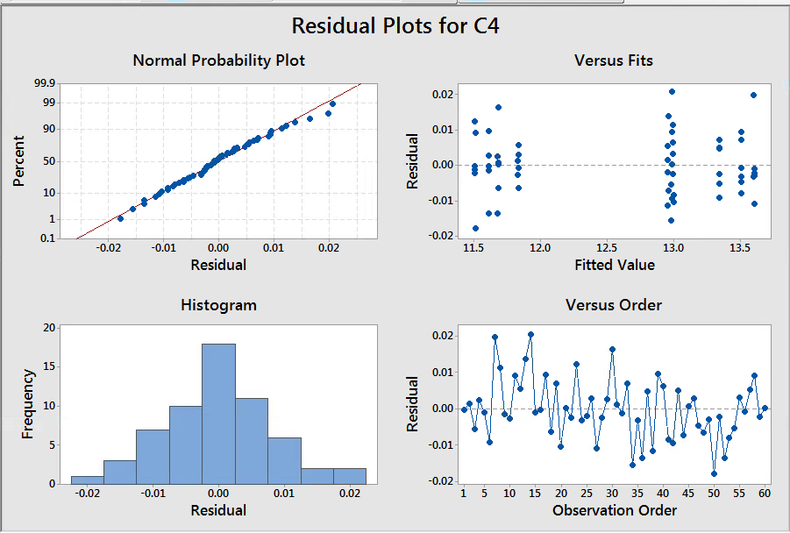

The above graphshows normal distribution no recognizable pattern

**Gage R&R Study - ANOVA Method**

Two-Way ANOVA Table With Interaction

|  |  |  |  |  |  |
| --- | --- | --- | --- | --- | --- |
| **Source** | **DF** | **SS** | **MS** | **F** | **P** |
| Parts | 9 | 38.7033 | 4.30037 | 48656.3 | 0.000 |
| Operators | 2 | 0.0001 | 0.00004 | 0.4 | 0.655 |
| Parts * Operators | 18 | 0.0016 | 0.00009 | 1.1 | 0.427 |
| Repeatability | 30 | 0.0025 | 0.00008 |  |  |
| Total | 59 | 38.7075 |  |  |  |

α to remove interaction term = 0.05

Two-Way ANOVA Table Without Interaction

|  |  |  |  |  |  |
| --- | --- | --- | --- | --- | --- |
| **Source** | **DF** | **SS** | **MS** | **F** | **P** |
| Parts | 9 | 38.7033 | 4.30037 | 50601.8 | 0.000 |
| Operators | 2 | 0.0001 | 0.00004 | 0.4 | 0.640 |
| Repeatability | 48 | 0.0041 | 0.00008 |  |  |
| Total | 59 | 38.7075 |  |  |  |

Hence we can see that the interaction doesn’t have a significant effect on the outcome of our experiment.

**Gage R&R**

|  |  |  |
| --- | --- | --- |
| **Source** | **VarComp** | **(%Contribution of VarComp)** |
| Total Gage R&R | 0.000085 | 0.01 |
| Repeatability | 0.000085 | 0.01 |
| Reproducibility | 0.000000 | 0.00 |
| Operators | 0.000000 | 0.00 |
| Part-To-Part | 0.716714 | 99.99 |
| Total Variation | 0.716799 | 100.00 |

|  |  |  |  |
| --- | --- | --- | --- |
| **Source** | **(SD)** | **(6 × SD)** | **(%SV)** |
| Total Gage R&R | 0.009219 | 0.05531 | 1.09 |
| Repeatability | 0.009219 | 0.05531 | 1.09 |
| Reproducibility | 0.000000 | 0.00000 | 0.00 |
| Operators | 0.000000 | 0.00000 | 0.00 |
| Part-To-Part | 0.846590 | 5.07954 | 99.99 |
| Total Variation | 0.846640 | 5.07984 | 100.00 |

Number of Distinct Categories = 129

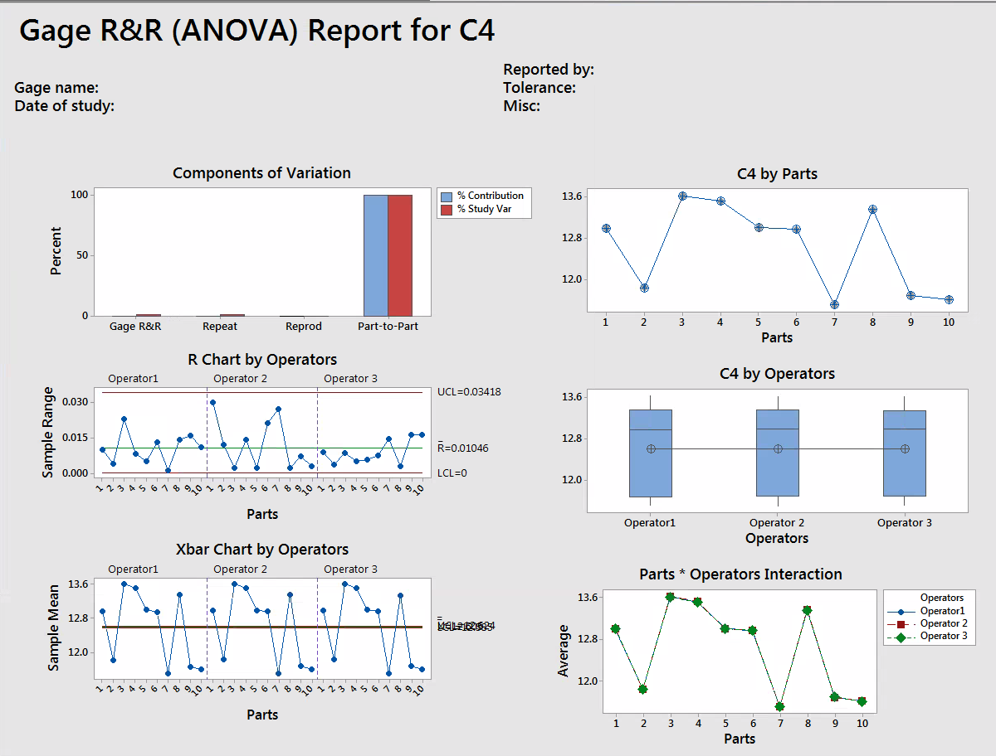

The above graph shows that the variation is high due to parts. Hence proving that the gauge is more precise than the parts and it is a proper measuring tool for the 3D printed parts.

* **Conclusion:**

The goal was to check the reliability of the gauge when measuring the 3D printed parts. By conducting this experiment and analyzing all the results we obtained it is safe to say that the gauge is a proper measurement device for these parts. The variation in measurement is higher due to the parts (It is well known that the 3D printers are not a very reliable manufacturing equipment when it comes to tolerance and precision). It is also noticeable that there is almost no variation due to the operator. This only goes to prove that the gauge is easy to use and even when used by different people, it will give us similar measurements.

* **Problems and Recommendations:**

3D printers have a variable tolerance level. The quality of the print can be changed but it increases the print time. In the above experiment a compromise between time and quality was made. In any further iteration of this experiment where time is not of concern, a higher quality of print can be obtained to decrease the variation in the measurement of the parts. Also, the gauge used is a very precise gauge. 3D printed parts are usually measured using gauges with lower precision. So the combination of the parts and gauge was bound to give us the above obtained results. It would be wise to use a different gauge or a better and precise part in any further experimentation.