* **Objective of Experiment:**

Find the effect of size of container, temperature of hot plate, and type of water on the time taken by the water to reach 200 degree Fahrenheit.

* **Factors:**

1. Size of container (small/ large)
2. Temperature of hot plate (High/medium)
3. Type of water (normal/ salty)

* **Response:**

The response is the time required for the solution to reach 190 degree Fahrenheit.

* **Experiment Type:**

2-level full factorial experiment(2^3)

* **Planning:**

The experiment is conducted with randomization in mind. The order of the experiment is randomized using Minitab. It’s made sure that the order isn’t trivial. The order includes the two levels of each factor and is mixed to avoid any lurking variables.

Blocking is another concept that was implemented during the planning of this experiment. The solution used involves mixing salt and water. To avoid any error due to different concentration of salt in the solution, blocking was done for every replicate. The amount of salt in the solution was constant (without human error in mind).

* **Experimental Setup:**

Apparatus: Hot Plate with high and medium settings, Water, Salt, Large and small container, thermometer, stopwatch.

The level of each factor in a run is decided based on the order obtained from Minitab. Each combination is carefully applied in the experiment. The time taken by the water to reach 200 degree Fahrenheit is measured.

* **Results: (fig. 1)**
* **Analysis:**

Analysis of Variance

**Source DF Adj SS Adj MS F-Value P-Value**

Model 9 703.432 78.159 520.89 0.000

Blocks 2 0.048 0.024 0.16 **0.853**

Linear 3 674.505 224.835 1498.41 0.000

Size of container 1 158.363 158.363 1055.41 0.000

Level of hot plate 1 507.362 507.362 3381.31 0.000

Water type 1 8.780 8.780 58.51 0.000

2-Way Interactions 3 28.580 9.527 63.49 0.000

Size of container*Level of hot plate 1 18.463 18.463 123.04 0.000

Size of container*Water type 1 3.590 3.590 23.92 0.000

Level of hot plate*Water type 1 6.527 6.527 43.50 0.000

3-Way Interactions 1 0.300 0.300 2.00 **0.179**

Size of container*Level of hot plate*Water type 1 0.300 0.300 2.00 **0.179**

Error 14 2.101 0.150

Total 23 705.533

From the ANOVA it is clear that blocking and the 3 way interaction will not have any significant effect on the experiment.

**Model Summary**

S R-sq R-sq(adj) R-sq(pred)

0.387362 99.70% 99.51% 99.12%

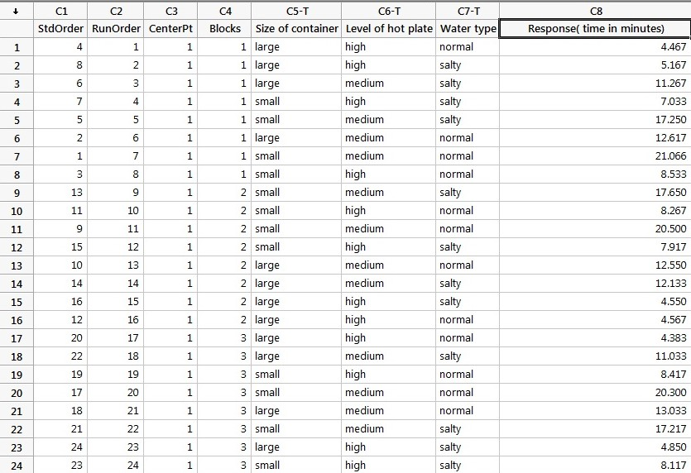

**fig. 1**

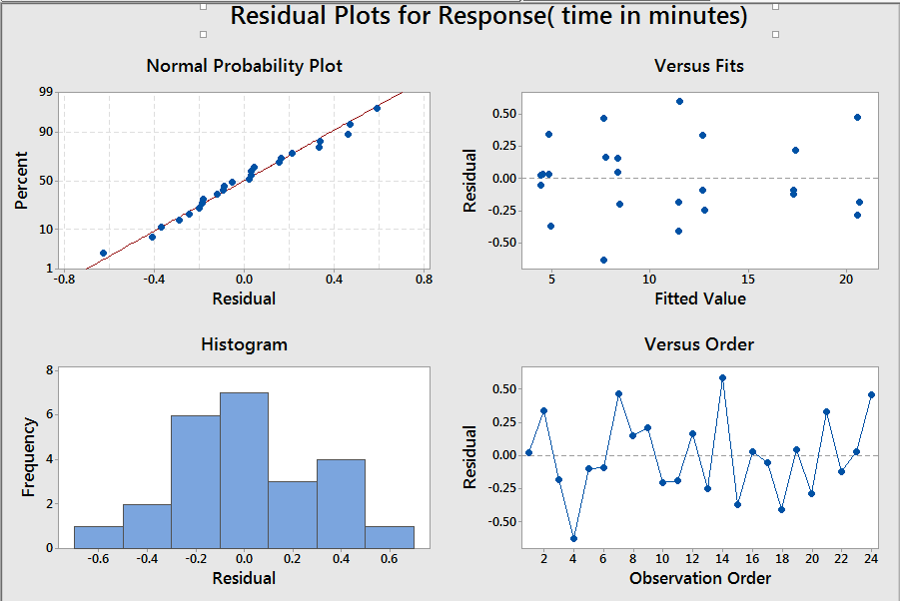

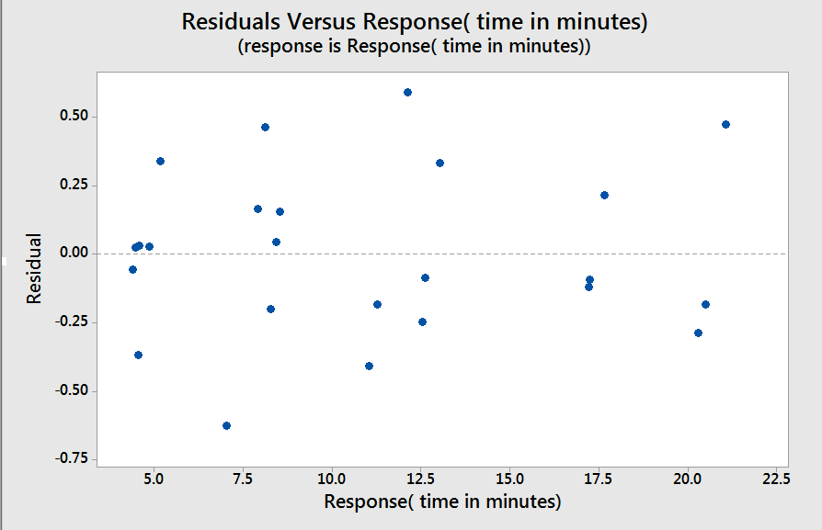

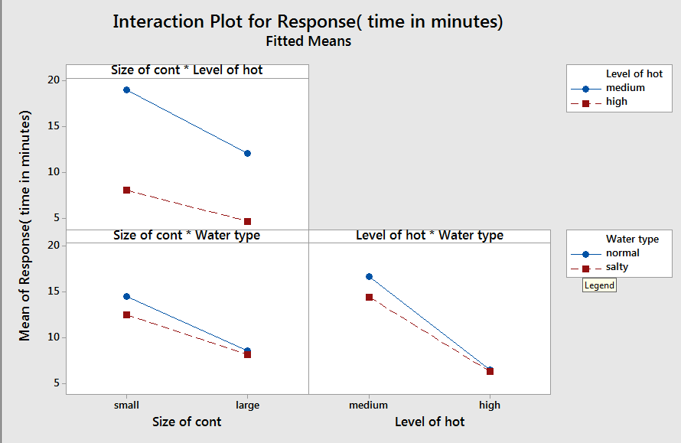

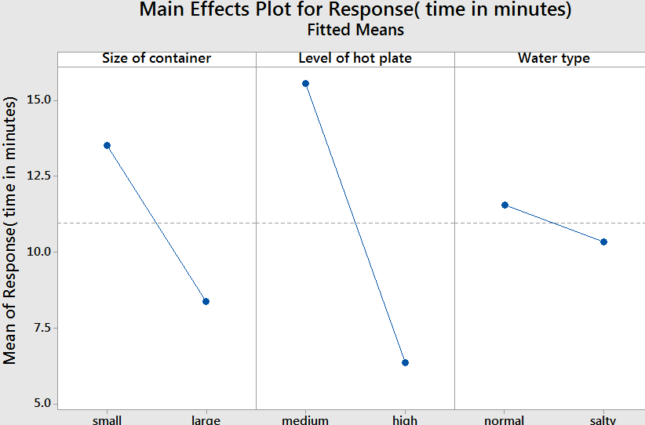

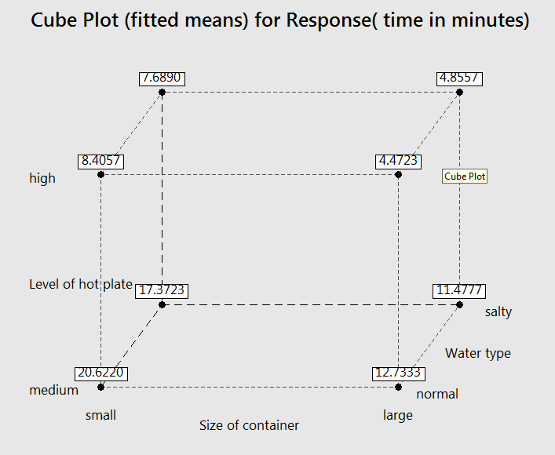

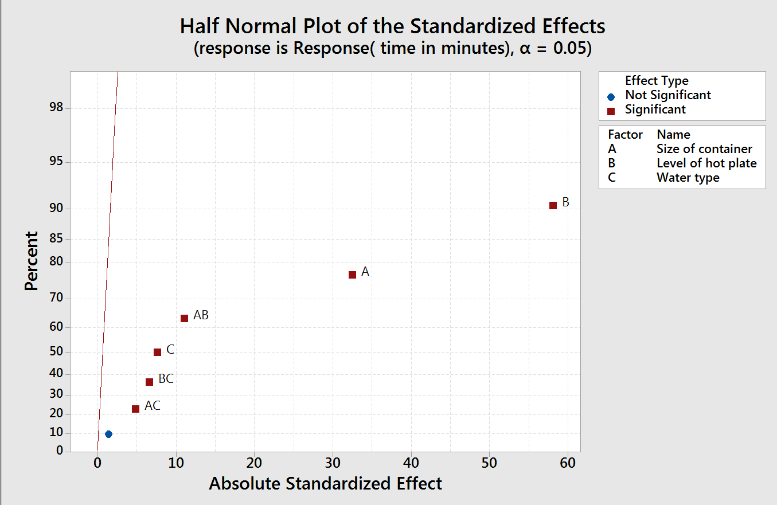

* **Verification:**

Regression Equation in Uncoded Units

Response( time in minutes) = 10.9535 - 2.5687 Size of container - 4.5978 Level of hot plate

- 0.6048 Water type

+ 0.8771 Size of container*Level of hot plate

+ 0.3867 Size of container*Water type

+ 0.5215 Level of hot plate*Water type

- 0.1118 Size of container*Level of hot plate*Water type

|  |  |  |  |  |
| --- | --- | --- | --- | --- |
| **Size of Container** | **Temperature of hot plate** | **Type of water solution** | **Observed Response (z)** | **Calculated Response (ẑ)** |
| Small | medium | normal |  | 20.6220 |
| Small | medium | salty |  | 17.3722 |
| Small | high | normal |  | 8.4054 |
| Small | high | salty |  | 7.6892 |
| Large | medium | normal |  | 12.7332 |
| Large | medium | salty |  | 11.4778 |
| Large | high | normal |  | 4.4726 |
| Large | high | salty |  | 4.8556 |

* **Conclusion:**