Article

Design and implementation of virtual coaches for healthy nutrition habits monitoring and encouragement.

Antonio Benítez Guijarro1 and Manuel Noguera García*

1 mrsasuu@gmail.com

**\*** Correspondence: e-mail@e-mail.com; Tel.: +xx-xxx-xxx-xxxx

Academic Editor: University of Granada

Received: date; Accepted: date; Published: date

**Abstract:** We currently live in a society where nutritional problems affect children, adults and the elderly due to poor nutrition caring and the lack of healthy habits. One way to solve nutritional imbalances is to record or organize what is to eat at different times of the day, thus making a meal plan that translates into a compendium of macronutrients and micronutrients that can be administered to accomplish eating a range of nutrients without exceeding or not getting over a healthy amount. Mobile technology and wearable computing have proven that it is possible to build different monitoring platforms to record a wide range of parameters that influence in nutrition. However, so far technical solutions, have disregarded the provision and encoding of gradual plans that help users to adopt a healthy nutrition habit. In this regard, it is equally important the design and representation of the information that the nutrion monitoring system is going to manage for the sake of maintainability and interoperability. As a palliative measure, we have developed a web and mobile system for the telemonitoring of users, focusing as the main objective the ease of use and the maximization of the autonomy of the users, directed especially to older people paying special care to the representation of information and making it as much customizable as possible. As the main part, the Android-based mobile application records daily data from users' food records and sync the data with the cloud, where all their information is processed and consulted by nutritionists administer monitored users.

**Keywords:** nutrition; telemonitoring; easy to use; cloud system; healthy habits; elderly; smarthpones; web system

1. Introduction

Lack of healthy habits, poor nutrition caring and other problems are the main causes of health issues in people life: the World Health Organization (WHO) has reported “… 39% of adults aged 18 years and over were overweight in 2016, and 13% were obese.” [1]. A good education about having a balanced and varied diet, reducing or eliminating potentially unhealthy foods and correctly managing daily intakes to achieve a rich and healthy diet, is one of the main solutions to this great social problem. But this process must be introduced from childhood to really be effective, because changing eating habits without knowledge or guidelines to follow, can be a rather complex process for an adult user. The option to go to a professional nutritionist can facilitate the change of eating habits, carrying out a strict and continuous monitoring of each user and making a meal plan and habits specific to each user [3][4]. At the same time, the elderly has difficulties in carrying out traditional food monitoring, in the process of making food records and continuing visits to the nutritionist because of their mobility issues and the difficulties in traditional monitoring methods. The technological solutions currently available do not serve as a simple and direct tool between the communication of users and nutritionists who supervise their nutritional habits, as these tools may not be very intuitive to older people, showing more information than the user needs, and directing the functionalities of the available applications to a self-monitoring not supervised by nutritionists in each process.

For this reason, we have designed a project that serves as a bridge between users and nutritionists, creating a simple tool adapted to older people, containing the essential functionalities to be able to evaluate the nutritional habits of each user, producing adaptable and interpretable data, which are processed by a cloud server and monitored by a web application for nutritionists in charge of users to establish guidelines and food plans adapted to each user.

Through a web system, nutritionists register, consult, evaluate and establish nutritional plans for each patient under their supervision. To do this, the system synchronizes and communicates all its modules, using a protected web API, which inserts, processes and delivers free and dynamic data of supervised users. Some of these non-sensitive data are available for use in other projects or studies.

The system is developed in context of an interdisciplinary research project called Avisame. The goal of the project is to combine domain knowledge from experts in physical activity interventions with modern mobile technology to design physical activity plans and the knowledge from nutrition experts as stated above.

Currently the project is in the process of improvement and validation by users, for later use with real consumers and professional supervisors.

This document is divided into four distinct sections. The first section contains a general description of the scheme, introducing the work described in this document, the objectives pursued and the motivations of this project. The second section presents the development process, specifying the analysis, design and implementation. The third section shows the general discussion behind development. And finally, the fourth section presents the conclusion and future work.

2. System Description and Development

A telemonitoring system is composed of two main elements, the monitored device or user, and monitoring equipment that will analyze the relevant data of the individual, comparing them with other objective data. Through this monitoring the supervisor can take measures to adjust the maximum to the monitored individual, attempted thus keeping that relevant data as close as possible to the target. Now moving this to the paradigm of our problem we would have an older person as a monitored user and the nutritionist as supervisor, observing the patient's food records translated to macronutrients and micronutrients in order to be compared by the tables of recommended daily amounts specified by the supervisor.

2.1. System modules

The software system consists of several modules:

* A mobile application based on Android, designed primarily for older people to record their meals and intakes daily.
* A web application based on NodeJs, html5 and CSS3, aimed at nutritionists for the management and supervision of the elderly, through which to track statistics, supervising, adding or eliminating food records, creating nutritional goals or diets, creating lists of food or tables comparatives etc.
* An API based in NodeJs, with well-defined interfaces to enable communication between all parts of the system. During the design of the API, data format and representation issues have also been considered, as well as the use of standard technologies to facilitate their extensibility, maintenance and interoperability with third party applications and systems.

The software we present has been developed in the context of a project of the national research plan and a European COST action and represents the subsystem in charge of a virtual nutritional adviser, integrated within a more complex system that includes virtual advisors based on graphic avatars and other aspects of healthy life, such as locomotion, postural ergonomics and physical exercise.

2.2. Architecture

The architecture of the system is based on the three parts mentioned above, connected through the cloud, which synchronizes the records of each user, downloading and uploading the data of the mobile applications of the monitored users automatically following a system of verification record creation dates, keeping the newer versions on the cloud server. The mobile application used by users registers offline in a SQLITE database managed by ORM Sugar, and periodically synchronizes the new nutritional records with the cloud server through HTTP requests using the framework Retrofit2, updating the new records on the server, or downloading the records entered by the nutritionist through the web administration panel. Additionally, during this synchronization, the new nutritional goals established by the nutritionists will be downloaded for that particular day. Figure 1 shows a general scheme of the system exposing the previously explained process.

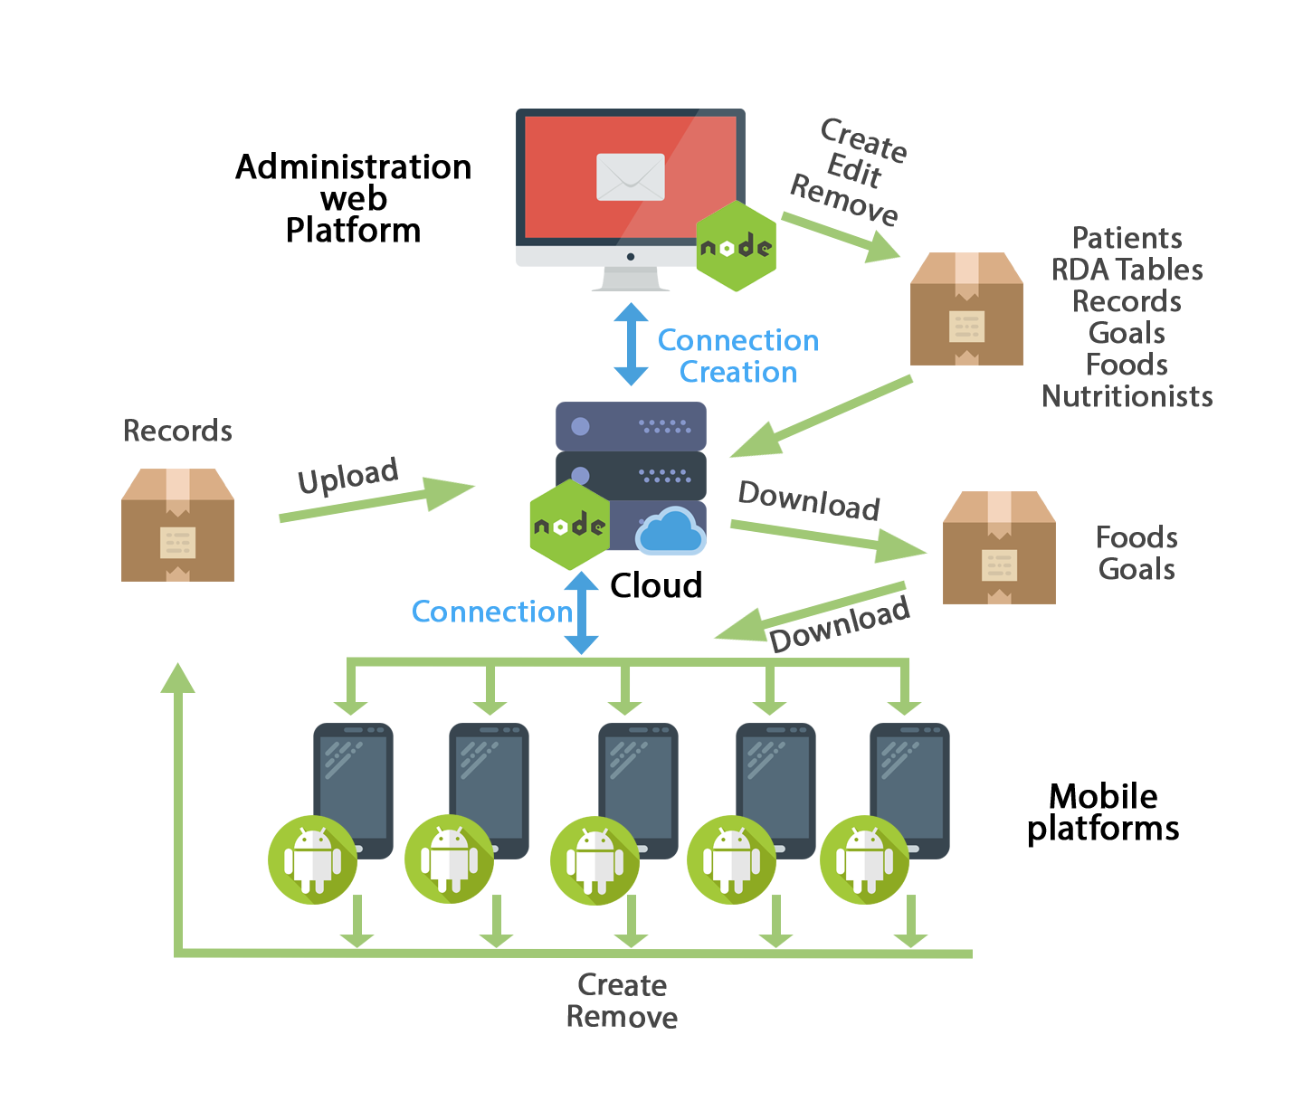

**Figure 1.** General scheme of the system.

2.3. Data and API

The main system data is sent and received through requests to the API, receiving and responding with JSON information. To secure sensitive system data, responses have been encrypted using JWT tokens, giving access to certain parts of the API only if the request is made with a valid access token. All other routes and requests without sensitive data are available through HTTP requests to the API, and receive responses in JSON format.

2.4. System data synchronization

In the case of the mobile platform, it will synchronize the food from the cloud when the date of modification of any of the foods is newer than the one stored in its internal database. In the case of the goals, it will download the information of these when it has something new, that is to say, when a new goal has been introduced in the system and hasn't synchronized yet. Finally, in the case of food records, those records that do not exist in the local database will be downloaded when a record with a modification date / creation with a more recent date appears in the cloud, and in the same way, if the application mobile detects that the cloud has an earlier version than its database will upload all new records. The Figure 2 shows the way it works.

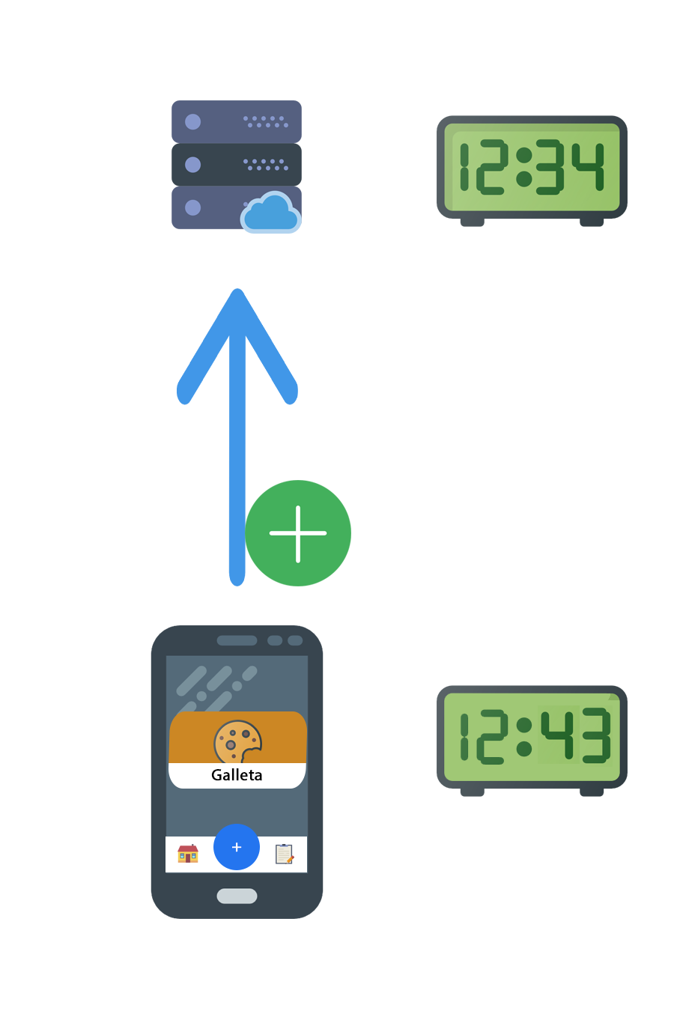

**Figure 2.** Synchronization of local data to the cloud.

2.5. Administration web platform

This system module is the main tool for nutritionists, with it, they will sign in the system the new users who will be supervised, create and manage the available foods throughout the system and their nutritional information, manage their own tables of recommended daily allowance, consult and will edit the food registries of supervised users in charge, establishing goals and nutritional plans based on the statistics obtained with their eating habits. To carry out their work, they will use a web interface based on HTML5 and Materialize CSS, with the following functionalities:

* **System of authentication and recognition of different users:**

Through the credentials introduced into the system, nutritionists will be able to access the web system through a login form, where the user type is automatically recognized; that is, user administrator, or nutritionist.

* **General administration panel:**

Through the general panel will access all the functionalities of the system (Figure 3).

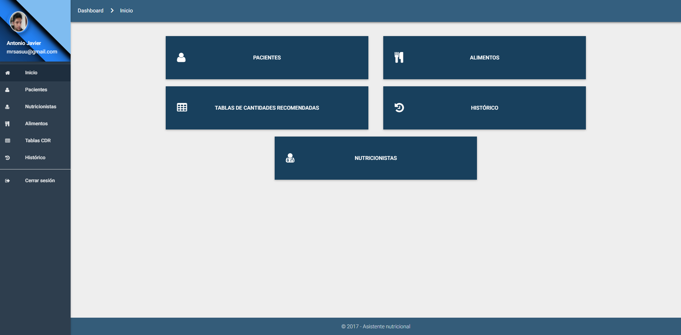

**Figure 3.** General administration panel.

* **Patient panel:**

Panel showing the list of patients associated with the nutritionist, showing the main data of the people monitored, and the options to add, display, edit and eliminate such users (Figure 4).

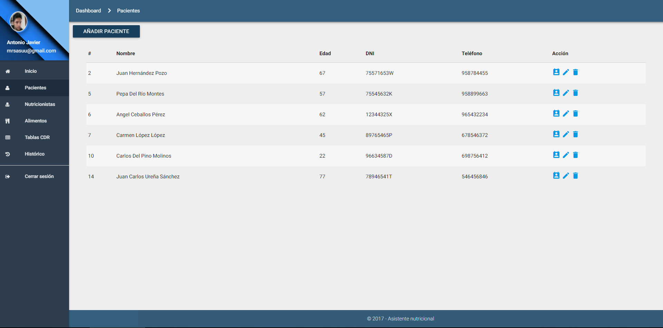**Figure 4.** Patient panel.

* **Patient's personal calendar:**

Calendar where the patient's food records and goals are displayed, being able to interact with clicks, eliminating or adding new ones to the desired date. The registration and goals form autocomplete the food to select through a query to available food (Figure 5,6 and 7).

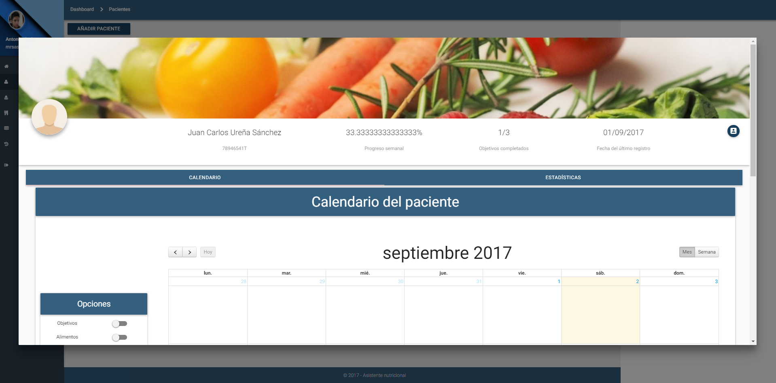

**Figure 5.** Patient display panel.

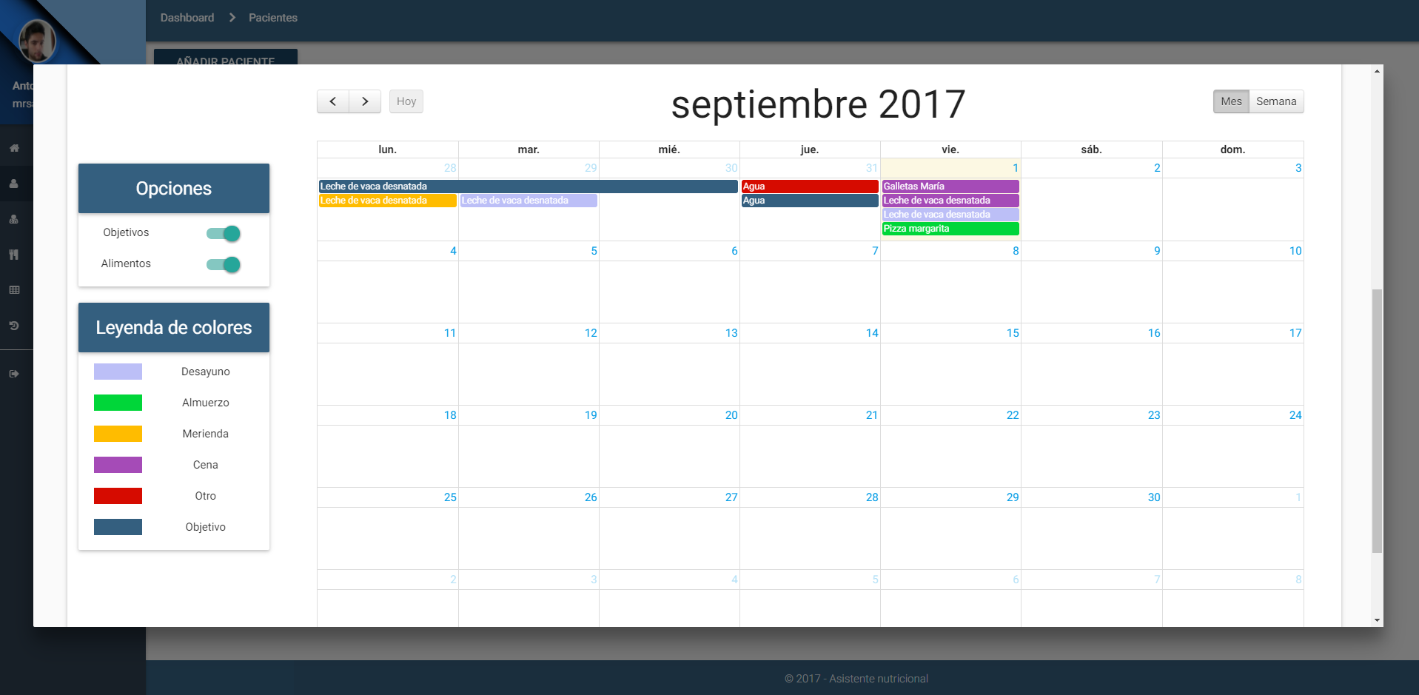

**Figure 6.** Patient's personal calendar.

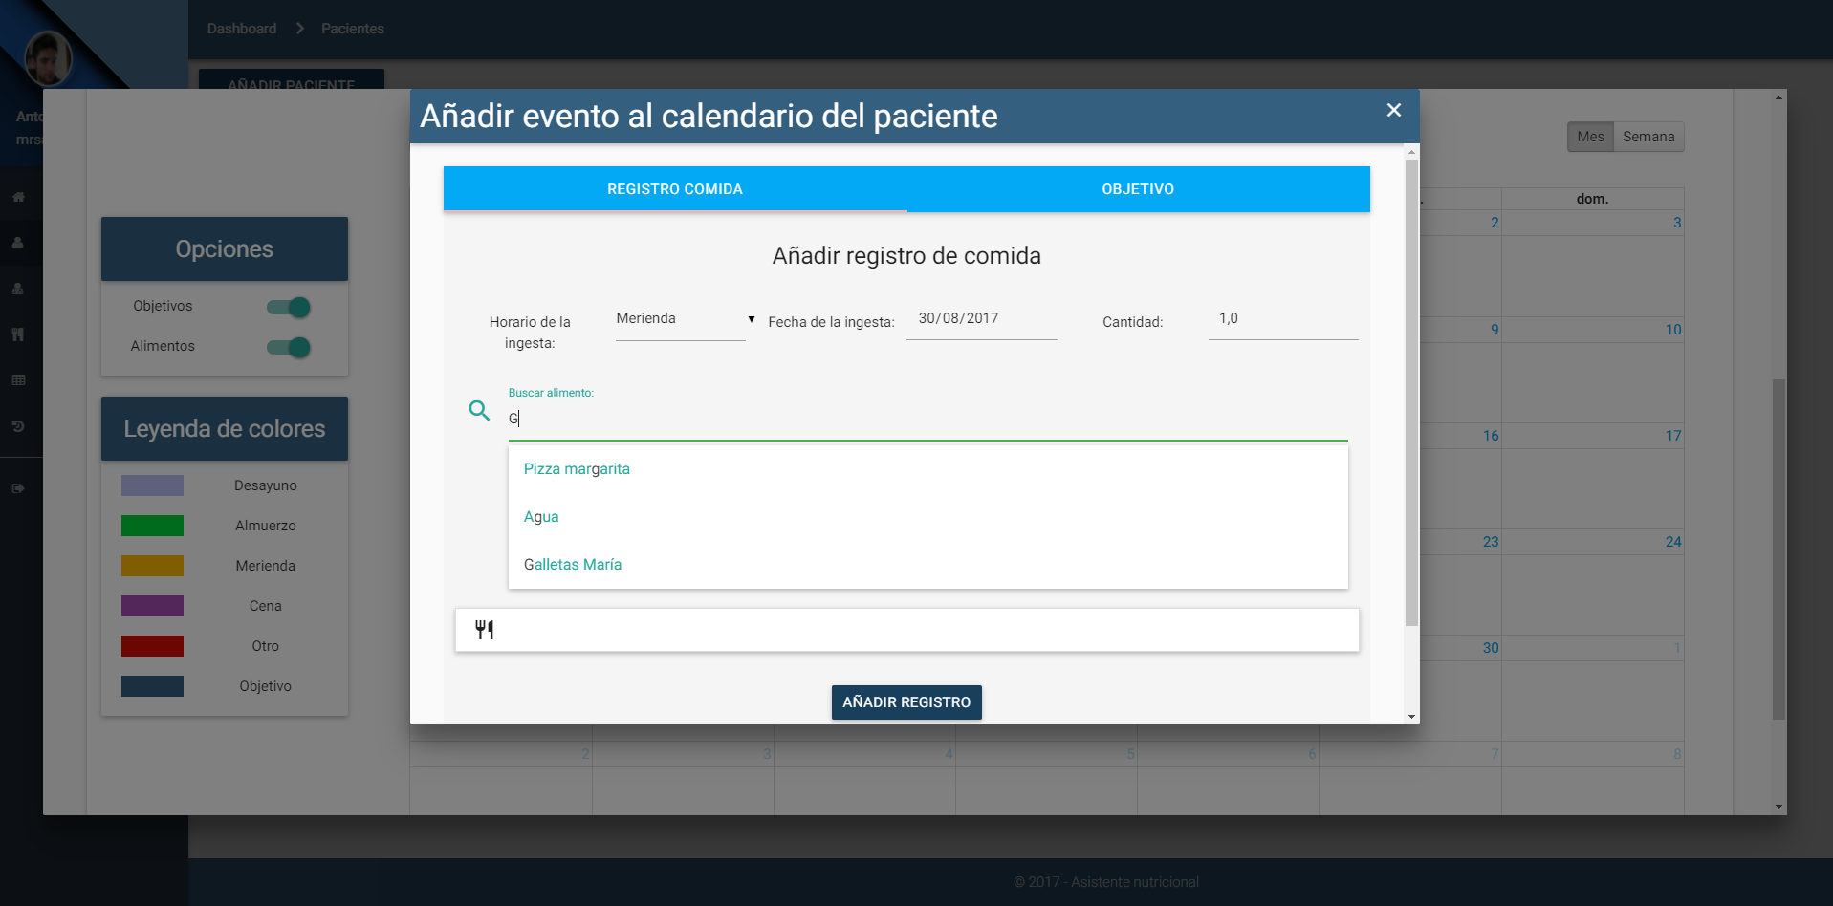

**Figure 7.** Form for the introduction of new records or goals.

* **Patient Statistics:**

Section where to generate a statistical report of the patient from the records recorded in the selected month, comparing these results with a table of RDA (daily recommended allowance) registered by that nutritionist and previously selected and where to observe a weekly summary disaggregated in timetables for the main macronutrients (Figure 8).

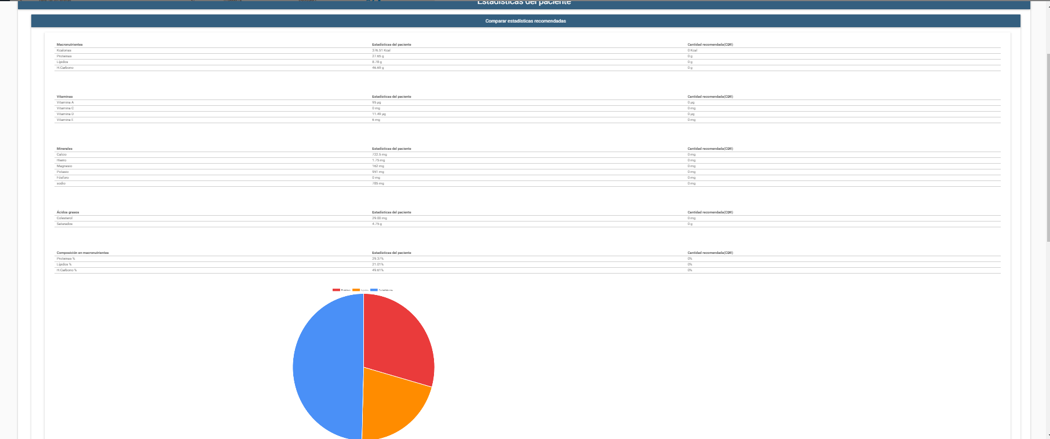

**Figure 8.** Comparative report generated through the patient records in the selected month and the chosen RDA table.

* **Nutritionists panel:**

Panel of management of nutritionists working in the system, differentiating if they have the ability to access this panel to manage other nutritionists through the field S.Admin. From this panel can be added, delete or modify the nutritionist users of the system (Figure 9).

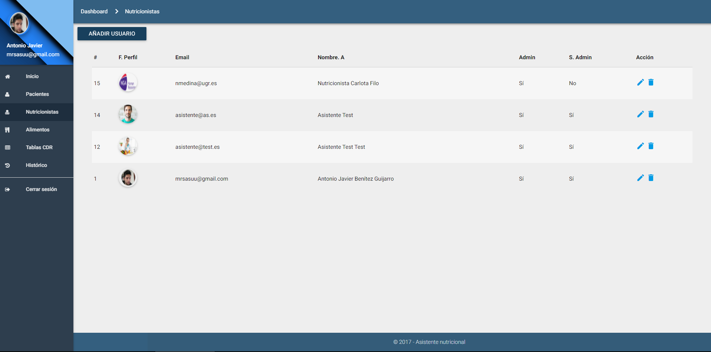

**Figure 9.** Nutritionists panel.

* **Management of food available in the system:**

Panel that allows the creation, modification and elimination of new foods in the system. Such foods will be used by the mobile application and the patient's personal calendar for the incorporation of new food records or goals. It should be noted that this section indicates the elements necessary for food registration; that is, the photographs to be used in the mobile application, their correspondence in portions, and all the nutritional information of the food. The quantity selection system developed is based on choosing quantities from photographs that visually represent the portion size, and transparently each photograph would correspond to a size. For example: If we drink skimmed cow's milk, we can take a small cup, a medium cup or a bowl of large milk, where each container corresponds to a different portion. For example, a small cup a portion of 100g, to the glass a portion of 200g and to the bowl one of 350g translating this to: cup = 1.0, cup = 2.0 and bowl = 3.5; since multiplying these portions by their correspondence would yield the equivalent of 100g, 200g and 350g. That is why one of the indispensable requirements is to correctly choose the equivalent photographs for the portions (Figure 10).

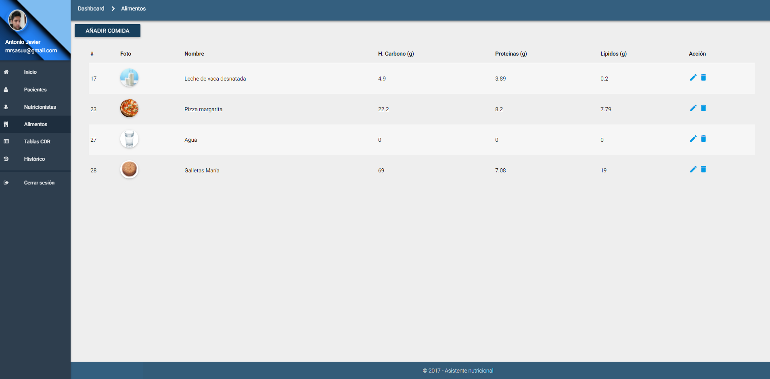

**Figure 10.** Food panel.

* **Management of daily recommended allowance (RDA) tables:**

Panel of creation, modification and elimination of tables of information to make the statistical comparisons of the people monitored and to generate the reports already described above (Figure 11).

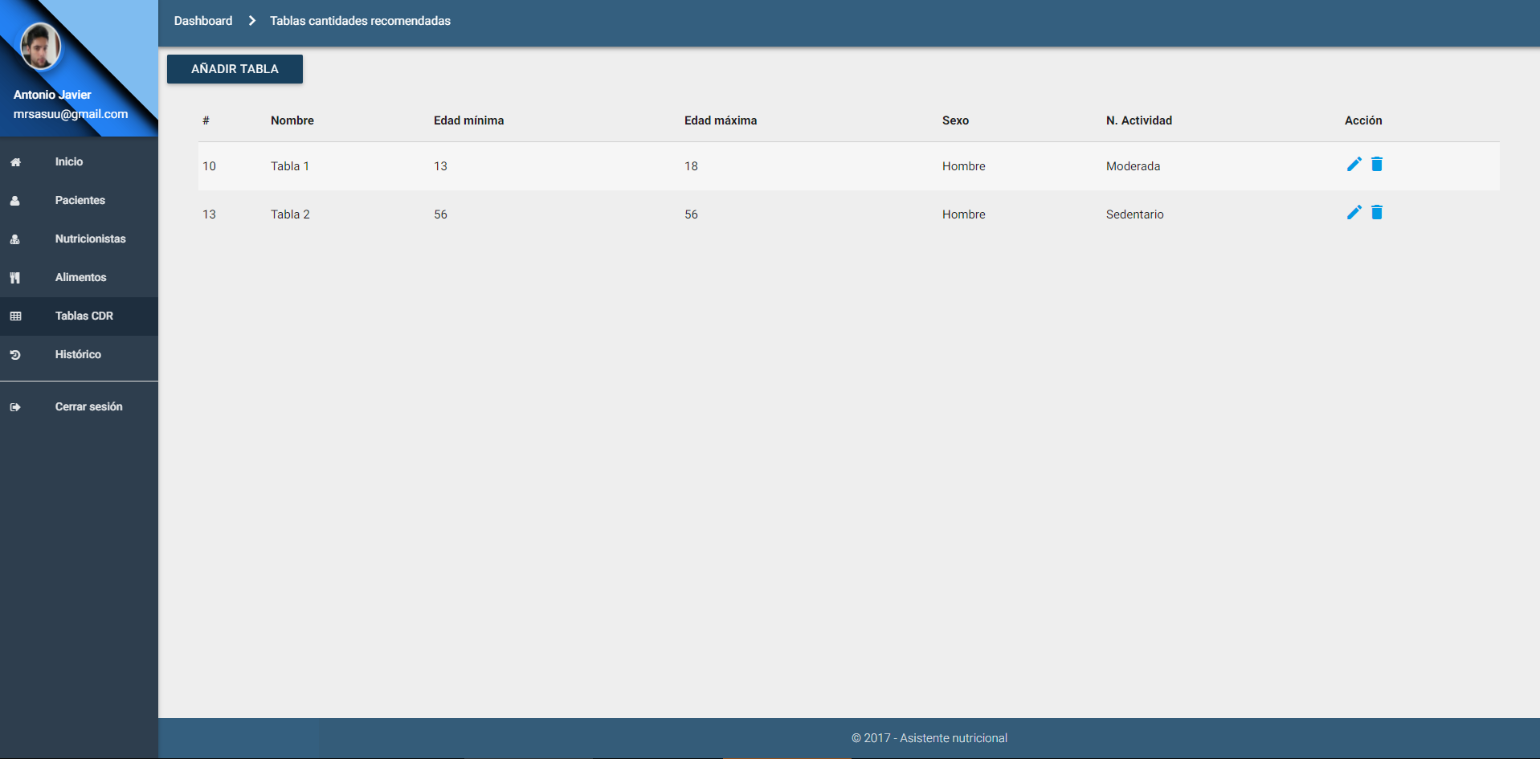

**Figure 11.** Management panel of the Recommended Daily Allowance (RDA) tables.

2.6. Mobile platform

The main tool of monitored users is an Android based mobile application, which will monitor their eating habits, noting the food intake throughout the day, introducing a new record in their mobile application, and synchronizing transparent way the data, so that almost in real time, the supervisors can keep track of the user. Through a simple interface [2], users record food ingested using a simple form where with three steps they select the schedule of intake, food and quantity taken. For this, we have implemented a quantity selection system of images that show representations of different portions for the same food, for example; annotating a specific beverage, displaying images with different sizes, making the user choose the photograph that most resembles the portion ingested. This system module has the following functionalities:

* **Secure authentication:**

Authentication protected by a generated token that only allows the connection to be opened from a point, thus making it unreachable.

* **Welcome screen and display of objectives:**

An initial screen that welcomes greeting depending on the schedule. At the same time, it shows more interesting information, such as today's pending goals, indicating that it should be taken and which portion size. This screen also shows the main buttons of the application, the simplification of actions to return to the home panel, add a new record, or view the annotated records. By pressing the + button, a simple menu will be displayed, where the type of intake record will be selected (Figure 12).

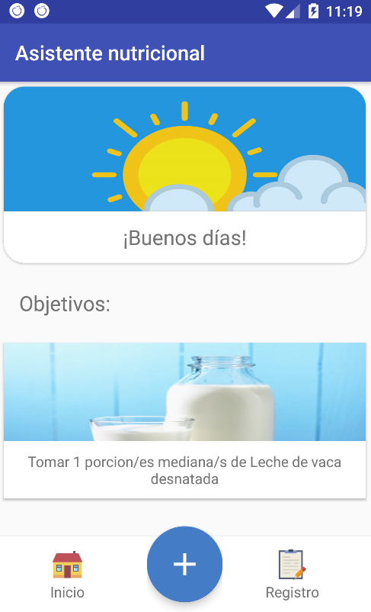 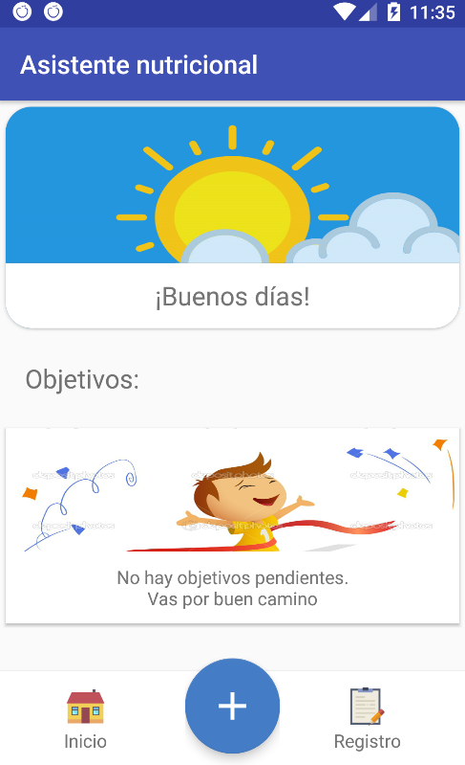

|  |  |
| --- | --- |
| (**a**) | (**b**) |
|  |  |

**Figure 12.** Welcome screen and display of outstanding goals.

* **Records system:**

Food selection screen to record obtained from the local database of the application. And quantity selection screen using the method described above (Figure 13, 14, 15 and 16).

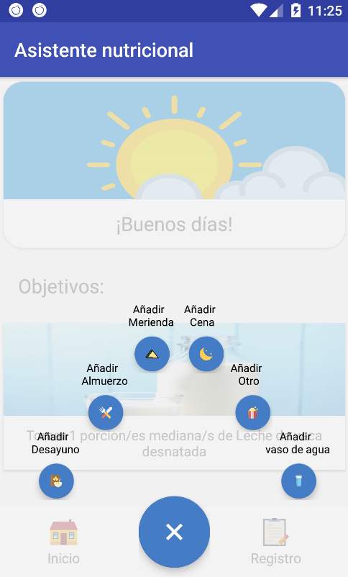

**Figure 13.** Drop down to register a meal.

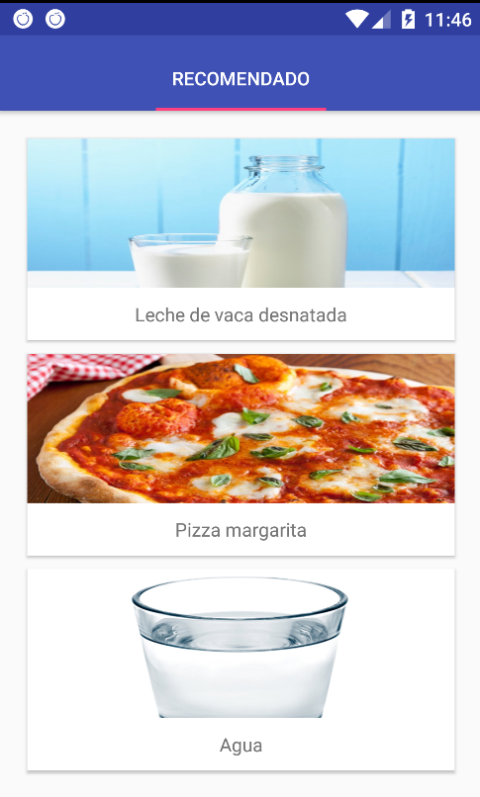

**Figure 14.** Food selection.

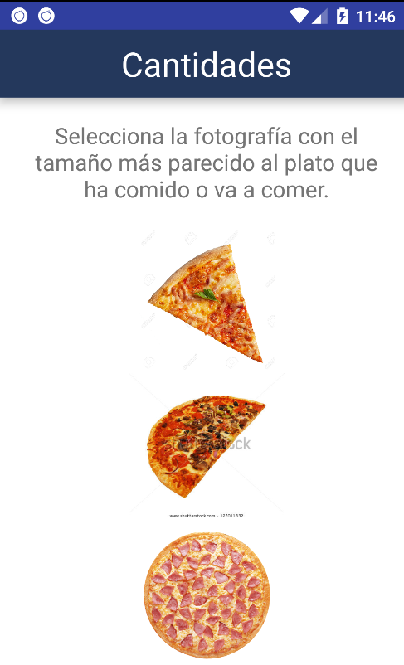

**Figure 15.** Quantity selection.

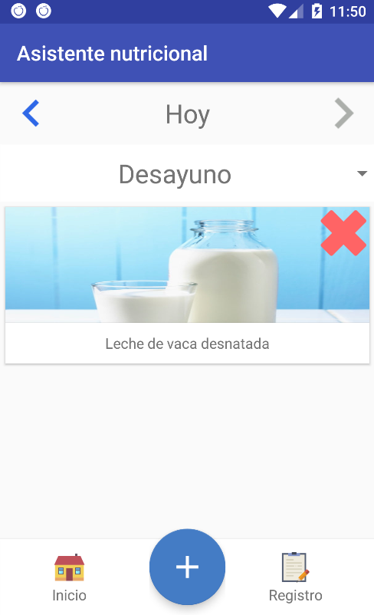

**Figure 16.** Record display panel.

* **Notification reminder system:**

Periodic notifications like in the case of the water drink reminder, or by schedule for food annotation reminders via the Android notification system (Figure 17).

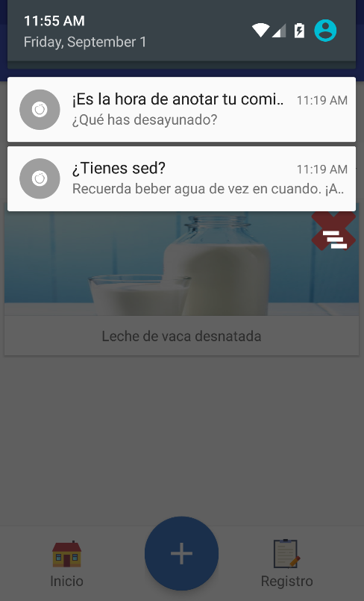

**Figure 17.** Notification reminder system.

3. Discussion

In this section we will explain the reasons for our chosen design, and some suggestions for future systems that work on the same theme as our project.

3.1.Architecture

After analyzing the domain of the problem described in the introduction, we decided to elaborate the solution taking as a main priority to create a system that synchronized all the data in an intelligent way, making the synchronizations to be realized only if they were necessary, but without introducing the system of firebase messaging from Google and basing it on a solution of its own. For this reason, we developed a design to execute the communications only when it was necessary to synchronize the databases, differentiating when the registers had to be uploaded to the server from the mobile, or when they had to be downloaded from it to the database of the telephone. Going to the part of the web application, it would only accede to the state of the database in each consultation, reason why on this side it did not have to consider anything additional.

Knowing that we would build the Android application from the beginning, we did a study of the best way to make HTTP connections on Android, and for this we compare the current methods in Android, choosing Retrofit, as it offered a higher speed to create the connections.

This cloud-centric architecture was chosen, but having local databases in the mobile application to ensure application performance at times when synchronization is not possible due to lack of connectivity, making it possible to have all the data centralized in a server capable of providing up-to-date information to both the nutritionist and patient supervised.

4. Conclusion and future work

During this project we have analyzed the general problems of the population in the nutritional field, highlighting the complication of daily recording in elderly people, proposing as a solution the project itself, providing tools for recording food records for monitored people, providing them with the necessary autonomy through the mobile platform. All this is mainly due to the difficulties in identifying and knowing the nutrients of a domain as wide as nutrition and food in general, and, on the other hand, due to the absence of ICT tools adapted to the profile of this type of users.

Likewise, the subsystems that make up the work under an open project, the web platform, mobile and the cloud server have been realized, satisfying the needs of each part and interoperating among all the platforms to achieve the following objectives:

* **Mobile platform:**
  + Development of a functional component that allows the registration, visualization and editing of the monitored user's food records.
  + Construction of a reminder system for recording food records and water intakes.
  + Elaboration of a complete system in the background that synchronizes all the useful data of the application and the server in an efficient way.
* **Web platform:**
  + Development of a system user management system (nutritionists), food, tables of quantities recommended for the realization of statistics, and users monitored with all the necessary functionalities to modify, modify, visualize and eliminate all their information.
  + Development of a specialized monitoring system for people monitored under a professional nutritionist who allows the visualization and editing of the daily nutritional information of their patients and the creation of statistics and personalized reports.
  + Creation of diets based on food objectives that the monitored user will see in the application.
  + History of the most relevant events of the system, identifying actions taken, date and responsible.
* **Cloud Server:**
  + Elaboration of the necessary functionality to interconnect all the components of the system.

For the following phases of our project, we highlight the improvement in the different modules that form the system, improving the format of certain data for the construction of databases with dynamic data structures, the updating of accessibility mechanics in the mobile platform, and the different validations of the use of each platform, in order to adapt the project to the results of the validations, bringing the final product closer to users and researchers.

References

1. WHO. (October de 2017). World Health Organization (WHO). Obtenido de WHO: http://www.who.int/mediacentre/factsheets/fs311/en/
2. Gell, N. M., Rosenberg, D. E., Demiris, G., LaCroix, A. Z., & Patel, K. V. (2013). Patterns of technology use among older adults with and without disabilities. The Gerontologist, 55(3), 412-421.Author 1, A.; Author 2, B. *Book Title*, 3rd ed.; Publisher: Publisher Location, Country, 2008; pp. 154–196, ISBN.
3. Osborne, D. R., & Voogt, P. I. (1978). The analysis of nutrients in foods. Academic Press Inc.(London) Ltd., 24/28 Oval Road, London NW1 7DX.
4. Wardle, J., Parmenter, K., & Waller, J. (2000). Nutrition knowledge and food intake. Appetite, 34(3), 269-275.

H:\documents\layout\new template June 2014\figures\CC-BY logo original v1.wmf© 2017 by the authors. Submitted for possible open access publication under the   
terms and conditions of the Creative Commons Attribution (CC BY) license (http://creativecommons.org/licenses/by/4.0/).