- INTRODUCTION

  - Background

- In the digital era, online shopping has become an essential part of modern consumer behavior, especially in industries like home decor and furniture. With increasing urbanization and evolving customer preferences, people are looking for a seamless, convenient, and personalized way to furnish their homes without the hassle of visiting physical stores. The rise of e-commerce has transformed the retail landscape, enabling customers to browse, customize, and purchase furniture and decor items from the comfort of their homes.

- However, despite the rapid growth of online furniture marketplaces, many platforms lack personalized shopping experiences, real-time customization options, and user-friendly navigation. Consumers often struggle with limited customization choices, inaccurate product previews, and inefficient order tracking, leading to a gap between expectation and reality. Moreover, security concerns in online transactions and inadequate administrative tools further hinder the effectiveness of digital furniture platforms.

- Recognizing these challenges, Decor Heaven is designed as an advanced e-commerce platform that bridges the gap between digital convenience and personalized shopping experiences. It offers a diverse range of furniture and home decor items, allowing users to tailor their selections based on size, color, and material. The platform integrates secure payment gateways, real-time inventory management, and customer engagement tools to enhance the overall shopping journey.

- With a focus on user-centric design and future scalability, Decor Heaven aims to revolutionize the way people shop for furniture by providing an intuitive, reliable, and interactive digital platform. It empowers customers to make informed purchasing decisions while streamlining administrative processes for business owners. By leveraging modern technologies such as React for the frontend, Spring Boot for the backend, and PostgreSQL for efficient data management, Decor Heaven ensures a seamless and secure online shopping experience.

  - Problem Statement

- Limited Customization and Personalization: In Many existing online furniture platforms offer a standard selection of products without the flexibility to customize aspects such as size, color, and material. This limitation forces customers to either compromise on their ideal choice or look for alternatives elsewhere, leading to frustration and lost sales opportunities.

- Inefficient Shopping and Navigation Experience: Many online furniture stores have cluttered interfaces and complicated navigation structures that make it difficult for users to browse products efficiently. Without a well-designed filtering system and a user-friendly layout, customers struggle to find relevant items, compare different products, and complete their purchases smoothly. This often results in abandoned carts and low customer engagement rates.

- Security and Payment Trust Issues: One of the primary concerns of online shoppers is data security, particularly when making transactions involving significant amounts of money, as is the case with furniture purchases. Many platforms fail to implement robust security measures, such as encryption, multi-factor authentication, or trusted payment gateways, which makes customers hesitant to enter their personal and financial details. The absence of secure payment options can lead to increased cart abandonment rates and reduced customer trust in the platform.

- Ineffective Order Tracking and Management: Customers expect a seamless post-purchase experience, including clear order tracking, easy returns, and reliable customer support. Many e-commerce platforms fail to provide a transparent system for monitoring order statuses, updating delivery details, or handling cancellations and refunds efficiently. This results in customer dissatisfaction, increased complaints, and negative brand perception.

- Limited Administrative and Inventory Management Tools: For business owners and administrators, maintaining an online furniture store requires effective tools for managing inventory, updating product details, and analyzing sales performance. Without a structured backend system, businesses face difficulties in keeping track of stock levels, processing customer orders, and generating insightful reports for data-driven decision-making. The lack of automated administrative tools leads to inefficiencies, errors, and delays in order fulfillment.

  - Objectives

The main objectives of the project are as follows:

- Personalized Shopping Experience: One of the key objectives is to offer a personalized shopping experience where customers can customize furniture items by selecting size, color, and material to match their interior design preferences. The platform will provide real-time product previews, ensuring users can visualize their choices before making a purchase. Additionally, AI-driven recommendations will be incorporated to suggest products based on customer preferences and browsing history, making the shopping experience more intuitive and engaging.

- Seamless and Intuitive User Interface: To ensure a seamless and intuitive user interface, Decor Heaven will be built with a clean, organized, and responsive design that functions smoothly across all devices, including desktops, tablets, and mobile phones. The platform will feature advanced filtering and search options, allowing customers to find their desired products quickly. The checkout process will be optimized for efficiency, reducing cart abandonment rates and improving overall user satisfaction.

- Secure and Reliable Transactions: Security is a top priority for Decor Heaven, and the platform will integrate secure and reliable transactions using Stripe for payment processing, supporting credit/debit cards and cash-on-delivery options. To protect user data, multi-factor authentication (MFA) and SSL encryption will be implemented, ensuring secure transactions and compliance with industry-standard data protection regulations such as GDPR and PCI DSS.

- Efficient Order and Inventory Management: The platform will also focus on efficient order and inventory management, providing customers with a user-friendly dashboard to track their active, completed, and canceled orders. Real-time inventory management tools will enable administrators to update product availability dynamically, ensuring accurate stock levels. Automated order confirmations, invoice generation, and shipping updates will be sent via email or SMS, keeping users informed throughout their purchasing journey.

- Enhanced Customer Engagement and Support: To enhance customer engagement and support, Decor Heaven will offer live chat support and an FAQ section to assist customers in real-time. A customer review and feedback system will be implemented to gather insights for continuous improvement, while a loyalty program or personalized discounts will help in customer retention and brand loyalty.

- Data Security: The Decor Heaven website will place a strong emphasis on data security, implementing robust measures to protect user information throughout their interactions with the site. Secure forms will be used for capturing sensitive information, such as during the booking process for test drives and vehicle configurations. All data transmitted through the website will be encrypted using SSL (Secure Socket Layer) technology, ensuring that personal information remains confidential and protected from potential cyber threats. Furthermore, compliance with data protection regulations such as GDPR will be prioritized, providing users with assurances about how their data is used and stored. By prioritizing data security, Decor Heaven reinforces its commitment to safeguarding customer trust and privacy, crucial elements in maintaining a positive brand reputation.

- Scalability and Future Growth: Looking towards the future, Decor Heaven is designed for scalability and future growth. The platform will support multi-language and multi-currency options, allowing for global expansion. A mobile-friendly experience will be prioritized, with future plans for developing native mobile apps for Android and iOS. Additionally, the integration of Augmented Reality (AR) will enable customers to visualize furniture in their homes before making a purchase, enhancing decision-making and reducing return rates. AI-driven analytics will be used to generate personalized marketing insights, helping businesses optimize sales strategies and customer engagement.

  - Scope:

  - User Features and Accessibility: The platform will offer a diverse catalog of furniture and home decor items, allowing users to explore different categories, compare options, and make informed decisions. Customers can easily navigate through the website using advanced filters for price, size, color, and material. The website will also include a personalized shopping experience, where users can configure furniture according to their preferences before making a purchase. To enhance accessibility, Decor Heaven will be fully responsive and mobile-friendly, ensuring smooth functionality across desktops, tablets, and smartphones. Customers will have access to their order history, enabling them to track active, completed, and canceled orders in real-time. Additionally, the website will feature multi-language support, allowing users from different regions to shop comfortably in their preferred language.

  - Secure Transactions and Payment Flexibility: A major aspect of Decor Heaven is ensuring a safe, transparent, and trustworthy transaction process for users. Since furniture purchases often involve significant financial transactions, it is essential to provide customers with a secure payment environment that protects their personal and financial data. To achieve this, Decor Heaven integrates advanced payment gateways, encryption protocols, and authentication mechanisms, ensuring that every transaction is safeguarded against fraud and unauthorized access. To protect sensitive user information, Decor Heaven employs SSL (Secure Socket Layer) encryption across all transactions. SSL encryption ensures that data transmitted between the user’s device and the website remains encrypted and unreadable to third parties. This prevents hackers or malicious entities from intercepting payment details, login credentials, or any other confidential information.

3. Administrative Tools and Inventory Management: For administrators and business owners, the platform will include a robust backend system to efficiently manage products, monitor inventory, and generate detailed sales reports. The inventory management system will provide real-time updates on stock levels, preventing overselling and ensuring product availability. Admins will also have access to an order management dashboard, allowing them to process customer orders, handle cancellations, and update order statuses dynamically. The reporting system will generate data-driven insights, helping business owners analyze sales trends, customer preferences, and product performance. This will enable better decision-making and targeted marketing strategies.

4. Scalability and Future Growth: The Decor Heaven website is designed to be highly scalable, allowing for future expansion. The platform will support multi-currency transactions to accommodate global customers. As part of future growth, Decor Heaven plans to introduce a dedicated mobile application for Android and iOS, ensuring a seamless shopping experience across all devices. To enhance the shopping experience, the website will integrate Augmented Reality (AR) features, allowing customers to visualize furniture in their spaces before making a purchase. Additionally, AI-powered analytics will be implemented to provide personalized product recommendations based on user behavior and preferences.

5. Customer Engagement and Community Building: The platform will focus on customer engagement by incorporating features such as live chat support, FAQs, and a review system where users can share feedback and rate products. A loyalty program will be introduced to encourage repeat purchases and customer retention. The website will also feature a blog section with interior design tips, helping users make informed decisions about their home decor choices. Additionally, Decor Heaven will foster a sense of community by creating an interactive forum or discussion platform where users can share ideas, showcase their home decor setups, and engage with other customers.

1.5 Purpose

  - Enhancing Customer Experience: Decor Heaven aims to provide a personalized and convenient shopping experience where customers can explore a wide variety of furniture and decor items. The platform allows users to customize furniture by selecting size, color, and materials, ensuring they find products that suit their unique tastes and home interiors. With an intuitive user interface and smart search filters, Decor Heaven makes it easy for customers to navigate through different product categories, compare options, and make informed purchasing decisions.

  - Seamless and Secure Transactions: One of the key purposes of Decor Heaven is to establish a safe and reliable online marketplace for home decor. By integrating trusted payment gateways like Stripe, the platform ensures secure transactions through multiple payment methods, including credit/debit cards, UPI, and cash-on-delivery (COD). Additionally, Decor Heaven employs SSL encryption, multi-factor authentication (MFA), and compliance with GDPR and PCI DSS regulations to protect user data and enhance transaction security.

  - Efficient Order and Inventory Management: To simplify the order management process, Decor Heaven provides users with a dedicated dashboard where they can track active, completed, and canceled orders. Customers receive real-time updates on their purchases, improving transparency and engagement. For administrators, the website includes inventory management tools that help in updating product availability, tracking stock levels, and generating sales reports, ensuring smooth business operations.

  - Empowering Business Owners and Sellers: Beyond benefiting customers, Decor Heaven is designed to support business owners, manufacturers, and vendors by providing a structured platform to manage and sell their products efficiently. The administrative panel allows sellers to list new products, update existing inventory, analyze customer preferences, and monitor sales trends. By offering these business tools, Decor Heaven helps vendors scale their operations and improve overall efficiency.

  - Encouraging Customer Engagement and Community Building: A key goal of Decor Heaven is to foster customer engagement by offering live chat support, product reviews, and interactive design inspiration. Users can access design tips, recommendations, and home decor trends, making Decor Heaven more than just a shopping platform—it becomes a hub for interior design inspiration and community interaction.

- LITERATURE REVIEW

  - Discussion of related work:
● Decor Heaven E-Commerce Website:

The furniture and home decor industry has undergone a significant transformation with the rise of e-commerce platforms. Traditional brick-and-mortar stores, which once dominated the industry, have faced increasing competition from online furniture retailers offering greater convenience, accessibility, and customization options. The integration of technology-driven solutions in e-commerce platforms has allowed customers to explore, personalize, and purchase furniture items without the need to visit physical showrooms.

● Evolution of Furniture E-Commerce Platforms:

Early e-commerce platforms for furniture shopping were limited in functionality, offering static product catalogs with fixed specifications and minimal customer interaction. These platforms lacked real-time customization, interactive visualization, and efficient order tracking, making it challenging for customers to make informed purchasing decisions. However, with advancements in web technologies, AI-driven recommendations, and augmented reality (AR), modern furniture e-commerce websites have revolutionized the way customers shop for home decor.

Leading global furniture brands such as IKEA, Wayfair, and Pepperfry have set benchmarks for digital transformation in the industry by implementing AI-powered recommendation systems, 3D product visualization, and smart inventory management. These platforms focus on enhancing user engagement through personalized shopping experiences, seamless checkout processes, and efficient delivery services. Despite these advancements, many platforms still struggle with high cart abandonment rates, security concerns, and lack of interactive customization tools, indicating a need for further innovation in the sector.

● Summary:

In summary, this project underscores the importance of creating a seamless digital experience for Decor Heaven customers, leveraging modern web technologies to meet the growing expectations of today’s digital-savvy users. The evolution of e-commerce has significantly transformed the furniture and home decor industry, making online shopping more accessible and convenient. While major platforms such as IKEA, Wayfair, and Pepperfry have successfully introduced digital solutions, many online furniture stores still face challenges such as limited customization, security concerns, inefficient order tracking, and poor mobile optimization. Customers often struggle with restricted personalization options, complex navigation, and a lack of interactive features like Augmented Reality (AR) for product visualization.

To address these gaps, Decor Heaven is designed as a next-generation furniture e-commerce platform, incorporating real-time product customization, AI-powered recommendations, secure payment gateways, and a seamless order management system. The platform focuses on providing a highly interactive and personalized shopping experience, ensuring users can tailor furniture selections to their preferences. Additionally, Decor Heaven enhances transaction security with SSL encryption, multi-factor authentication (MFA), and compliance with global data protection standards.

By integrating AR visualization, mobile optimization, and AI-driven analytics, Decor Heaven aims to bridge the gap between traditional and digital furniture shopping, making it a more efficient, secure, and user-friendly experience. This approach ensures that customers receive a superior online shopping journey, while business owners benefit from advanced inventory and sales management tools. The platform’s commitment to innovation and scalability positions it as a leading contender in the evolving furniture e-commerce industry.

3. PROPOSED METHOD

3.1 Description of the research methods and techniques used
- Setting up the Development Environment: The first step in building Decor Heaven is setting up a robust development environment with all the necessary tools for web development. The primary code editor used is Visual Studio Code (VS Code), which offers extensive support for extensions that enhance productivity, syntax highlighting, and debugging. For frontend development, React.js is used to build a dynamic and interactive user interface, ensuring a seamless shopping experience. Tailwind CSS is incorporated for styling, providing a responsive and visually appealing layout across different devices. On the backend, Spring Boot is implemented to handle server-side logic, API communication, and data management. The PostgreSQL database is used to store structured data securely, including user profiles, product listings, and order details. Additional tools such as Postman are set up for API testing, while ES Lint and Prettier are integrated to maintain clean and consistent code formatting. These tools streamline the entire development process, from writing code to testing and deploying the website.
- Designing the User Interface: The UI/UX design of Decor Heaven is crafted to reflect the platform's modern, elegant, and intuitive aesthetic. A primary focus is on creating a visually engaging and easy-to-navigate interface, ensuring users can browse, customize, and purchase furniture effortlessly.
  - Responsive Design: Using Tailwind CSS, the website is optimized for various screen sizes, ensuring seamless usability on desktops, tablets, and mobile devices.
  - Intuitive Navigation: The UI features well-structured product categories, search filters, and interactive elements to help users find their desired furniture items efficiently.
  - Call-to-Action (CTA) Optimization: Prominent "Buy Now", "Customize", and "Add to Cart" buttons enhance user engagement and drive conversions.
  - Smooth Transitions and Interactive Elements: Animations and real-time product customization previews improve the user experience, making shopping more immersive.
- Managing User Authentication: Security is a top priority for Decor Heaven, ensuring that user data and transactions are protected against unauthorized access. The authentication system includes:
  - JWT (JSON Web Token) Authentication: Used to create secure user sessions, ensuring that only authorized users can access sensitive data.
  - Google Sign-In and OTP Verification: Multi-factor authentication (MFA) is implemented using Google Sign-In and OTP-based email/SMS verification for additional security.
  - Role-Based Access Control (RBAC): Differentiated access levels for customers, administrators, and vendors, ensuring that users only interact with relevant system functionalities.
  - These security measures enhance user trust and protect personal information from data breaches and cyber threats.
- Testing and Debugging: To ensure error-free performance, Decor Heaven undergoes extensive testing across different devices and browsers. Testing methods include:
  - Cross-Browser Testing: The website is tested on Chrome, Firefox, Safari, and Edge to ensure compatibility across multiple platforms.
  - Performance Testing: Load testing is conducted to optimize page speed, database queries, and API response times, ensuring smooth operation even under high traffic.
  - Automated Unit and Integration Testing:
    - Jest and Mocha/Chai are used to test React components and backend logic.

    - Super-test and Postman validate API functionality, ensuring seamless communication between the frontend and backend.
    - Security Testing: Penetration tests are performed to identify potential vulnerabilities in authentication and payment systems.
    - Through continuous testing, Decor Heaven ensures stability, security, and optimal performance for a seamless shopping experience.
- Deploying the Website: Once the website is fully developed and tested, it is deployed on cloud platforms to ensure scalability and reliability.
- Hosting on AWS or Azure: The platform is deployed on AWS (Amazon Web Services) or Microsoft Azure, allowing for high availability, load balancing, and auto-scaling to handle peak traffic periods.
- Continuous Integration and Continuous Deployment (CI/CD):

  - GitHub Actions or Jenkins automates the deployment process, ensuring new updates, bug fixes, and optimizations are seamlessly integrated without website downtime.
  - Content Delivery Network (CDN) Optimization: To improve loading speed, a CDN (such as Cloudflare) is used to cache static resources, reducing latency for global users.
  - By deploying on a scalable cloud infrastructure, Decor Heaven guarantees fast performance, minimal downtime, and a superior user experience across different locations.

Flow Chart :
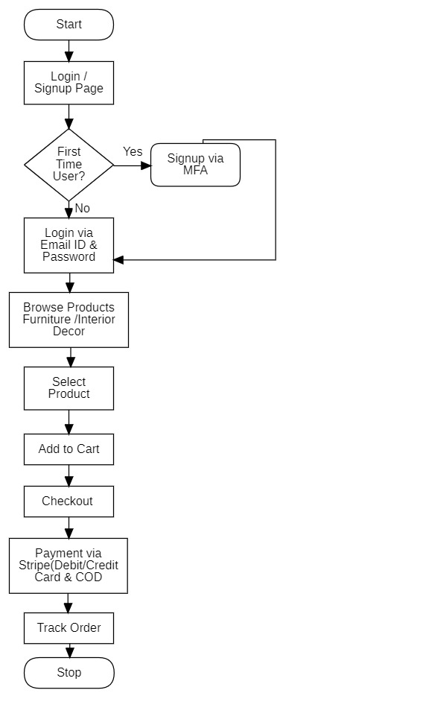
fig 3.1.1(simple activity diagram for Decor Heaven Website )
The above activity diagram illustrates the process of booking a product on the Décor Heaven website. Below is a detailed explanation of each component:

- Decor Heaven Website:
  - This represents the starting point, where users interact with the Decor Heaven website to access the booking functionality.
- Start:
  - This marks the beginning of the user's journey on the Decor Heaven website.
- Login / Signup Page:
  - Users are directed to the login/signup page, where they need to either log in or create a new account.
- First-Time User? (Decision Point):
  - This step determines if the user is new to the platform.
  - If Yes, they go through a multi-factor authentication (MFA) signup process.
  - If No, they proceed with logging in using their Email ID & Password.cancellation.
- Browse Products (Furniture / Interior Decor):
  - After logging in, users can explore the available furniture and interior décor products.
- Select Product:
  - The user selects a product they wish to purchase from the displayed options.
- Add to Cart:
  - Once a product is selected, it is added to the shopping cart.
- Checkout:
  - The user proceeds to the checkout process, confirming the selected items.
- Add Payment via Stripe (Debit/Credit Card & COD):
  - Users choose their preferred payment method, which can be:
    - Stripe
    - Debit Card
    - Credit Card
    - Cash on Delivery (COD)

- Track Order:
  - After successful payment, users can track their order status through the website.
- Stop:
  - This marks the end of the transaction process.
Summary:
This diagram outlines the end-to-end flow of a user purchasing a product from the Decor Heaven website. The process includes user authentication, product browsing, selection, checkout, payment, and order tracking. It ensures secure transactions with MFA-based signup for new users and multiple payment options for a seamless shopping experience.

DFD Level 0:
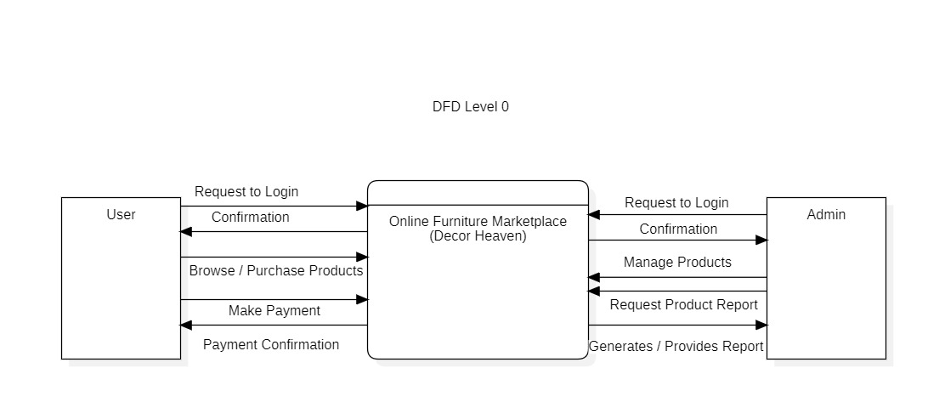fig 3.1.2(DFD Level 0 diagram for Decor Heaven Website )

This DFD Level 0 provides an overview of the Decor Heaven system, where users can browse, purchase products, and make payments, while admins manage products and generate reports.
Entities and Data Flow Explanation
- User (Customer):
- Request to Login: The user sends a request to log in to the system.
- Confirmation: The system verifies and confirms the login.
- Browse / Purchase Products: Users can explore and select furniture or interior decor products.
- Make Payment: Once a product is selected, users proceed with the payment process.
- Payment Confirmation: The system confirms the payment status.

- Online Furniture Marketplace (Decor Heaven) [Main System]:
- Acts as the central processing unit, managing user interactions and transactions.
- Handles login requests, product browsing, payments, and admin activities.
- Facilitates data flow between users and admins.
- Admin:
- Request to Login: The admin logs into the system for management purposes.
- Confirmation: The system verifies and confirms the admin's login.
- Manage Products: The admin can add, update, or remove products in the system.
- Request Product Report: The admin can generate reports on product sales, inventory, or customer activity.
- Generates / Provides Report: The system processes and provides the requested report.
Summary:
This DFD Level 0 provides a high-level view of how data moves within the Decor Heaven online furniture marketplace. It shows how users interact with the platform to purchase products, while administrators manage inventory and track sales reports. Further DFD Level 1 and DFD Level 2 diagrams could break down these processes into more detailed steps.

DFD Level 1:

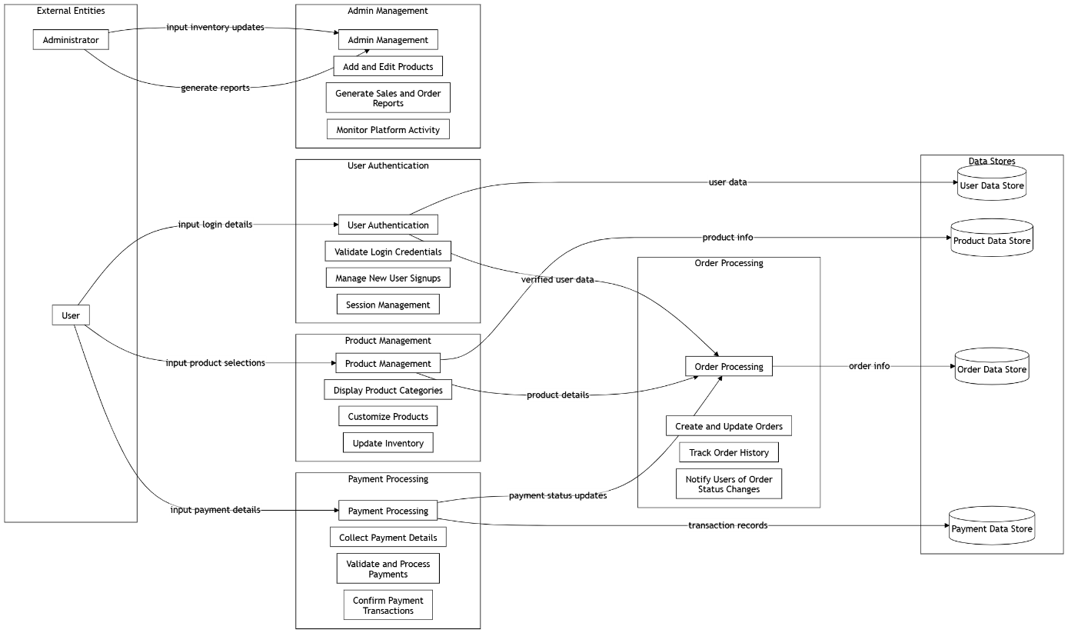

fig 3.1.3(DFD Level 1 for Decor Heaven Website )

The DFD Level 1 expands on DFD Level 0 by breaking down the major processes involved in the Decor Heaven online furniture marketplace. It details how users and administrators interact with various subsystems, how data flows through different components, and how data is stored.
Key Components of DFD Level 1
External Entities:
- User (Customer)
- Administrator
These entities interact with the system by providing inputs (login details, product selections, payments, inventory updates) and receiving outputs (order confirmations, reports, payment status updates).
Main Processes

- User Authentication
- Handles login credentials, new user sign-ups, and session management.
- Ensures only verified users access the system.
- Inputs: User login details
- Outputs: Verified user data
- Product Management
- Displays product categories for users.
- Allows customization of products.
- Updates inventory when new products are added or removed.
- Inputs: Product selections
- Outputs: Product details
- Payment Processing
- Collects payment details from users.
- Validates and processes payments.
- Confirms payment transactions.
- Inputs: Payment details
- Outputs: Payment status updates, transaction records
- Order Processing
- Creates and updates orders based on user purchases.
- Tracks order history.
- Notifies users about order status changes.
- Inputs: Verified user data, product info, payment status updates
- Outputs: Order info, transaction records
- Admin Management
- Allows administrators to add/edit products.
- Generates sales and order reports.
- Monitors platform activity.
- Inputs: Inventory updates, report generation requests
- Outputs: Updated inventory, reports
Data Stores
The system maintains multiple data stores to manage different types of information:
- User Data Store - Stores user authentication details.
- Product Data Store - Stores product details and inventory updates.
- Order Data Store - Stores order information and history.
- Payment Data Store - Stores payment transactions.

Summary:
This DFD Level 1 provides a detailed breakdown of how users and administrators interact with the system. It defines the sub-processes that handle authentication, product management, payment processing, order processing, and admin management. Additionally, it shows how data is stored and managed across different data stores to ensure smooth operations in the Decor Heaven marketplace.

Use Case Diagram:
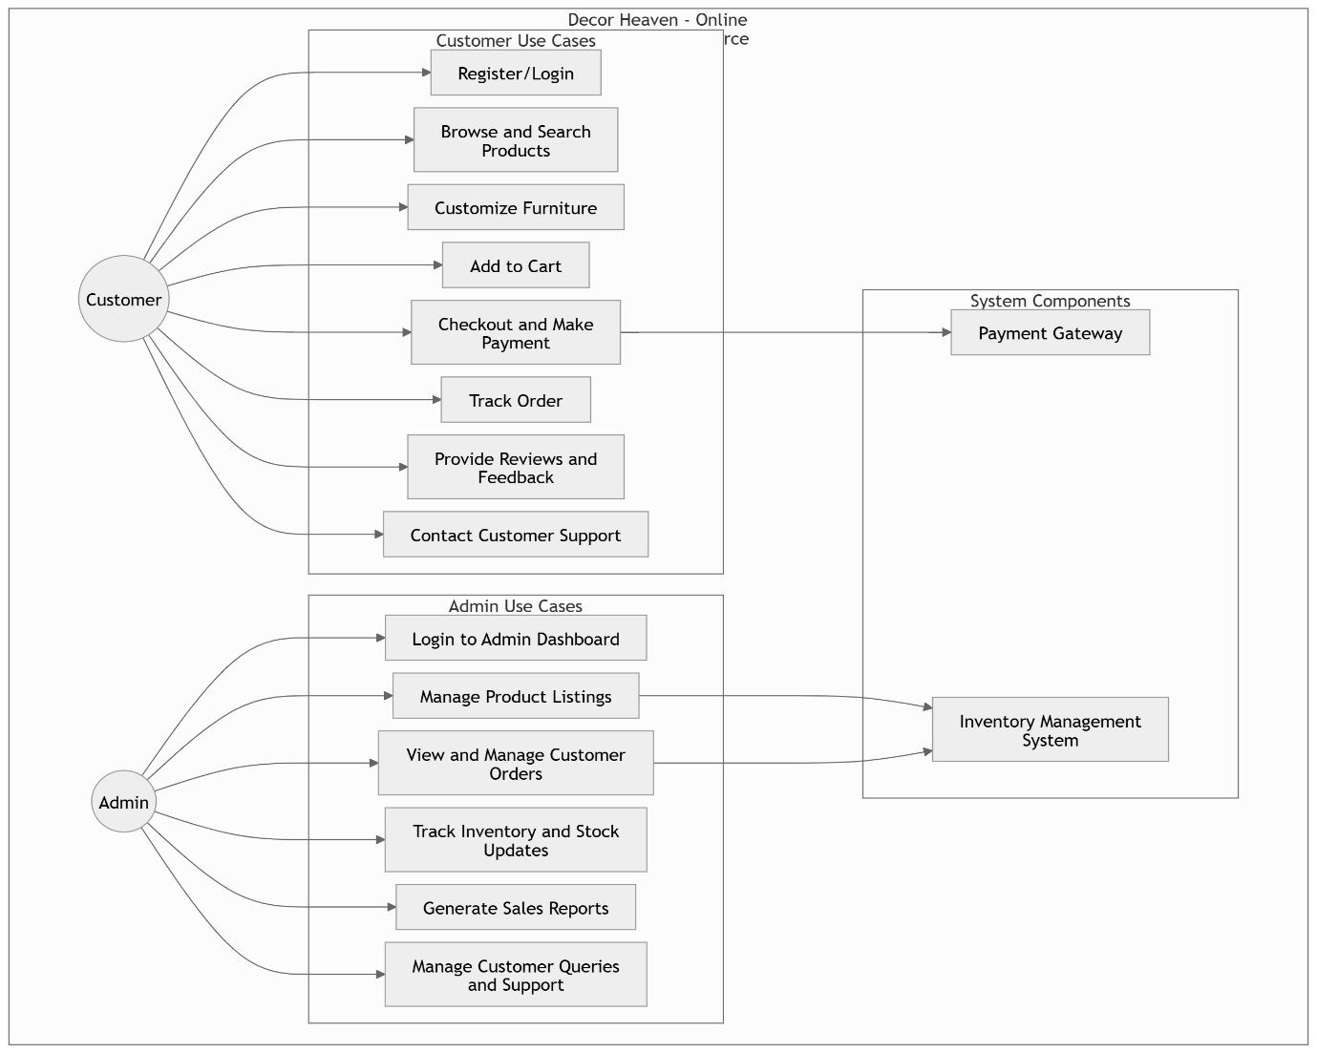
fig 3.1.4(Use case Diagram for Decor Heaven Website)
Class Diagram:
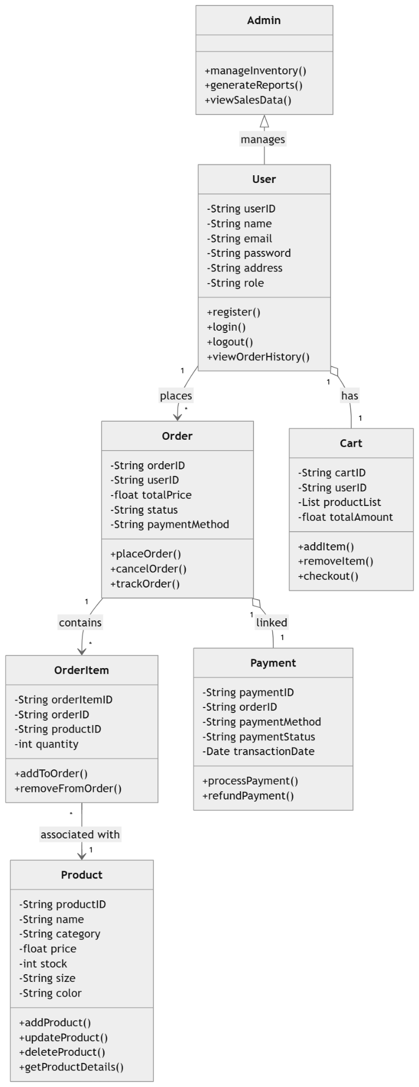

fig 3.1.5(Class Diagram for Decor Heaven Website)
Entity Relationship Diagram:

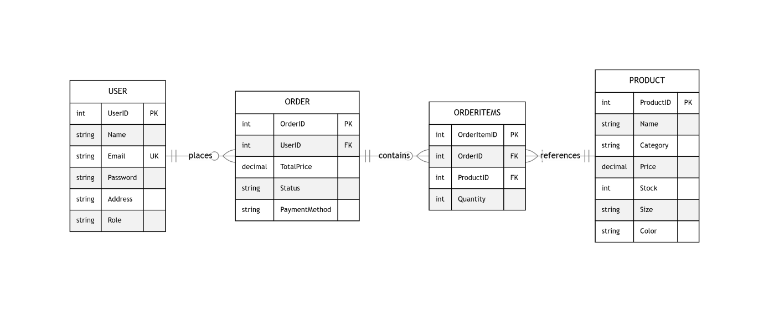

fig 3.1.6(Entity Relationship Diagram for Decor Heaven Website)

Descriptions of Entities:
Entities with Attributes and Datatypes
- User

  - UserID (Primary Key): SERIAL
  - Name: VARCHAR(100)
  - Email: VARCHAR(150) (Unique constraint)
  - Password: VARCHAR(255)
  - Address: TEXT
  - Role: VARCHAR(50) (e.g., "Admin" or "Customer")
- Product
  - ProductID (Primary Key): SERIAL
  - Name: VARCHAR(150)
  - Category: VARCHAR(100)
  - Price: DECIMAL(10, 2) (Two decimal places for monetary values)
  - Stock: INTEGER
  - Size: VARCHAR(50)
  - Color: VARCHAR(50)
- Order
  - OrderID (Primary Key): SERIAL
  - UserID (Foreign Key): INTEGER (References User.UserID)
  - TotalPrice: DECIMAL(10, 2)
  - Status: VARCHAR(50) (e.g., "Active", "Completed", "Cancelled")
  - PaymentMethod: VARCHAR(50) (e.g., "Stripe", "Cash on Delivery")
- OrderItems
  - OrderItemID (Primary Key): SERIAL
  - OrderID (Foreign Key): INTEGER (References Order.OrderID)
  - ProductID (Foreign Key): INTEGER (References Product.ProductID)
  - Quantity: INTEGER

Relationships with Cardinality
- User → Order:
  - Relationship: 1:N (One User places many Orders)
  - Foreign Key: UserID in Order table references UserID in User.
- Order → OrderItems:
  - Relationship: 1:N (One Order contains many OrderItems)
  - Foreign Key: OrderID in OrderItems table references OrderID in Order.
- OrderItems → Product:
  - Relationship: N:1 (Many OrderItems reference one Product)
  - Foreign Key: ProductID in OrderItems table references ProductID in Product.

4. RESULTS AND DISCUSSION

4.1 Presentation and analysis of the results obtained:
- Enhanced User Experience: The Decor Heaven website has been designed to provide a seamless and engaging shopping experience for customers looking to explore and purchase furniture. The intuitive interface allows users to effortlessly browse different categories, customize furniture options, and make purchases with ease. Features like real-time product visualization, interactive 3D views, and AI-based recommendations enhance the user journey, ensuring that customers find exactly what they need. By integrating an easy-to-navigate layout and a personalized shopping experience, Decor Heaven reinforces its brand as a modern, customer-focused platform.
- Cost-Effective Solution: The online platform significantly reduces costs for both customers and the business. Traditionally, customers would need to visit physical furniture stores, which could be time-consuming and inconvenient. With Decor Heaven's online store, customers can now explore a wide range of products, compare prices, and make informed purchasing decisions without leaving their homes. This convenience not only saves time but also reduces transportation and showroom maintenance costs. Additionally, automated order processing and customer support features lower operational expenses by minimizing the need for extensive human involvement, allowing the business to scale efficiently while maintaining high customer satisfaction.
- Mobile Responsiveness: While the website is optimized for desktops, mobile responsiveness is an ongoing improvement area. Given that a significant portion of online shoppers browse through smartphones and tablets, ensuring a fully responsive design is a top priority. The goal is to provide a consistent and high-quality shopping experience across all devices, allowing users to seamlessly add items to their cart, customize furniture pieces, and complete purchases on mobile without any performance issues. Efforts are underway to enhance mobile compatibility, ensuring that features like real-time customization, augmented reality (AR) furniture previews, and order tracking function smoothly on all devices.
- Secure Data Handling: Since Decor Heaven deals with sensitive customer information—including payment details, personal addresses, and purchase history—data security is a top priority. The website is equipped with strong encryption protocols, ensuring that all transactions are protected from unauthorized access. Secure payment gateways (such as Stripe, PayPal, and UPI options) enhance trust, providing customers with multiple secure payment options. Additionally, compliance with GDPR and other privacy regulations ensures that user data is handled responsibly, reinforcing Decor Heaven’s commitment to customer privacy and security.
- Scalability and Flexibility: As Decor Heaven expands its offerings, the website’s infrastructure is designed for scalability to handle increased traffic, especially during peak shopping seasons such as festive sales, discount events, and new product launches. The cloud-based architecture enables the platform to scale dynamically, ensuring smooth performance regardless of demand. Furthermore, the website’s modular design allows for future feature enhancements, such as:
  - Augmented Reality (AR) Furniture Preview, allowing customers to visualize furniture in their homes before purchasing.
  - AI-driven Interior Design Suggestions, providing users with curated recommendations based on their style preferences.
  - Subscription-based Membership Plans, offering exclusive discounts, design consultations, and priority shipping.
  - By incorporating these scalable and flexible solutions, Decor Heaven ensures long-term adaptability and competitiveness in the online furniture market.
- Community Engagement: To build a strong customer base, the website includes community engagement tools, such as:
  - User-generated content and reviews, allowing customers to share their experiences and showcase how they’ve styled their homes using Decor Heaven products.
  - Interior Design Forums, where users can discuss home decor trends, seek professional advice, and exchange design ideas.
  - Virtual and Offline Events, including online webinars with interior designers, furniture styling workshops, and local showroom exhibitions.
  - By fostering a sense of community, Decor Heaven not only enhances customer retention but also builds a loyal audience that actively engages with the brand.

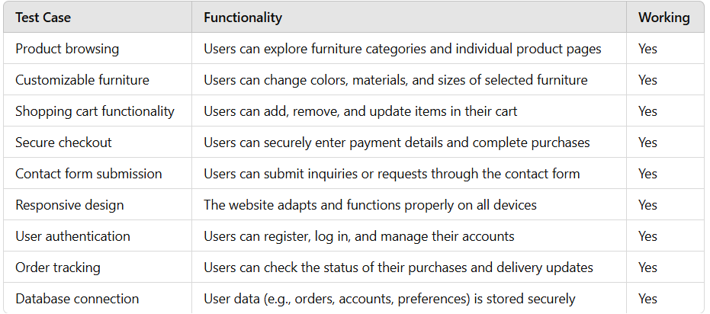
Table 4.1.1(test cases and functionality)

5. CONCLUSION AND FUTURE SCOPE

Conclusions of the Decor Heaven Website are:

- Enhanced Customer Engagement: The Decor Heaven website is built to enhance customer engagement by providing an interactive and immersive experience for furniture shoppers. Customers can explore a wide range of furniture options, visualize how they will look in different settings, and customize their selections based on color, material, and design preferences. The website eliminates the need for customers to visit physical stores, making it more convenient to browse and purchase products from the comfort of their homes. Features like personalized recommendations, wishlist creation, and virtual previews ensure a more engaging shopping experience, making customers feel more involved in their purchase decisions. Additionally, a seamless contact and support system ensures that customers receive timely assistance, further strengthening the relationship between Decor Heaven and its customers. By integrating customer engagement tools such as reviews, ratings, and community discussions, the website fosters an interactive environment where users can share their experiences and gain insights from other buyers. This not only enhances trust but also encourages repeat visits and word-of-mouth recommendations.

- Data Privacy and Security: With the increasing concerns surrounding online data privacy, Decor Heaven places a strong emphasis on securing customer information. The website is designed with encryption protocols and secure authentication measures to protect sensitive data, including user accounts, payment details, and order history. All transactions are conducted through secure payment gateways, ensuring that customer financial information remains protected. The platform also adheres to international data privacy regulations, such as GDPR (General Data Protection Regulation), to safeguard user privacy and prevent unauthorized access to personal data. Additionally, by implementing multi-factor authentication (MFA) and SSL certificates, the website ensures that only verified users can access their accounts, reducing the risk of fraud and identity theft. These security measures increase customer trust and confidence, making them more comfortable engaging with the platform.

- User-Friendly Experience: The Decor Heaven website is designed with a focus on simplicity, clarity, and ease of use. The intuitive interface ensures that customers can quickly navigate through product categories, apply filters, and find the furniture pieces they need without confusion. The website incorporates aesthetic yet functional design principles, ensuring that customers have a smooth and enjoyable experience. Features like quick view, zoom-in options, 360-degree product previews, and augmented reality (AR) integration allow users to visualize how products will look in their homes before making a purchase decision. Since many users prefer shopping on their mobile devices, the website is fully responsive, meaning it adjusts to different screen sizes and functions smoothly across desktops, tablets, and smartphones. The fast-loading pages and minimalistic design further enhance the user experience, making online furniture shopping effortless and enjoyable. Even for users with limited technical skills, the website’s straightforward checkout process, real-time order tracking, and user-friendly dashboard ensure that navigating and managing purchases is stress-free.

- Operational Efficiency: The automation of key processes in the Decor Heaven website has led to significant improvements in operational efficiency. Instead of relying on manual inventory management and customer service, the website streamlines processes such as:
  - Real-time inventory updates: Customers can see product availability instantly, reducing order cancellations due to stock issues.
  - Automated order processing: Orders are processed faster with minimal manual intervention, leading to quicker dispatch and delivery.
  - Integrated customer support system: AI-powered chatbots and FAQs handle common customer inquiries, reducing the need for direct human assistance.
  - Efficient logistics tracking: Customers can track their orders in real-time, reducing complaints and inquiries related to shipping.
  - By minimizing manual work and automating repetitive tasks, Decor Heaven can allocate more resources toward enhancing customer experience and expanding its product range. This not only improves cost-efficiency but also ensures faster service delivery, making the brand more competitive in the online furniture market.

Also the future scope of the same are:

- Enhanced User Authentication: To further strengthen security on the Decor Heaven website, advanced authentication methods can be implemented, ensuring a seamless yet secure user experience. Incorporating biometric authentication, such as fingerprint or facial recognition, adds an extra layer of security, especially for sensitive actions like managing personal information, tracking orders, and saving custom design preferences. Biometric authentication allows users to log in effortlessly while ensuring their data remains protected from unauthorized access. By leveraging cutting-edge technology, Decor Heaven enhances trust in its platform, providing customers with confidence that their personal and payment information is safeguarded against security threats.

- Database Integration for Personalization: A comprehensive database will enable Decor Heaven to deliver highly personalized experiences to its customers. By securely storing user preferences, browsing history, and past interactions, the website can provide tailored recommendations that align with individual tastes.
  - For example:
  - Users can receive furniture recommendations based on their previously viewed or saved items.
  - Special promotions or discounts can be offered based on purchase history and seasonal preferences.
  - The ability to save and revisit room designs ensures a consistent, customized experience across all user sessions.
  - With robust database integration, Decor Heaven not only enhances the shopping experience but also fosters customer loyalty by offering relevant and engaging content.

- Multi-Device Support: To ensure seamless access, Decor Heaven will optimize the website for mobile devices, tablets, and desktops, allowing users to:
  - Browse and purchase furniture on the go.
  - Save and modify room designs across multiple devices.
  - Engage with the community and customer support anytime, anywhere.
  - By ensuring a consistent experience across all platforms, Decor Heaven meets the growing demand for flexibility and convenience in the digital shopping experience.

- Increased Interactivity: To create a more engaging shopping experience, the Decor Heaven website can introduce AI-powered chatbots and voice assistants for real-time customer support. These features would:
  - Answer questions regarding product specifications, shipping details, and return policies.
  - Guide customers through the furniture customization process using interactive 3D renderings.
  - Offer personalized styling tips based on a user’s home decor preferences.
  - By integrating dynamic animations, interactive room layouts, and personalized interfaces, the website ensures a more immersive and visually appealing shopping journey, making customers feel more confident in their selections.

- Daily User Engagement: To encourage frequent visits, Decor Heaven can introduce features that enhance daily engagement, such as:
  - Home Decor Tips & Trends: A blog section with expert advice on interior design, furniture care, and seasonal trends.
  - Project Planner Tool: Allows users to save and manage room designs for future purchases.
  - Loyalty Rewards Program: Customers earn points for purchases, referrals, and reviews, which can be redeemed for discounts.
- Community for Decor Heaven Enthusiasts: Creating a dedicated community platform on the Decor Heaven website would allow customers to connect, share home decor ideas, and discuss furniture styles and trends. Features could include:
  - Discussion forums where users can share decorating tips and seek advice.
  - User-generated content, allowing customers to upload photos of their furnished spaces.
  - Live Q&A sessions with interior design experts.
  - By fostering a sense of community, Decor Heaven can strengthen customer relationships, turning casual shoppers into loyal brand advocates.

6. REFERENCES

[1] Spring Boot Developer. Available: https://spring.io/projects/spring-boot

[2] WCAG 2.1 Compliance. Available: https://www.w3.org/TR/2023/REC-WCAG22- 20231005/

[3] React.js Documentation. Available: https://legacy.reactjs.org/docs/getting-started.html

[4] Java Documentation. Available: https://dev.java/learn/

[5] Payment Testing . Available: https://docs.stripe.com/testing

[6] Postgres SQL, Documents . Available: https://www.postgresql.org/docs/

[7] Udemy.org, “Full Stack: React and Java Spring Boot - The Developer Guide”
[Online]:https://www.udemy.com/course/full-stack-react-and-java-spring-boot-the-developer-guide/?srsltid=AfmBOop1QsB9OjidhDdXQasgtNwFhxkmGEyBM22H4EeWNE-oifFEtPHS&couponCode=ST4MT240225A

[8] Geeks for Geeks, "Java Full Stack Web Development”[Online]:
https://www.geeksforgeeks.org/courses/java-full-stack-development-classroom.

[9] Auth0,” Use for Login ”: https://auth0.com/.

[10] Tailwind CSS : https://tailwindcss.com/.

[11] Visual Studio, "Platform to Code ," https://code.visualstudio.com/.

[12] JwtCheck, "Use for Authentication": https://jwt.io/

[13] Vite , "Guide to develop React Project" https://vite.dev/guide/.

[14] Selenium , "Use for testing Project ," https://www.selenium.dev/.

[15] Vite +Tailwind, "Build Project with Vite + Tailwind," https://tailwindcss.com/docs/guides/vite .

[16] Stripe ,” Payment Gateway ”: https://dashboard.stripe.com/test/dashboard.

Plagiarism Report

