- INTRODUCTION

  - Background

- In the digital age, businesses across industries must adapt to meet the growing expectations of tech-savvy customers. The automotive sector, in particular, has witnessed a significant shift towards digital platforms as consumers increasingly rely on online services for various tasks. Car companies, like Audi, are under pressure to provide seamless, interactive, and intuitive online experiences that reflect their brand's luxury and innovation.

- Audi, a global leader in the automotive industry, recognizes the need to offer a robust online presence that caters to the evolving demands of its customers. From booking test drives to configuring vehicles, and accessing company information, the modern-day customer expects a user-friendly digital platform. As more consumers embrace digital solutions, a well-designed website has become essential for enhancing customer engagement, streamlining services, and maintaining Audi’s brand reputation.

- In today's competitive automotive market, it’s critical for Audi to deliver an online experience that not only meets user expectations but also reinforces its position as a luxury brand. This need for a cutting-edge digital solution is the driving force behind the development of an advanced website for Audi. By focusing on user experience, the website will serve as a comprehensive platform where customers can interact with the brand and its offerings—ensuring that Audi remains relevant and accessible in the digital landscape.

- The website is designed to offer personalized interactions, enabling users to easily navigate through various services, such as test drive bookings, vehicle configurations, and access to the latest company updates. This initiative underscores Audi’s commitment to innovation and its desire to provide customers with an engaging, secure, and efficient online experience, ultimately ensuring a lasting impression of the brand.

- Moreover, the Audi website will feature a community section where Audi enthusiasts and customers can connect with each other. This platform will allow users to stay informed about local meetups, car showcases, and other events, fostering a sense of belonging and engagement within the Audi fanbase. This additional feature enhances the website's ability to not only deliver services but also build a thriving community around the brand.

  - Problem Statement

- Consumer Expectations and Challenges: In today's fast-paced digital world, consumers expect instant access to information and services, particularly from premium brands like Audi. However, potential car buyers and Audi enthusiasts often face obstacles when trying to interact with the brand online. The lack of an integrated digital solution makes it difficult for users to book test drives, configure their desired Audi models, or stay updated on the latest company news. This gap in Audi's digital offerings leaves customers with fragmented experiences, which detracts from the brand's luxury image.

- Inconvenience of Traditional Processes: Many customers still have to visit dealerships in person for tasks that could easily be done online, such as making inquiries, booking test drives, or even getting vehicle details. This traditional process is not only time-consuming but also inconvenient for tech-savvy consumers who prefer quick, online interactions. As a result, the absence of a comprehensive digital platform causes friction, limiting the efficiency and convenience that customers expect from a high-end brand.

- Need for a Seamless, User-Centric Website: To address these challenges, Audi needs to create a fully functional, user-friendly website that delivers a streamlined experience for customers. The site should allow users to effortlessly book test drives, customize their preferred Audi models, and access real-time updates from the company—all from the comfort of their devices. This solution would ensure that Audi customers can interact with the brand’s services at any time and from anywhere, enhancing convenience and satisfaction.

- Enhancing Customer Relationships through Digital Engagement: By offering a digital-first, seamless platform that integrates all necessary functionalities, Audi can transform how it engages with customers. The website would not only simplify user interactions but also strengthen customer relationships by providing a more personalized, efficient, and accessible experience. This shift toward a comprehensive digital solution will help Audi maintain its competitive edge, ensuring that it meets the expectations of its modern, tech-driven audience.

  - Objectives

The main objectives of the project are as follows:

- Test Drive Booking: The Audi website will offer a seamless platform for users to book test drives online, making it convenient for potential buyers to experience their desired vehicles firsthand. Users will be able to select their preferred Audi model, choose a suitable date, and pick a nearby dealership without needing to visit the physical location. This functionality will streamline the booking process, allowing users to fill out an intuitive form that captures their details, preferences, and any specific requests they might have regarding the test drive. Automated confirmations will be sent via email or SMS, providing users with all necessary information about their upcoming test drive, including location details and any documents they may need to bring. By eliminating the need for in-person visits just to schedule a test drive, Audi enhances user convenience and demonstrates its commitment to a modern, user-friendly approach.

- Car Configuration: The website will enable users to configure and personalize their Audi vehicles through an engaging online tool. Users can explore various models and select from a range of features, colors, and packages to create their ideal vehicle. The car configuration tool will provide real-time visualizations, allowing users to see how their choices impact the overall look of the car. This interactive feature will also include a real-time cost estimator, showing users how different options affect the total price. For instance, if a user chooses a premium package or additional features like advanced safety systems, the tool will instantly update the price, helping users stay informed about their budget throughout the configuration process. This customization experience not only empowers customers to create a vehicle that reflects their personal style but also builds excitement and anticipation for their purchase.

- Ease of Use: To maximize user satisfaction, the Audi website will focus on being intuitive and user-friendly. The design will feature a clean interface, allowing users to navigate through various sections—such as car models, test drive bookings, and configuration tools—without confusion. User experience (UX) best practices will be employed, ensuring that key features are easily accessible and that the layout is logical and straightforward. For example, prominent call-to-action buttons will guide users toward booking test drives or exploring car configurations. Moreover, tooltips and help icons will be included to assist users as they navigate the site, making the experience inclusive for all users, regardless of their technical proficiency. By prioritizing ease of use, Audi ensures that visitors to the website can engage with the brand effortlessly and enjoyably.

- Real-Time Updates: To keep users informed and engaged, the website will provide real-time updates on company news, job opportunities, and upcoming events. A dedicated news section will be featured prominently on the homepage, showcasing the latest announcements and updates from Audi. This could include new model releases, company milestones, and promotional events. Additionally, users will have access to a jobs page where they can view and apply for current openings within Audi. To ensure that users do not miss important updates, the website can offer an email newsletter subscription option, allowing users to receive notifications about new content directly in their inbox. By delivering timely and relevant information, Audi strengthens its relationship with users, demonstrating transparency and engagement.

- Mobile Compatibility: Recognizing the importance of accessibility, the Audi website will be developed with responsive design in mind. This means that the site will function smoothly across all devices, including desktops, tablets, and smartphones. By utilizing frameworks such as Bootstrap or Tailwind CSS, the design will adapt to various screen sizes and orientations, ensuring a consistent user experience regardless of how the website is accessed. Key features will remain easily accessible, with touch-friendly buttons and intuitive navigation designed for mobile use. Users will be able to complete tasks such as booking test drives or configuring vehicles just as easily on their mobile devices as they would on a desktop. This emphasis on mobile compatibility is crucial in today’s digital landscape, where a significant portion of users interact with brands primarily through their smartphones.

- Data Security: The Audi website will place a strong emphasis on data security, implementing robust measures to protect user information throughout their interactions with the site. Secure forms will be used for capturing sensitive information, such as during the booking process for test drives and vehicle configurations. All data transmitted through the website will be encrypted using SSL (Secure Socket Layer) technology, ensuring that personal information remains confidential and protected from potential cyber threats. Furthermore, compliance with data protection regulations such as GDPR will be prioritized, providing users with assurances about how their data is used and stored. By prioritizing data security, Audi reinforces its commitment to safeguarding customer trust and privacy, crucial elements in maintaining a positive brand reputation.

- Customer Interaction: To enhance user engagement and foster a sense of community, the Audi website will integrate customer reviews and feedback mechanisms. This feature allows potential buyers to read reviews from current Audi owners, offering insights into the experiences others have had with various models. The website will also enable users to leave their feedback, allowing Audi to understand customer sentiment and improve its offerings. Additionally, the integration of a Q&A section or forum can facilitate discussions among users, enabling them to ask questions about vehicles, share experiences, and connect with fellow Audi enthusiasts. This increased interactivity not only creates a more dynamic online experience but also helps build brand loyalty by making customers feel heard and valued.

  - Scope:

1. User Accessibility: The Audi website will serve as the primary digital platform for customers, providing easy access to a wide range of services without the need to physically visit a dealership. This approach empowers users to book test drives and configure vehicles from the convenience of their own homes or on the go. By integrating user-friendly features such as straightforward navigation and a simple booking process, customers can quickly find the information they need and complete actions efficiently. The website will support various user profiles, allowing for tailored experiences based on individual preferences. For example, returning users may see previously saved configurations or relevant promotions tailored to their interests. By enabling customers to engage with Audi’s services conveniently, the website not only enhances the user experience but also strengthens the connection between Audi and its clientele.
2. Enhanced Security: Given the sensitive nature of the data handled on the Audi website, enhancing security is a top priority. The site will implement robust security measures, including data encryption for all transactions, especially during sensitive operations such as booking a test drive or configuring a vehicle. This means that personal information, such as names, addresses, and payment details, will be securely transmitted and stored, mitigating the risk of unauthorized access. Additionally, the website will comply with international data protection regulations (such as GDPR) to ensure that user privacy is respected and protected. Regular security audits and updates will be conducted to maintain high security standards. By prioritizing data security, Audi builds trust with its customers, assuring them that their personal information is handled with the utmost care and confidentiality.
3. Responsiveness: The Audi website will be designed with responsiveness at its core, ensuring that it functions smoothly across all devices, including desktops, tablets, and smartphones. A responsive design is critical in today’s digital landscape, where users expect to access services seamlessly, regardless of the device they are using. This will involve using modern web development techniques, such as CSS media queries and flexible layouts, to adapt content to various screen sizes and resolutions. Users will enjoy a consistent experience, with all features—such as booking test drives and car configurations—easily accessible on any device. Whether users are browsing on a large desktop screen or a small mobile device, the interface will adjust to maintain usability and visual appeal, enhancing user satisfaction and engagement with the brand.
4. Real-Time Content Management: To keep customers informed and engaged, the Audi website will feature real-time content management, providing updates for news, job opportunities, and company announcements instantly. A dedicated news section will allow users to stay up-to-date with the latest developments in the Audi world, including new model releases, events, and company initiatives. Additionally, a job listing page will feature current openings, allowing potential employees to view and apply for positions without delays. Implementing a content management system (CMS) will allow Audi's marketing team to update the website easily and efficiently, ensuring that users always have access to the most current information. By offering timely updates, Audi reinforces its commitment to transparency and customer engagement, keeping users connected with the brand.
5. Scalability: The website will be designed with scalability in mind, enabling it to handle increasing traffic and user interactions as Audi’s customer base grows. This includes leveraging cloud-based hosting solutions that can dynamically adjust resources to accommodate higher traffic levels during peak times, such as promotional events or new model launches. The architecture will be built to support potential feature expansions without sacrificing performance, ensuring that the website remains fast and responsive even as more users engage with the platform. Regular performance monitoring and optimization will also be implemented to ensure that loading times are minimized, providing a smooth user experience. By focusing on scalability, Audi ensures that its digital platform can evolve alongside the brand and its customers, maintaining high standards of service and performance.

1.5 Purpose

- The purpose of the Audi website is to design and develop a comprehensive, userfriendly digital platform that enhances customer engagement with the brand. It aims to provide a seamless online experience where users can easily book test drives, configure their preferred Audi models, and stay updated with real-time company news and events.

- The primary objective of the website is to streamline customer interactions by offering an all-in-one platform that caters to the needs of Audi enthusiasts, potential buyers, and existing customers. The website will allow users to explore Audi’s vehicle lineup, customize configurations, and connect with local dealers for test drives—all from the convenience of their devices.

- By integrating features such as real-time updates, customer accounts, and mobile responsiveness, the Audi website aims to foster a dynamic and immersive user experience. The purpose is to create a platform that not only reflects Audi’s brand image of luxury and innovation but also makes customer interactions more efficient, enjoyable, and accessible.

- Additionally, the platform will offer exclusive content for Audi fans, including virtual meetups and car showcases in their local areas, further strengthening the community around the brand and enhancing customer loyalty through continuous engagement.

- LITERATURE REVIEW

  - Discussion of related work:
● Audi Car Company Website:

The design and development of a fully functional Audi website serve as the foundation for this project. This platform is tailored to allow users to conveniently book test drives, configure cars, and access real-time updates about the company. The primary goal of this website is to eliminate the need for customers to physically visit a dealership, thereby offering a cost-effective and time-saving solution. By integrating these services into a single, user-friendly platform, Audi customers can engage with the brand whenever and wherever they choose, enhancing convenience and accessibility.

The website's emphasis on user-friendly navigation ensures that even less tech-savvy users can navigate easily through the platform. Responsive design plays a crucial role in this, as the website must function smoothly across a wide range of devices, including desktops, smartphones, and tablets. This guarantees that users receive a consistent and engaging experience regardless of their preferred device. The convenience provided by the website allows customers to make decisions and interact with Audi's services at their own pace, reducing the pressure of in-person dealership visits.

● Design of Audi Website for Customer Engagement:

This project highlights the role of the Audi website in fostering customer engagement through its digital offerings. Much like a modern chatting application that uses Bluetooth to enable cost-effective and low-power communication, the Audi website is designed to connect customers to the brand in a streamlined and efficient manner. It acts as a communication tool between Audi and its customers by offering key features that users can access with minimal effort. For instance, the ability to book test drives or configure vehicles online keeps customers actively engaged with Audi’s services, without requiring them to leave their homes or visit a dealership in person.

Moreover, by integrating real-time updates about the brand’s events, job opportunities, and promotional activities, the website provides Audi with a direct and effective means of communicating with its audience. This helps Audi maintain an open dialogue with its customers, keeping them informed and engaged, thus fostering loyalty. The ability to interact with the brand online empowers customers to take control of their experience, creating a sense of belonging and reinforcing Audi’s commitment to customer satisfaction.

● Summary:

In summary, this project underscores the importance of creating a seamless digital experience for Audi customers, leveraging modern web technologies to meet the growing expectations of today’s digital-savvy users. By enabling users to book test drives, configure cars, and interact with the brand online, the website reflects Audi’s dedication to innovation and luxury, maintaining its image as a cutting-edge automotive brand.

The website not only serves as a comprehensive platform for engaging with Audi’s services but also offers a cost-effective solution by reducing the need for physical dealership visits. Real-time updates about new models, promotions, and company news enhance user engagement by keeping customers connected to the brand. Additionally, the integration of secure transactions ensures that customers can interact with the platform confidently, knowing their personal and payment information is protected.

Ultimately, the website highlights how responsive design, customer engagement tools, and real-time information contribute to a more satisfying and interactive user experience. Audi’s website aligns with the brand’s core values of luxury, innovation, and customer-centricity, further solidifying its position in the competitive automotive market.

3. PROPOSED METHOD

3.1 Description of the research methods and techniques used
- Setting up the Development Environment: The first step is to install and configure all necessary tools for web development. The main tool used for coding is Visual Studio Code (VS Code), a versatile and popular code editor that supports various extensions for productivity, syntax highlighting, and debugging. For the backend development, Node.js is installed to run JavaScript server-side code, and React.js is used for the frontend to create a dynamic user interface. Additional tools such as Postman are set up for API testing, and ESLint and Prettier are added for ensuring code quality and formatting. These tools streamline the entire development process, from writing code to testing and deploying the website.Creating a New Project: Initialize the project using Create React App for the frontend and set up Express.js as the backend framework. This involves setting up the directory structure, specifying dependencies (e.g., React, Express, and MongoDB/PostgreSQL), and creating basic routes and components to manage user interactions like test drive bookings and car configuration.
- Designing the User Interface: The user interface (UI) is designed to reflect Audi's brand identity, focusing on a modern, luxurious aesthetic. This is achieved by using Tailwind CSS or Bootstrap, both of which offer responsive design frameworks that make the website compatible across various screen sizes, from desktops to mobile devices. The UI design includes intuitive navigation, clear call-to-action buttons, and smooth transitions between different sections of the site. Key pages such as the Test Drive Booking, Car Configuration, and Contact Us forms are designed with user-friendliness in mind, making it easy for customers to access the services they need without any confusion. The responsive design ensures that the site provides a consistent experience on all devices, enhancing accessibility.Implementing Backend Connectivity: Using Node.js and Express.js, server-side functionality is built to handle user requests, such as booking a test drive or configuring a car. MongoDB is connected to store user data securely, and APIs are created to enable communication between the frontend and backend.
- Managing User Authentication: Auth0 and JWT (JSON Web Tokens) To ensure the website is secure, Auth0 and JWT (JSON Web Tokens) are implemented for user authentication. Auth0 provides a simple and secure way to manage login and registration processes, while JWTs are used to maintain user sessions and protect access to sensitive areas of the website, such as booking details or personal car configurations. This system ensures that only authorized users can access their data, preventing unauthorized access or data breaches. The authentication process is seamless, and once users log in, they can view their personalized configurations and bookings securely.
- Testing and Debugging: To ensure that the website works flawlessly across different environments, extensive testing is performed. The site is tested on various browsers, including Chrome, Firefox, and Safari, and across different devices to ensure consistent functionality. Testing also includes performance tests to optimize load times and security tests to safeguard user data. Automated testing tools such as Jest or Cypress are used to automate unit and integration tests, ensuring that key functionalities like the booking system and configuration tool work as expected. Any bugs or performance issues are identified and resolved during this phase to deliver a smooth user experience.
- Deploying the Website: Once the website has been fully developed and tested, it is deployed on cloud platforms like AWS or Azure. These platforms are chosen for their scalability and reliability, allowing the website to handle increasing traffic efficiently. Continuous Integration/Continuous Deployment (CI/CD) pipelines are set up to automate future updates. This means that new features, bug fixes, or optimizations can be deployed automatically without causing downtime. By hosting the website on a scalable infrastructure, Audi ensures that the platform can grow with its user base and handle peak traffic during special promotions or product launches.

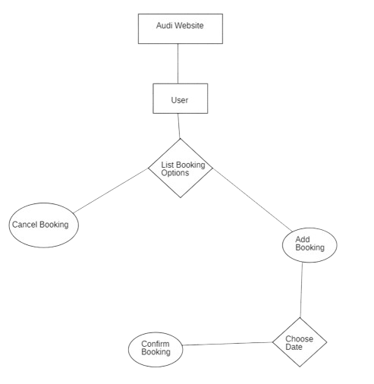
fig 3.1.1(simple activity diagram for Audi Company Website )
The above activity diagram illustrating the process of booking on an Audi website. Here's the explanation of each component:
- Audi Website:
  - This represents the starting point, where users interact with the Audi website to access the booking functionality.
- User:
  - The entity that is making the booking. Users log in and interact with the website to explore booking options.
- List Booking Options (Decision Point):
  - The user is presented with a list of booking options, which typically include actions such as adding a booking or canceling an existing booking. This step splits into two possible outcomes: add a booking or cancel a booking.
- Cancel Booking:
  - If the user chooses to cancel a booking, they are directed to this process. This could involve selecting a previous booking and confirming the cancellation.
- Add Booking:
  - If the user decides to create a new booking, they proceed with this option. This step initiates the booking process by gathering relevant information for a new booking.
- Choose Date (Decision Point):
  - After selecting to add a booking, the user is asked to choose a preferred date for their booking (likely for a test drive or another service).
- Confirm Booking:
  - Once the date is selected, the user confirms their booking. This step finalizes the booking by storing the details and sending confirmation to the user.
In summary, the diagram outlines a simplified flow of booking interaction where users can either cancel an existing booking or add a new one by choosing a date and confirming it on the Audi website.

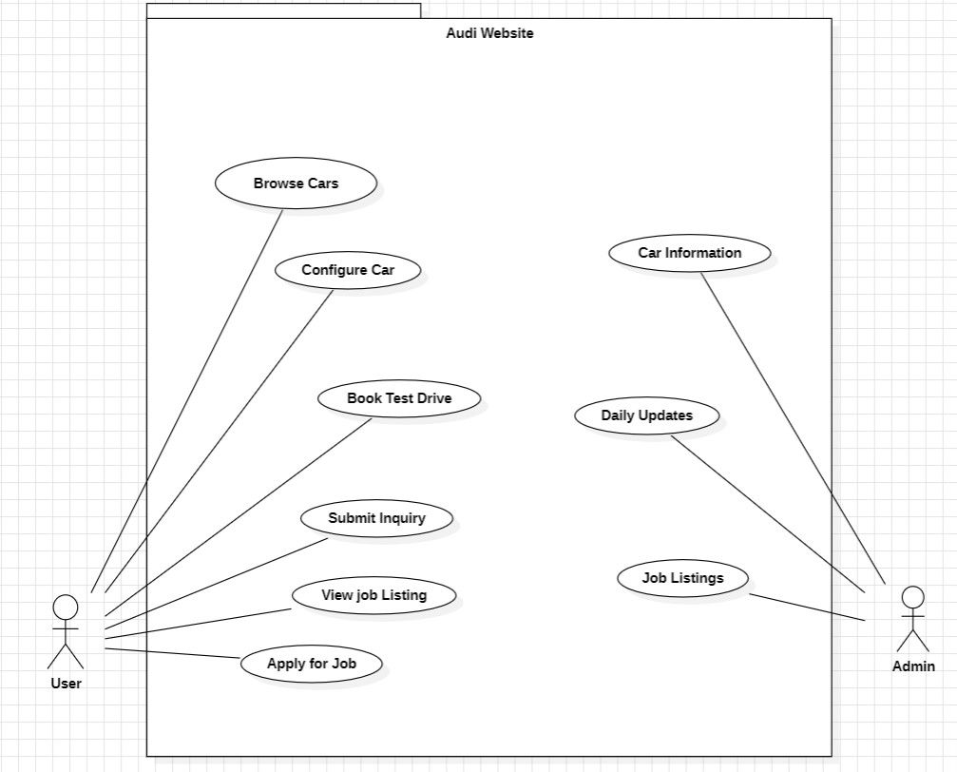fig 3.1.2(use case diagram for Audi Website )

This is a Use Case Diagram for an Audi Website, which illustrates the interactions between users and the system. It shows how both the user and admin interact with various functionalities of the website. Here's a detailed explanation:
Actors:
- User:
  - Represents a visitor or customer using the Audi website to explore services like browsing cars, booking test drives, and applying for jobs.
- Admin:
  - Represents the administrator who manages the website content, including car information, daily updates, and job listings.
Use Cases:
- Browse Cars:
  - The user can explore the range of Audi cars available on the website. This feature allows users to view different models, specifications, and features.
- Configure Car:
  - Users can personalize or configure their chosen Audi vehicle by selecting specific features, colors, packages, and additional accessories.
- Book Test Drive:
  - This functionality allows users to book a test drive online, choosing the model they want to test and their preferred date and location for the test drive.
- Submit Inquiry: • Users can submit any inquiries or questions they have regarding Audi’s products or services through the website.
- View Job Listing:
  - Users interested in employment opportunities can view available job listings posted on the Audi website.
- Apply for Job:
  - Once the user finds a suitable job listing, they can apply for it directly through the website.
- Car Information (Admin):
  - The admin is responsible for updating and maintaining accurate car information for the website, ensuring users have the latest details on all Audi models.
- Daily Updates (Admin):
  - The admin also manages daily updates for news, company announcements, events, and other relevant content that needs to be displayed on the website.
- Job Listings (Admin):
  - Admin can post, update, and manage job listings that users can view and apply for on the website.
Summary:
The diagram outlines a clear distinction between user and admin roles. Users can browse, interact with the cars, book test drives, and apply for jobs, while admins manage and update key content like car details, job listings, and daily updates. This ensures that both the public facing and backend components of the website are efficiently handled.

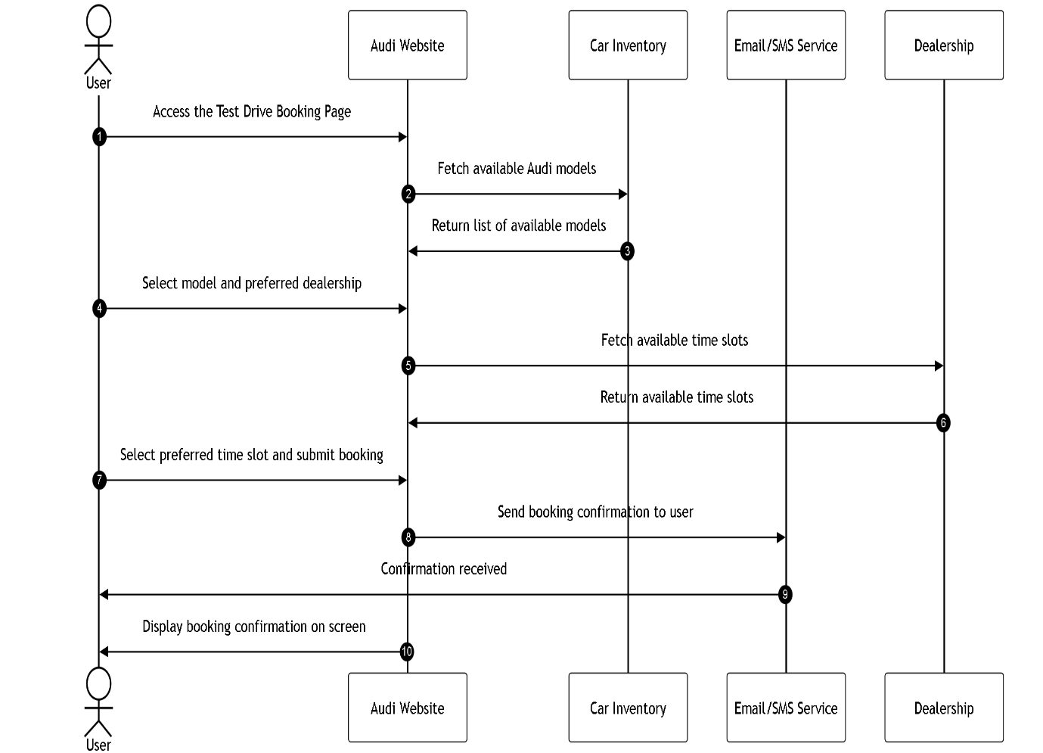

fig 3.1.3(sequence diagram for Audi Website )

This diagram represents a Sequence Diagram for an Audi Website, depicting the flow of interactions between the user, the website, and external systems involved in the booking process. Here's a breakdown of the components:
Entities:
- User:
  - Represents the customer or user who is interacting with the Audi website to book a test drive or other services.
- Audi Website:
  - The primary interface the user interacts with for browsing vehicles, booking test drives, and configuring cars.
- Car Inventory:
  - A system or database that holds the available cars for test drives or other services.
- Email/SMS Service:
  - A system responsible for sending confirmation notifications to the user about their booking via email or SMS.
- Dealership:
  - The physical dealership associated with the booked test drive, which receives the details of the user's booking and prepares the car for the test drive.
Steps in the Sequence:
- User Request:
  - The user interacts with the Audi website by making a request, such as booking a test drive.
- Request Car Availability:
  - The Audi website sends a request to the Car Inventory system to check the availability of the requested car for the selected date and time.
- Response from Car Inventory:
  - The Car Inventory system checks its records and responds to the Audi website, confirming whether the car is available.
- Booking Confirmation:
  - Once the availability is confirmed, the website presents the available options to the user, and the user proceeds with confirming the booking.
- Booking Details Submission:
  - The Audi website processes the booking details, such as car model, date, and time, and submits the confirmation.
- Notify Dealership:
  - The website communicates with the Dealership, informing them of the test drive booking, so they can prepare the car for the user.
- Send Confirmation to User:
  - After submitting the booking, the website requests the Email/SMS Service to send a confirmation notification to the user.
- User Receives Notification:
  - The Email/SMS Service sends the confirmation notification (via email or SMS) to the user, providing them with the booking details.
- Dealership Prepares Car:
  - The Dealership gets the car ready for the user based on the booking details sent earlier.
- Booking Completed:
  - The entire sequence ends with the completion of the booking process, where the website confirms the finalized booking with the user.

Summary:
This sequence diagram shows the flow of information between the user, the Audi website, and external systems like the Car Inventory, Email/SMS Service, and the Dealership. The main goal of this interaction is to facilitate a smooth booking process for the user while ensuring communication with the relevant entities (car availability, dealership preparation, and user notification).

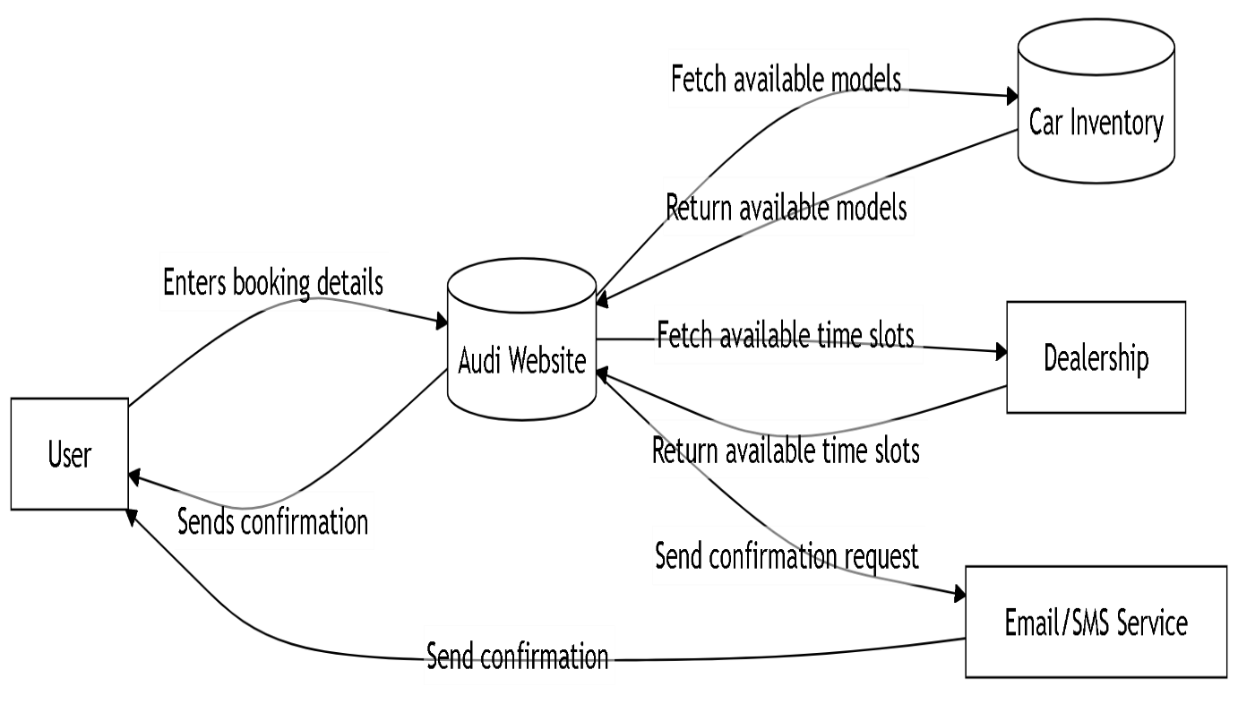

fig 3.1.4 (data flow level 1 diagram for Audi Website )

This diagram represents a Sequence Diagram for an Audi Website, depicting the flow of interactions between the user, the website, and external systems involved in the test drive booking process.
Entities:
- User:
  - Represents the customer interacting with the Audi website to book a test drive or other services.
- Audi Website:
  - The main interface the user interacts with to browse available cars, book test drives, and configure other options.
- Car Inventory:
  - A system or database that holds information about available cars for test drives and other services.
- Email/SMS Service:
  - A system responsible for sending confirmation notifications to the user about their booking via email or SMS.
- Dealership:
  - The physical location associated with the booked test drive, which receives booking details and prepares the car for the user.

Steps in the Sequence:
- User Request:
  - The user initiates the process by interacting with the Audi website, such as entering booking details for a test drive.
- Request Car Availability:
  - The Audi website sends a request to the Car Inventory system to check the availability of the selected car for the chosen date and time.
- Response from Car Inventory:
  - The Car Inventory system checks its records and responds to the Audi website, confirming the availability of the requested car.
- Booking Confirmation:
  - The Audi website displays available car models and time slots to the user. After reviewing the options, the user confirms the booking details.
- Booking Details Submission:
  - The Audi website processes the confirmed booking details (car model, date, time) and submits the information for further processing.
- Notify Dealership:
  - The Audi website informs the Dealership about the booking details. The dealership receives this information to prepare the car for the user’s test drive.
- Send Confirmation to User:
  - After submitting the booking, the Audi website communicates with the Email/SMS Service to send a confirmation message to the user containing booking details.
- User Receives Notification:
  - The Email/SMS Service sends the confirmation to the user, providing the necessary details such as car model, test drive time, and dealership location.
- Dealership Prepares Car:
  - The dealership prepares the selected car based on the received booking details to ensure the vehicle is ready for the scheduled test drive.
- Booking Completed:
• The booking process concludes with the Audi website confirming the finalized booking to the user. At this stage, all entities (user, dealership, and services) are aligned for the scheduled test drive.

Summary:
This sequence diagram outlines the flow of communication and processes between the User, Audi Website, and external systems like Car Inventory, Dealership, and Email/SMS Service. The main objective of the interaction is to ensure a seamless booking process, enabling the user to confirm a test drive while informing the relevant entities for preparation (e.g., checking car availability, notifying the dealership, and sending confirmation to the user). This system ensures a streamlined, real-time experience for both the customer and dealership.

4. RESULTS AND DISCUSSION

4.1 Presentation and analysis of the results obtained:
- Enhanced User Experience: The Audi website has been designed to offer a seamless and interactive experience for customers, making it easy for them to access essential services like booking test drives, configuring vehicles, and exploring real-time updates from the company. The intuitive navigation ensures that users can effortlessly engage with different sections of the website, whether they're exploring car models or scheduling a test drive. The streamlined design reduces friction and enhances usability, leading to a more satisfying user journey from start to finish. Features like personalized vehicle configurations allow users to build their ideal Audi model, reinforcing Audi's brand as a premium, customer-centered company. The ease of use significantly improves customer satisfaction and keeps them engaged with the brand digitally.
- Cost-Effective Solution: One of the key benefits of the Audi website is its ability to reduce costs for both customers and Audi. Traditionally, customers would have to visit a dealership in person to book a test drive or inquire about specific vehicle models, which can be both time-consuming and inconvenient. With the introduction of online features like test drive bookings and car configuration, customers can now complete these actions from the comfort of their own homes, saving time and transportation costs. This also reduces the operational burden on Audi dealerships by automating a significant portion of the customer interaction process. By handling bookings, inquiries, and even service scheduling online, the website reduces the need for extensive staff involvement, lowering administrative overhead and allowing employees to focus on in-person sales and service experiences. This automation not only enhances efficiency but also improves customer satisfaction by offering a more flexible way to engage with the brand.
- Mobile Responsiveness: The website, while functional on desktops, is currently facing challenges with mobile responsiveness. Given the increasing number of users who access the internet via mobile devices, it is essential for the Audi website to offer a fully responsive experience across all platforms, including smartphones and tablets. Although the current version of the website is not yet optimized for mobile, significant efforts are being made to enhance compatibility and provide a smooth browsing experience for users on the go. The goal is to ensure that users can perform all essential actions—such as booking test drives, configuring cars, and accessing news—without any loss in performance or design quality, regardless of the device they are using. By focusing on mobile optimization, Audi will be able to tap into a larger audience, including users who rely primarily on mobile devices for browsing and shopping.
- Secure Data Handling: Given the sensitive nature of the data handled by the Audi website—such as personal information during bookings or vehicle configurations—security is a top priority. The website employs strong encryption protocols to ensure that all user transactions and data exchanges are secure. This is especially important when customers book test drives or configure their cars online, as they are required to share personal information. By utilizing secure encryption, the Audi website builds trust with users by guaranteeing that their data is protected from unauthorized access. This focus on data security also ensures that the website complies with industry standards and privacy regulations, such as GDPR, further enhancing user confidence in the platform. The secure handling of data contributes to Audi’s reputation as a premium brand that values customer privacy and security.
- Scalability and Flexibility: As Audi continues to grow its customer base and expand its digital services, the website’s infrastructure is designed with scalability in mind. This ensures that the website can handle increased traffic, particularly during high-demand periods such as new model launches, promotions, or special events. The cloud-hosted architecture of the website enables Audi to scale its infrastructure dynamically, ensuring that performance remains consistent even as more users engage with the platform. Additionally, the website is built with future flexibility in mind, meaning that new features or enhancements—such as advanced car configurators or virtual reality test drives—can be added without disrupting the user experience. This modular and flexible approach ensures that the website can grow and adapt alongside Audi’s evolving digital strategy, supporting the company's long-term goals and maintaining a competitive edge in the automotive market.
- Community Engagement: The website will feature community engagement tools, such as forums or event sections where Audi enthusiasts and customers can connect. Users will be able to find local Audi events, car showcases, and meetups in their area, fostering a sense of community among Audi fans. This additional engagement strengthens brand loyalty, turning customers into active participants in Audi’s brand ecosystem, and enhancing the overall user experience.

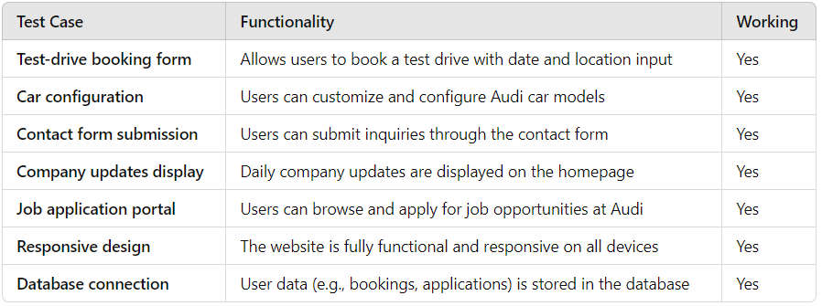
Table 4.1.1(test cases and functionality)

5. CONCLUSION AND FUTURE SCOPE

Conclusions of the Audi Website are:

- Improved Customer Engagement: The Audi website is designed to provide a seamless and interactive platform that significantly enhances customer engagement. By offering an integrated online experience where users can easily book test drives, configure cars, and access real-time company updates, Audi strengthens its connection with customers. The website ensures that every interaction, whether browsing through car models, customizing features, or scheduling a test drive, reflects Audi’s commitment to luxury and innovation. Customers can interact with the brand from the comfort of their homes, reducing the need to visit dealerships in person. This increased accessibility encourages more frequent engagement and helps Audi maintain strong relationships with both potential buyers and long-term customers. By offering personalized services through features like car configuration, the website elevates user satisfaction, making each customer feel valued and connected to the Audi brand.Data Privacy and Security: The website prioritizes user security by encrypting sensitive data, ensuring that personal information and transactions are handled with the highest level of privacy.

- Data Privacy and Security: In today’s digital landscape, data privacy and security are paramount, especially for a premium brand like Audi. The website prioritizes user security by encrypting sensitive data, ensuring that all personal information and transactions are handled with the utmost care. Features like test drive bookings, vehicle configurations, and user accounts involve the exchange of sensitive details, including contact information and preferences. The website implements robust encryption protocols to protect this data from unauthorized access, offering customers peace of mind as they engage with the platform. Furthermore, Audi’s compliance with GDPR and other data protection regulations reinforces its commitment to safeguarding user privacy. By investing in advanced security measures, the website not only protects its users but also builds trust and loyalty, ensuring that customers feel confident when interacting with the brand online.

- User-Friendly Experience: One of the primary goals of the Audi website is to deliver a user-friendly experience that caters to a wide range of customers. The website’s design is both intuitive and easy to navigate, allowing users to quickly find the services they need. Whether users are scheduling a test drive, exploring vehicle configurations, or reading company updates, the clear layout and streamlined design make interactions effortless. The website is built with responsive design principles, ensuring that it functions smoothly across devices, from desktops to smartphones, providing a consistent and high-quality experience regardless of the platform. This accessibility not only attracts tech-savvy customers but also ensures that those with minimal technical skills can easily use the website. By focusing on simplicity and ease of navigation, Audi ensures that all users, regardless of their digital literacy, can efficiently access the services they need without any frustration.

- Operational Efficiency: The website also brings significant improvements in operational efficiency for both Audi and its customers. By automating key processes, such as test drive bookings, vehicle configurations, and inquiries, the website reduces the need for customers to visit dealerships in person, saving them time and effort. This automation also benefits Audi by minimizing administrative tasks, freeing up dealership staff to focus on providing higher-level services, such as personalized customer care and in-person sales. By streamlining operations, the website not only enhances customer convenience but also optimizes internal processes, leading to reduced operational costs for Audi. The efficiency gained from online bookings and configurations means fewer manual tasks for dealership employees, allowing them to concentrate on providing a premium customer experience. This cost-effective solution benefits both customers and the brand by reducing friction in the customer journey and ensuring smooth interactions at every touchpoint.

Also the future scope of the same are:

- Enhanced User Authentication: To further enhance the security of the Audi website, advanced authorization methods can be implemented, ensuring a secure and seamless user experience. Incorporating biometric authentication, such as fingerprint or facial recognition, adds an extra layer of security, particularly for sensitive actions like managing personal information, test drive bookings, and vehicle configurations. Biometric authentication provides frictionless access, allowing users to log in quickly while ensuring their data is protected from unauthorized access. By utilizing cutting-edge technologies like biometrics, Audi can enhance trust in the brand's online platform, ensuring customers feel confident that their personal information is secure.

- Database Integration for Personalization: By building a comprehensive database that securely stores user information, Audi can deliver personalized experiences to its customers. The website can offer tailored recommendations based on a user’s browsing history, preferences, and previous interactions with the platform. For example, users could receive customized vehicle recommendations, promotions, or financing options based on their past configurations or models they have shown interest in. This database integration not only enhances the user experience but also strengthens customer loyalty by providing relevant content and offers that resonate with individual preferences. The database would also support features like saving test drive bookings, configurations, and past interactions, ensuring a consistent, personalized experience across all user sessions.

- Virtual Reality Test Drives: To elevate the Audi website experience, integrating Virtual Reality (VR) technology would allow potential buyers to experience Audi models in a virtual environment, offering immersive test drives from the comfort of their homes. With VR, users can explore the interior and exterior of vehicles, test different configurations, and get a feel for how the car drives—all without having to visit a dealership. This innovative feature would appeal to tech-savvy consumers and those who may not have immediate access to an Audi dealership. By leveraging VR, Audi can offer next-level interactivity, giving potential buyers a realistic experience that mimics an in-person test drive, ultimately increasing user engagement and boosting sales conversions.

- Increased Interactivity: The Audi website can further engage users by introducing AI-based chatbots and voice chat for instant customer support. AI-driven chatbots can provide real-time assistance, answering questions about vehicle specifications, promotions, or service appointments, while voice chat offers a more personal touch for users seeking live support. Additionally, the inclusion of interactive animations and personalized interfaces would create a more dynamic experience. For instance, users could see 3D car renderings that change based on their configuration choices, adding an engaging visual element to the customization process. These interactive features make the website more user-centric and can help guide potential buyers through their decision-making process, enhancing their overall experience with Audi.

- Daily User Engagement: To boost daily user engagement, the Audi website can integrate additional features such as maintenance reminders, service bookings, and lifestyle app integration. Users could receive notifications when their vehicle requires servicing or schedule maintenance appointments directly through the site. Integration with lifestyle apps could also allow users to book Audi experiences, such as track days or brand events, further enriching their engagement with the Audi ecosystem. By offering a seamless way to manage their Audi ownership experience, the website becomes more than just a portal for vehicle purchases—it becomes a comprehensive tool for maintaining and enhancing their relationship with the brand.

- Community for Audi Enthusiasts: Creating a dedicated community platform on the Audi website would foster engagement among Audi enthusiasts and customers. This feature would allow users to connect with other Audi fans, share their experiences, and discuss everything from vehicle modifications to local events. Audi could also use this platform to organize meetups and car showcases, allowing users to RSVP to events in their area, enhancing the sense of community. Such a platform would not only increase customer retention but also strengthen Audi’s brand loyalty by turning customers into advocates and long-term members of the Audi family.

- Multi-Device Support: To ensure seamless access to the website, multi-device support is essential. The Audi website will be optimized for a range of platforms, including mobile devices, tablets, and desktops, ensuring that users can interact with Audi’s services from any device at their convenience. This means that users can configure cars, book test drives, or connect with the Audi community on their smartphone while on the go, and later pick up where they left off on a desktop or tablet. Ensuring cross-platform compatibility enhances user experience and ensures that Audi can engage customers wherever they are, meeting the growing demand for flexibility and convenience in the digital age.

6. REFERENCES

[1] Audi Brand Design. Available: https://www.audi.in/in/web/en.html

[2] WCAG 2.1 Compliance. Available: https://www.w3.org/TR/2023/REC-WCAG22- 20231005/

[3] React.js Documentation. Available: https://legacy.reactjs.org/docs/getting-started.html

[4] Node.js Documentation. Available: https://nodejs.org/docs/latest/api/documentation.html

[5] Audi Website Figma. Available: https://shorturl.at/lrfcD

[7] freeCodeCamp.org, "How to Learn MERN and Become a Full-Stack Developer [Online]:https://www.freecodecamp.org/news/mern-stack-roadmap-what-you-need-to-know-to-build-full-stack-apps/

[8] GeeksforGeeks, "Mern Full Stack Web Development”[Online]:
https://www.geeksforgeeks.org/courses/mern-full-stack-development-classroom.

[9] Auth0,” Use for Login ”: https://auth0.com/.

[10] Tailwind CSS : https://tailwindcss.com/.

[11] Visual Studio, "Platform to Code ," https://code.visualstudio.com/.

[12] JwtCheck, "Use for Authentication": https://jwt.io/

[13] Vite , "Guide to develop React Project" https://vite.dev/guide/.

[14] Selenium , "Use for testing Project ," https://www.selenium.dev/.

[15] Vite +Tailwind, "Build Project with Vite + Tailwind," https://tailwindcss.com/docs/guides/vite .

[16] React Three Fiber ,” Use for 3d design”:
https://r3f.docs.pmnd.rs/getting-started/introduction .

Plagiarism Report

