Asher Smithson
Djon Harrison
Scott Johnson
Jackson Webster
Milestone #2
Below are the .sql output tables:
Department:
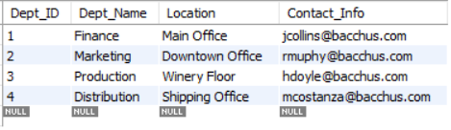
Employee:
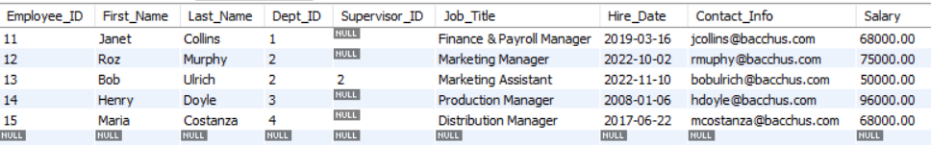
Supplier:
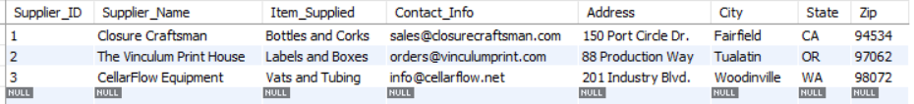

Here is the python output tables:
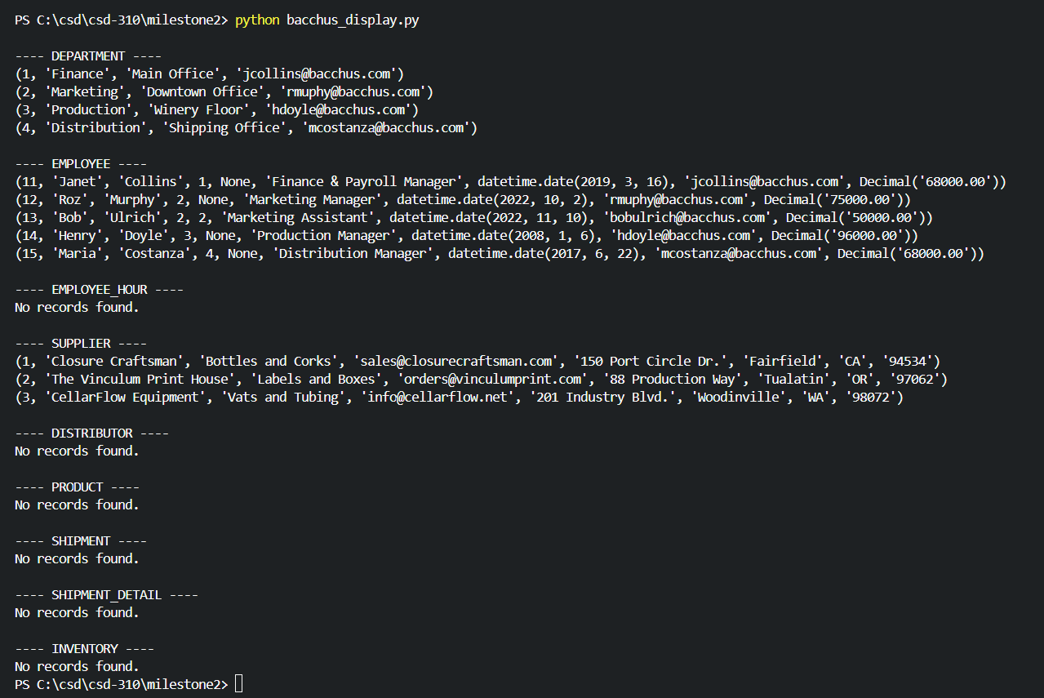

Revised ERD:
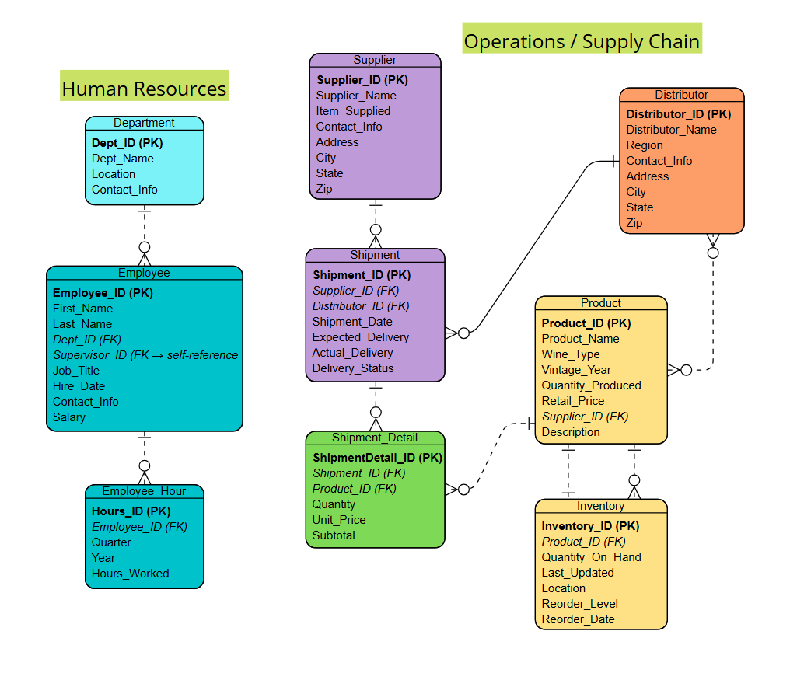
SQL References:
MySQL. (2024). ALTER TABLE statement. MySQL 8.0 Reference Manual. https://dev.mysql.com/doc/refman/8.0/en/alter-table.html
MySQL. (2024). DROP TABLE statement. MySQL 8.0 Reference Manual. https://dev.mysql.com/doc/refman/8.0/en/drop-table.html
MySQL. (2024). Server system variables: foreign_key_checks. MySQL 8.0 Reference Manual. https://dev.mysql.com/doc/refman/8.0/en/server-system-variables.html#sysvar_foreign_key_checks
MySQL. (2024). The InnoDB storage engine: FOREIGN KEY constraints. MySQL 8.0 Reference Manual. https://dev.mysql.com/doc/refman/8.0/en/create-table-foreign-keys.html

