Milestone # 3
Business Decisions
- Supplier Delivery Performance
  - Delivery on time? Consistently?
  - Track the gap between Expected_Delivery dates and Actualy_Delvery to identify problem months
    - This could show potential impact in production with late deliveries
    - My need to change suppliers or make production adjustments
Tables: Shipment, Supplier
Key fields: Expected_Delivery, Acutual_Delivery, Supplier_Name
Notes: DATEDIFF(Actual_Delivery, Expected_Delivery) ← will need to create; group by YEAR(Expected_Delivery), MONTH(Expected_Delivery), and supplier. Will also need to include counts for on-time vs late.
Purpose: to understand whether suppliers are consistently delivering on time. The focus is on comparing Expected_Delivery against Acutal_Delivery to identify late shipments and see if any months show a pattern of delays. This ties directly into production planning, especially for bottling, labeling, and equipment supplies. If a delay trend is spotted, some adjustments may be needed to the ordering schedules or evaluate alternative suppliers.
- Wine Distribution & Sales ← Need Visibility
  - How are each wines performing once produced?
  - Identify which wines sell as expected, underselling, and which distributors carry which wines.
  - Ties in with marketing adjustments, distributor changes, and productions shifts
Tables: Shipment → Shipment_Detail → Product → Distributor
Key fields: Product.Wine_Type, Shipment_Detail.Quanitity, Shipment_Detail.Unit_Price, Distributor_Name
Notes: Will need to summarize the quantity and revenue by wine type and distributor. One option is to do this by quarter.
Purpose: Once products leave the winery, Stan and Davis need to know how each wine is performing with distributors. Shipment records show which products are being moved, which wine type sells faster than others, and which distributors are actively carrying them. This report makes it easier to see whether certain wines are underperforming or if specific distributors are moving more volume than others. This also supports marketing and production adjustments.
- Employee Hours per Quarter
  - How many hours has each employee worked over the last 4 Quarters?
  - This involves staffing, payroll, and workflow planning
    - Are they balanced? Under/overstaffed? Overextended?

Tables: Employee_Hour → Employee → Department
Key fields: Quarter, Year, Hours_Worked
Notes: Place a filter to last four quarters present in the data. Show totals and department roll-ups.
Purpose: The owners also want a clear view of how many hours each employee has worked across the past four quarters. This information helps identify workload distribution across departments and can reveal whether anyone is overextended or if certain areas may need more staffing. It also supports payroll accuracy and planning.

Summary
- Supplier delivery timing
- Wine distribution & sales trends
- Employee hours by Quarter
Expected columns
- Employee | Dept | Year | Q1 | Q2 | Q3 | Q4 | Total_ Year_Hours
(Or one row per employee-quarter with a pivot in Python)

Optional Business Decisions/Report Options
Inventory status & Reorder Watchlist
- Inventory + Product: show items below Reorder_Level, days since Last_Updated, and Quantity_On_Hand
Supplier Mix by Product
- Product + Supplier: map out which supplier provides which product/materials
Distributor Map
- Distributor.Region + shipped SKUs: list which regions carry which wine types and volume ← this requires more fabricated information than the case study provides
Price & Margin Snapshot (More info needed)
- Uses Shipment_Detail.Unit_Price instead of a cost field ← not currently present
Python scripts →
#1—report_supplier_delivery.py
Pulls:
- Supplier name
- Expected vs. actual delivery
- Days late/early
- Delivery month
- Delivery status
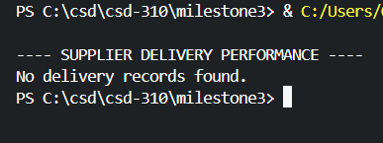
#2—report_wine_distribution.py
Pulls (from joined tables):
- Wine type
- Distributor name
- Quantity shipped
- Unit price
- Total revenue (calculated)
- Shipment month/quarter (optional, depending on the query)
Purpose:
Show how each wine performs once it leaves the winery. This helps identify top-selling wines, underperforming wines, and which distributors move the most product.
Approach:
- Join Shipment → Shipment_Detail → Product → Distributor
- SUM(Shipment_Detail.Quantity)
- SUM(Shipment_Detail.Quantity * Shipment_Detail.Unit_Price)
- Group by Wine_Type and Distributor_Name
- Optional: add a QUARTER(Shipment_Date) field to break results into quarters
- Order by wine type or revenue, depending on what looks cleaner for the report
Expected Output Shape:
Wine_Type | Distributor | Quantity_Sold | Revenue | Quarter (optional)
Example Output (with placeholders):
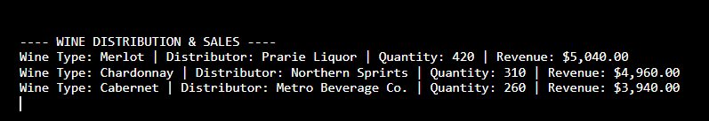
#3— report_employee_hours.py
Pulls:
- Employee name
- Department name
- Year
- Quarter
- Hours worked
- (Optional) Total hours per employee for the year
Purpose:
Identify workload distribution across the last four quarters. Helps determine if employees or departments are under/over-utilized and informs staffing or scheduling adjustments.
Approach:
- Join Employee_Hour → Employee → Department
- Filter to the last four quarters available in the dataset
- SUM(Hours_Worked) grouped by employee, year, quarter
- Optional pivot inside Python: one row per employee with Q1-A4 columns
- Add a yearly total if needed for cleaner comparison
- Order by department, then employee for readability
Expected Output Shape:
Employee | Dept | Year | Quarter | Hours_Worked ← (or pivoted variant)
Example Output (with placeholders):
