Module 3.2 Assignment

Scott Johnson
Bellevue University
CSD325: Database Development
Professor Parks
December 19th, 2025

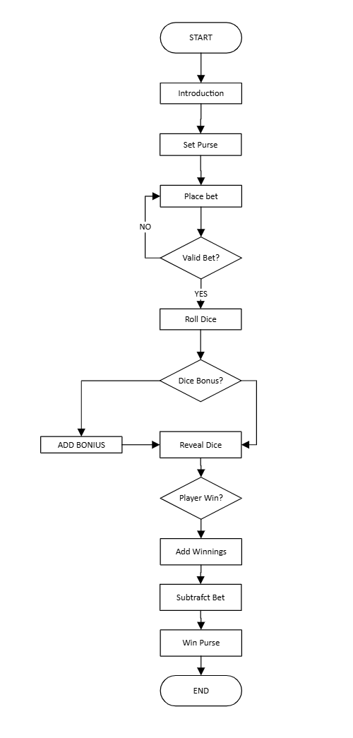

https://github.com/mrscottyj/CSD_325.git

