Module 8.2 Assignment

Scott Johnson
Bellevue University
CSD325: Advanced Python
Professor Parks
February 14th, 2025

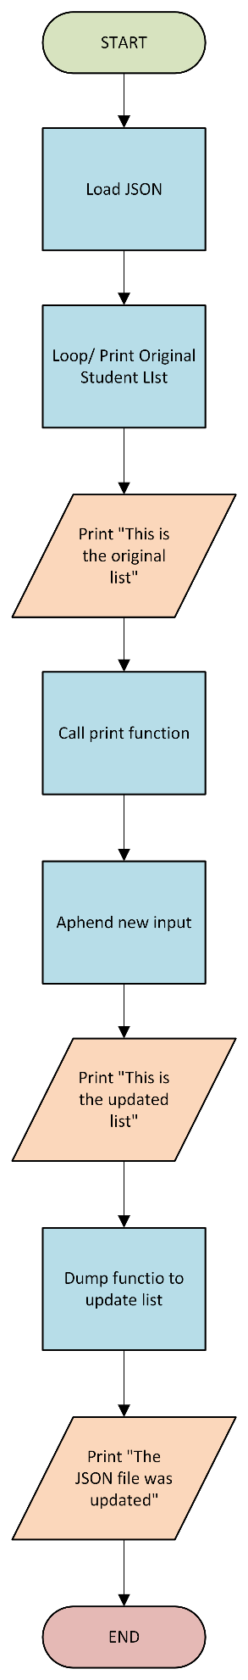
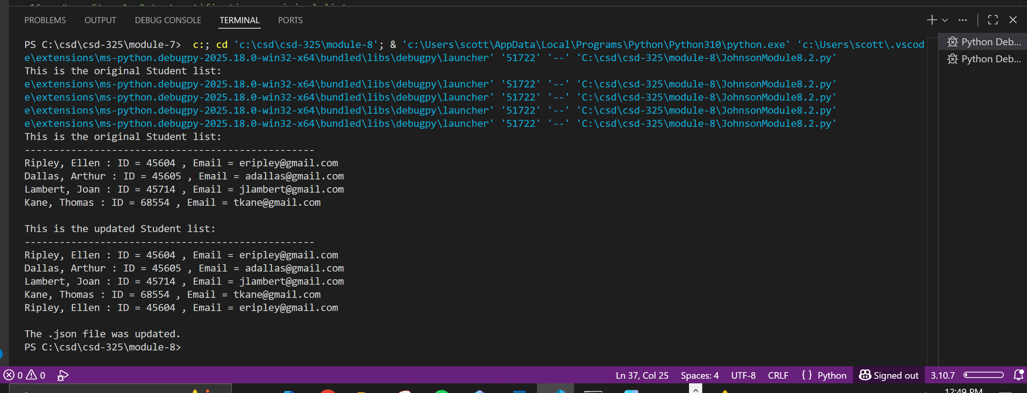

The dialog box saying the file was change did not populate. However. The file was updated successfully. Not sure why the dialog box didn’t show up.

[
{
"F_Name": "Ellen",
"L_Name": "Ripley",
"Student_ID": 45604,
"Email": "eripley@gmail.com"
},
{
"F_Name": "Arthur",
"L_Name": "Dallas",
"Student_ID": 45605,
"Email": "adallas@gmail.com"
},
{
"F_Name": "Joan",
"L_Name": "Lambert",
"Student_ID": 45714,
"Email": "jlambert@gmail.com"
},
{
"F_Name": "Thomas",
"L_Name": "Kane",
"Student_ID": 68554,
"Email": "tkane@gmail.com"
},
]

