Module 1.3 Assignment

Scott Johnson
Bellevue University
CSD440: Server-Side Scripting
Professor Payne
March 20th, 2025

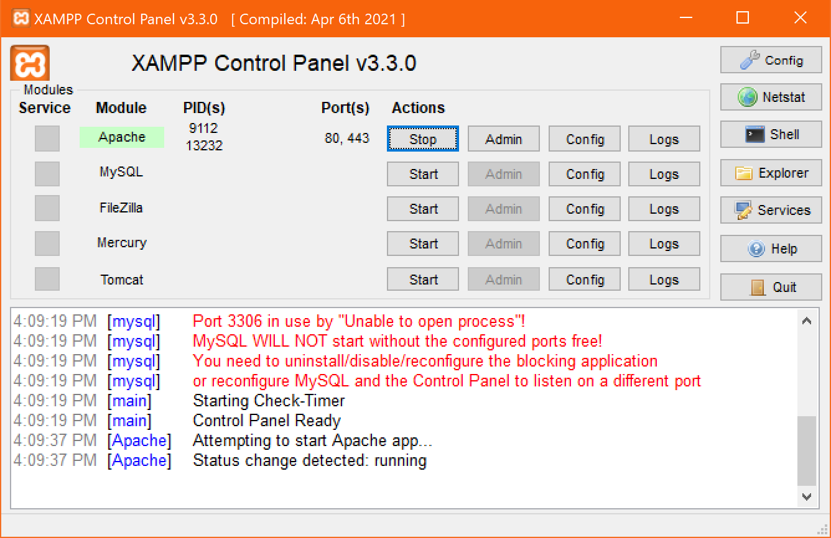
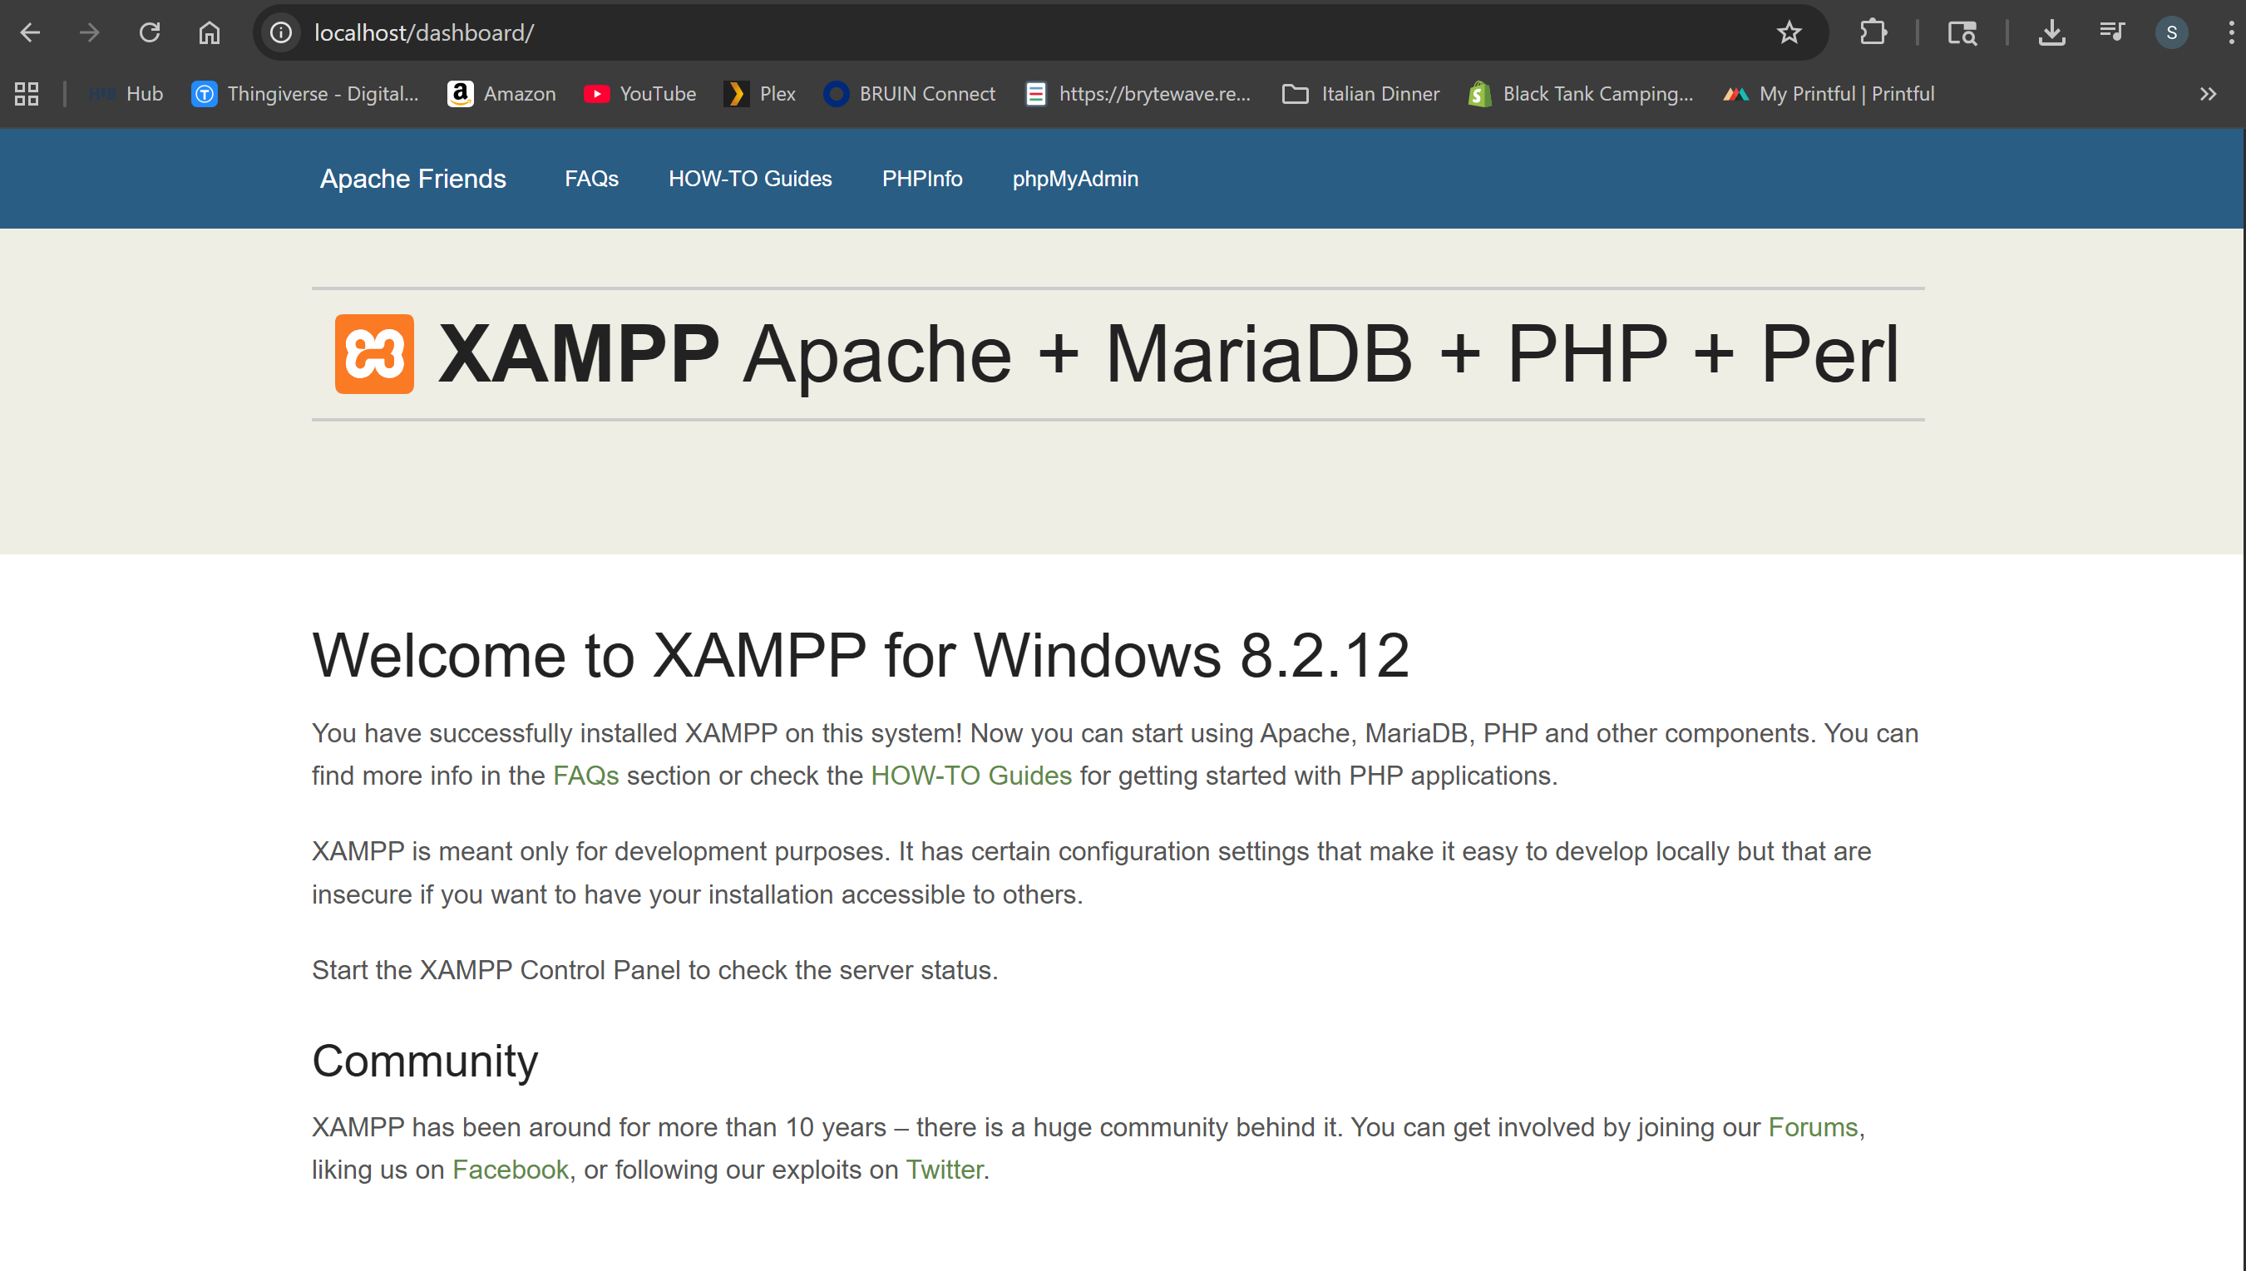
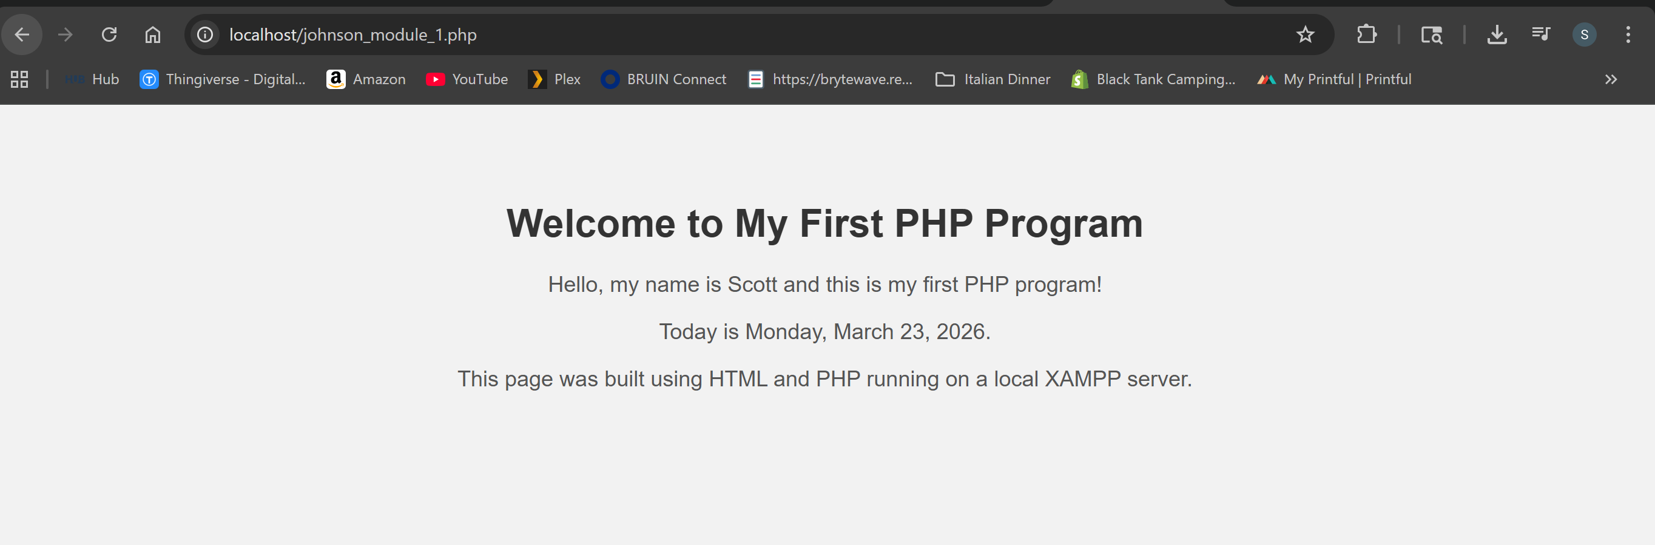
Not sure why its showing Monday when it pulls the date. But that’s a future date.

