* A small-scale (individual or small team) instance of the SonarQube server requires at least 2GB of RAM to run efficiently and 1GB of free RAM for the OS.
* 20 GB Storage.
* 

Run as ec2-user and not as root user.

* 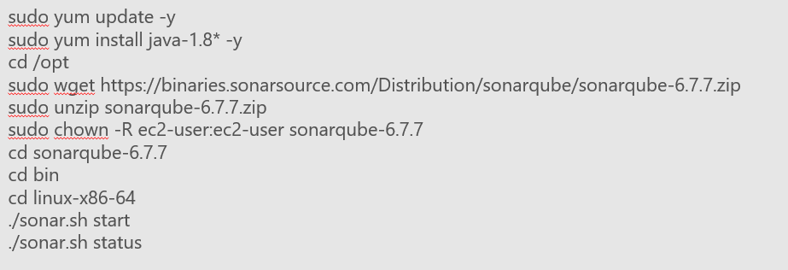
* 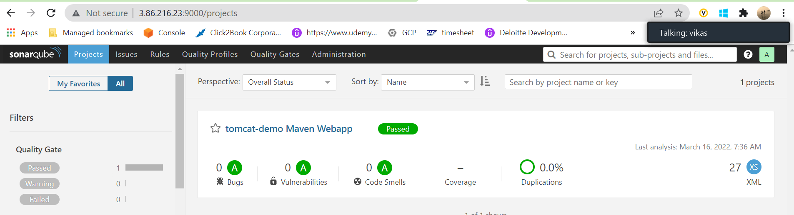
* 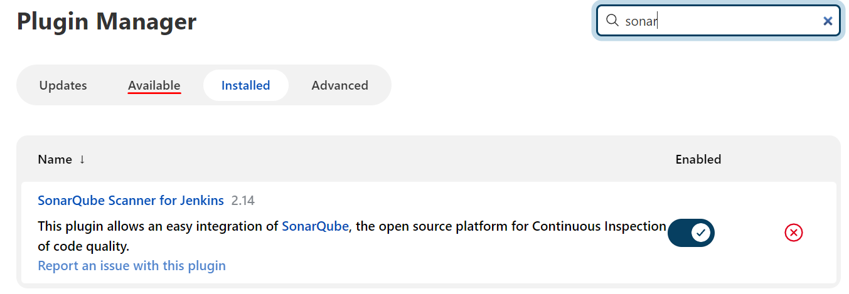
* 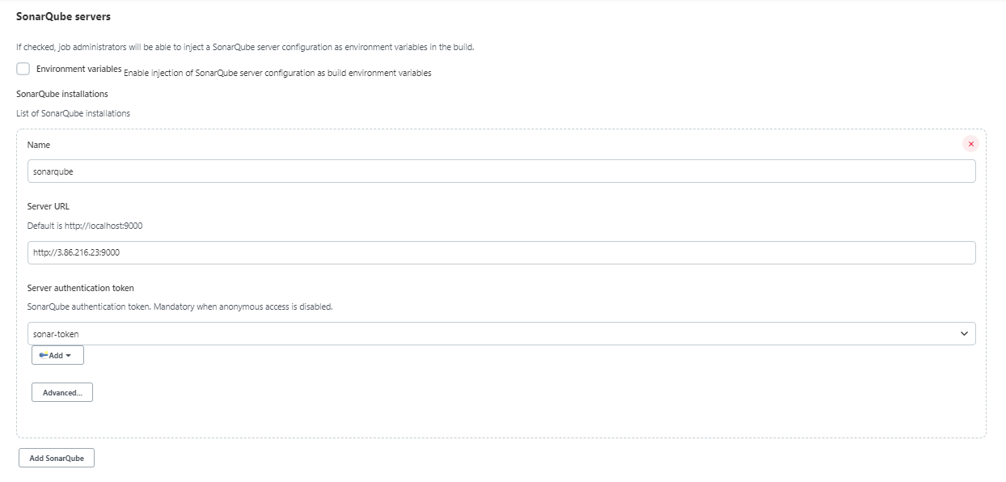
* Create a Jenkins pipeline job using: <https://github.com/vikas99341/tomcat-demo/blob/main/Jenkinsfile2>
* 
 