1. Create an ec2 instance and install Terraform.

* sudo yum install -y yum-utils shadow-utils
* sudo yum-config-manager --add-repo https://rpm.releases.hashicorp.com/AmazonLinux/hashicorp.repo
* sudo yum -y install terraform

1. Make sure the terraform is installed.

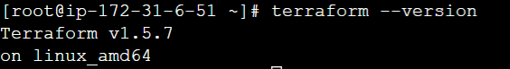

1. Clone the git repo to find the latest code and execute it to get the Jenkins server up and running with Ansible and git installed.

* https://github.com/vikas99341/Terraform-codes/tree/8dc06ac0822ae6abf352cd1f8870c9dd1b922dd1/tf-jenkins

1. Check if Jenkins and Ansible are installed. Run command “service Jenkins status”, If Jenkins is up and running start Jenkins we @ <public-ip>:8080.
2. Do the initial set for Jenkins and install the Ansible and Terraform plugins. Once the plugin is installed check for global tool configuration.

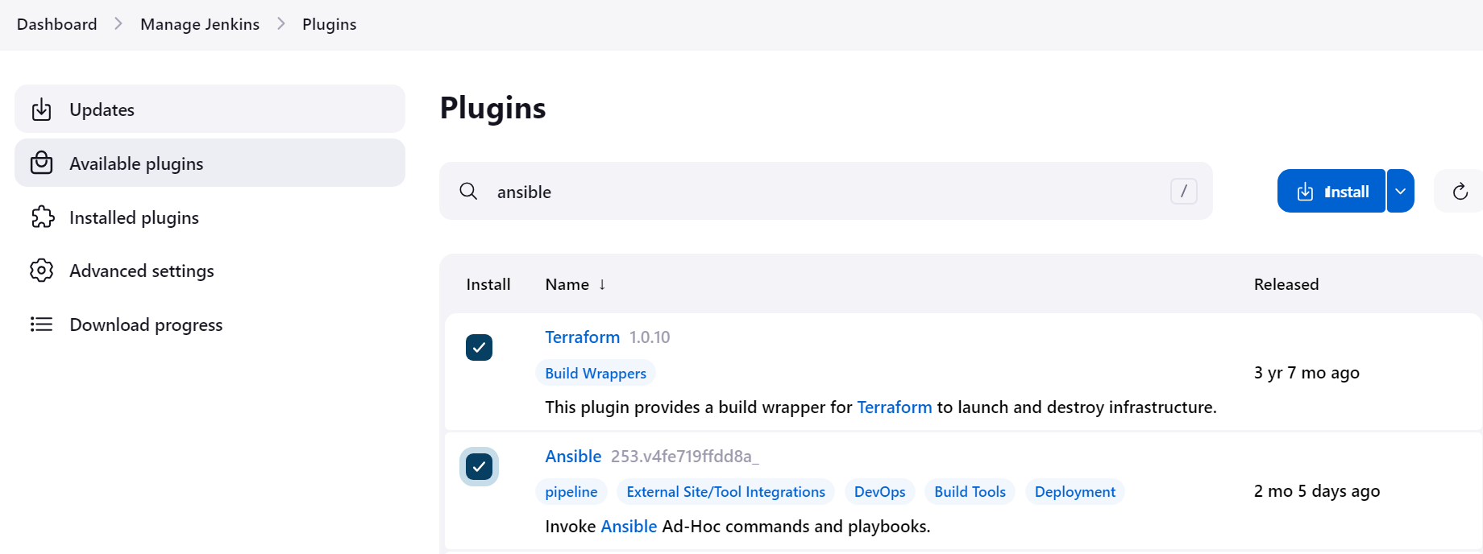

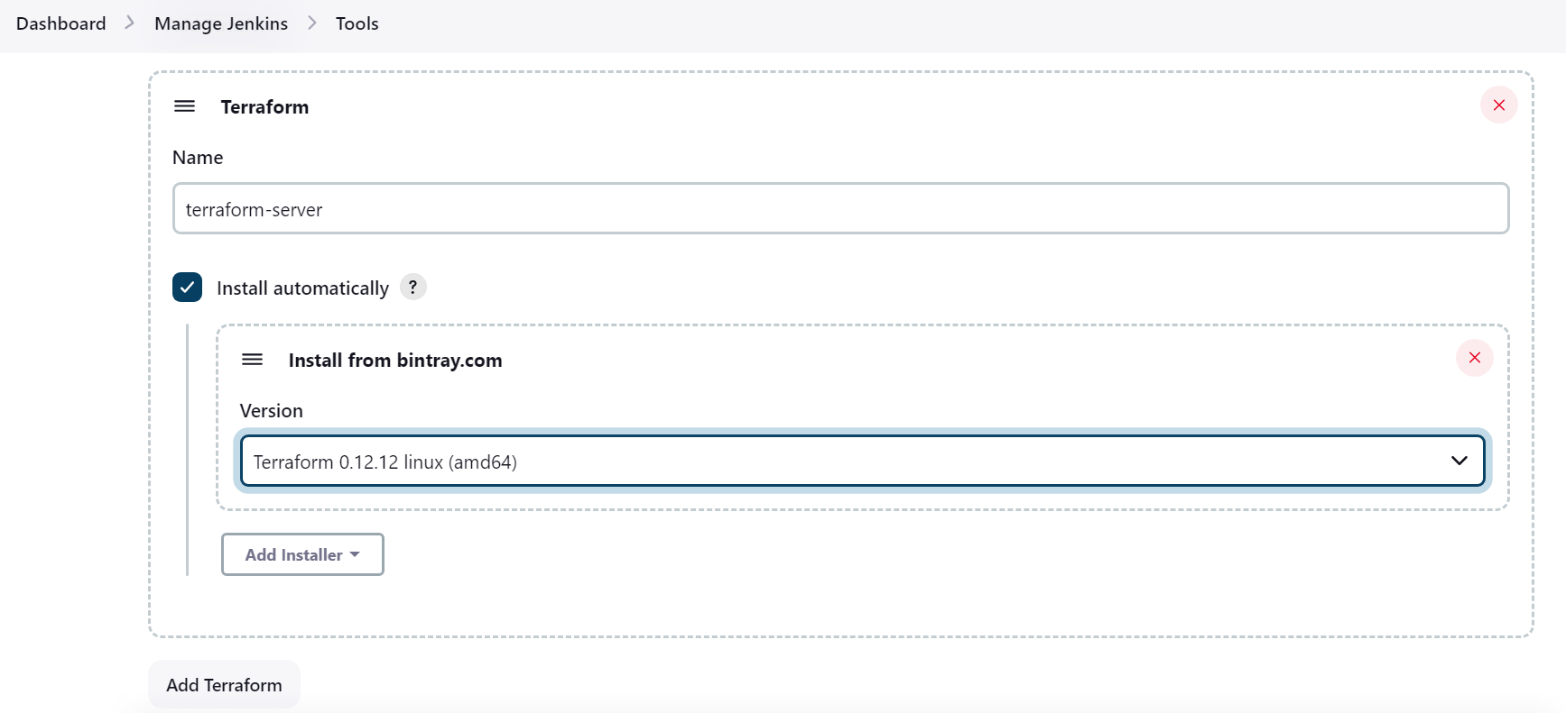

1. Create a new pipeline job.

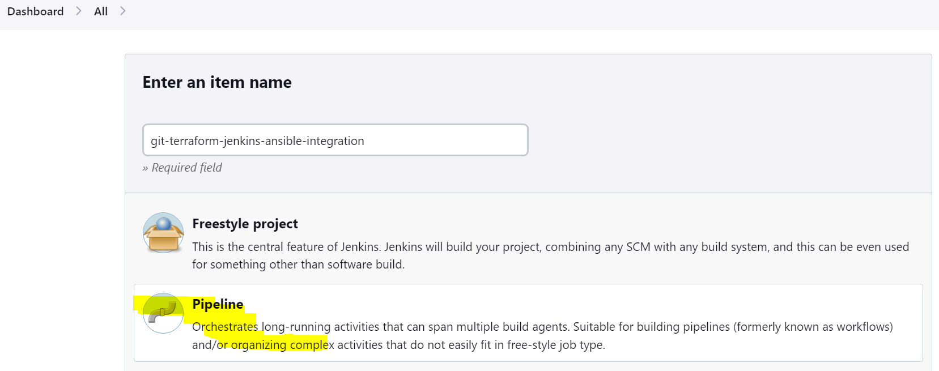

1. Take the code from the git repo and configure the Jenkins job.

* https://github.com/vikas99341/jenkins-terraform-ansible-integration.git

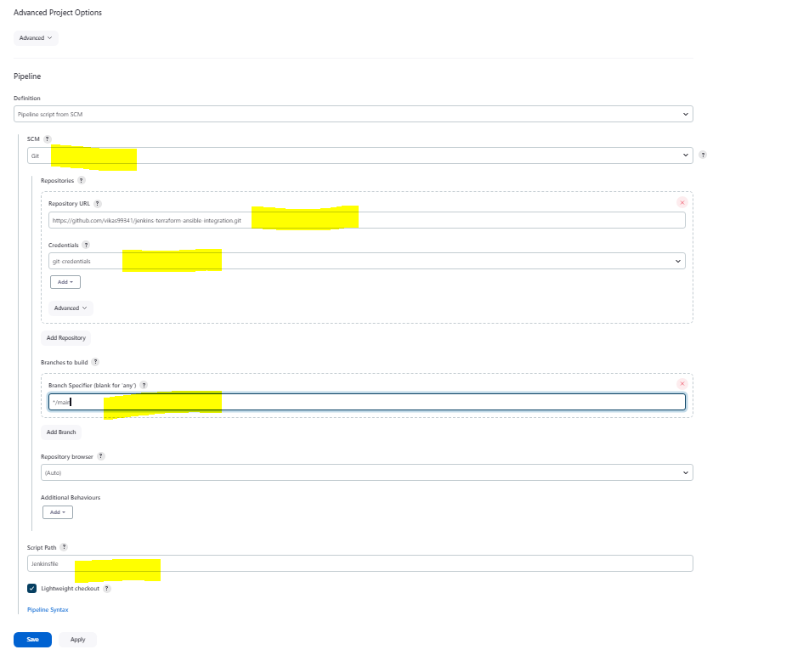

1. Execute the job and check console output.

