Jenkins:

Source Code --- compile -- syntax check --- artifact (binary format)
Continuous Integration - whatever changes are done -- > commit to SCM Tester + deployment overall progress

Different machine (Environment) -- > Uniform Environment bring everything together (Jenkins)

- Create a key pair
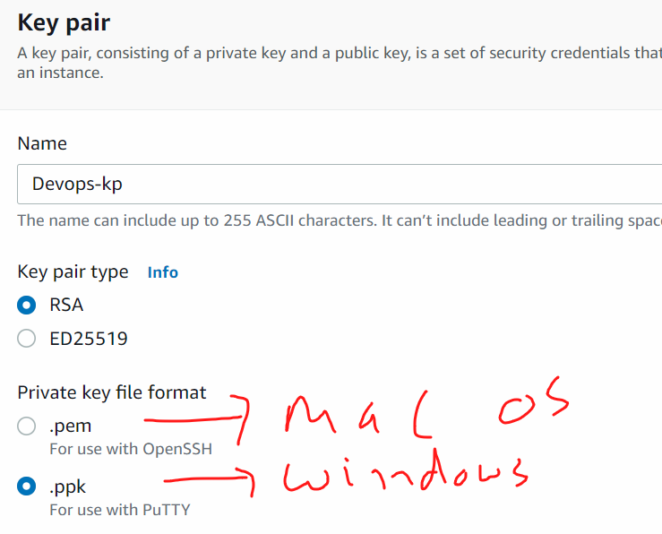
- Create a Security Group

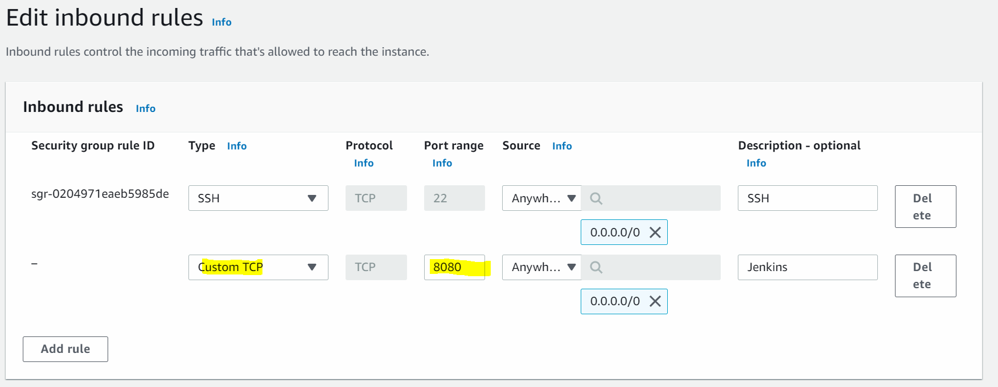

- Create an Ec2 (Amazon Linux + t2 micro + 8 GB storage + default values)

https://www.jenkins.io/doc/book/installing/linux/#prerequisites

Red Hat / CentOS -- > Weekly release

- sudo yum update -y
- sudo su –
- hostname Jenkins-server
- sudo su –
- yum install java-1.8* -y
- java -version
- sudo wget -O /etc/yum.repos.d/jenkins.repo \
https://pkg.jenkins.io/redhat/jenkins.repo
- sudo rpm --import https://pkg.jenkins.io/redhat/jenkins.io.key
- sudo yum install jenkins
- service Jenkins start
- service Jenkins status
- systemctl enable Jenkins
start Jenkins on web: <public-ip>:8080
cat /var/lib/jenkins/secrets/initialAdminPassword
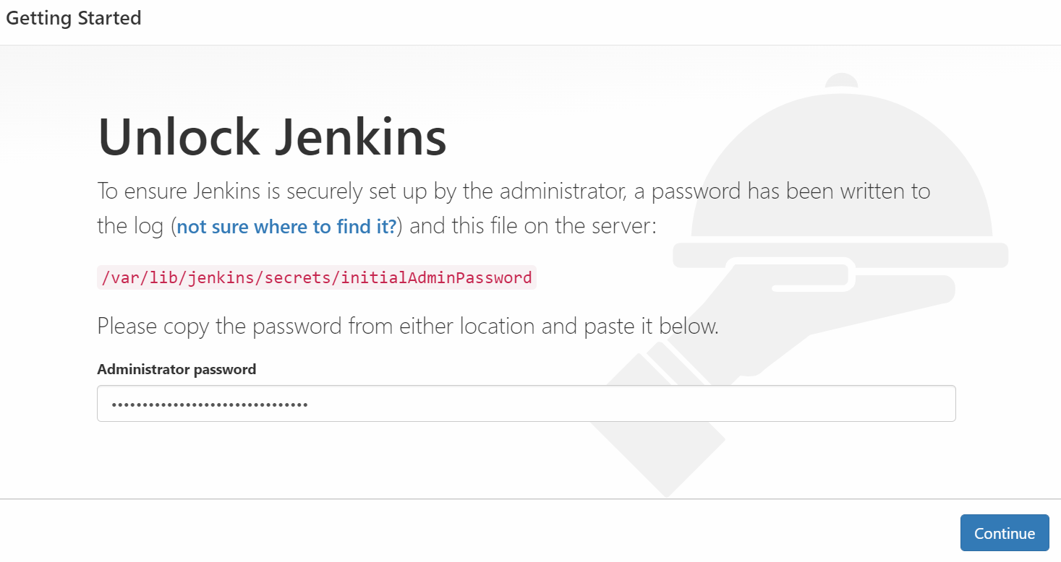
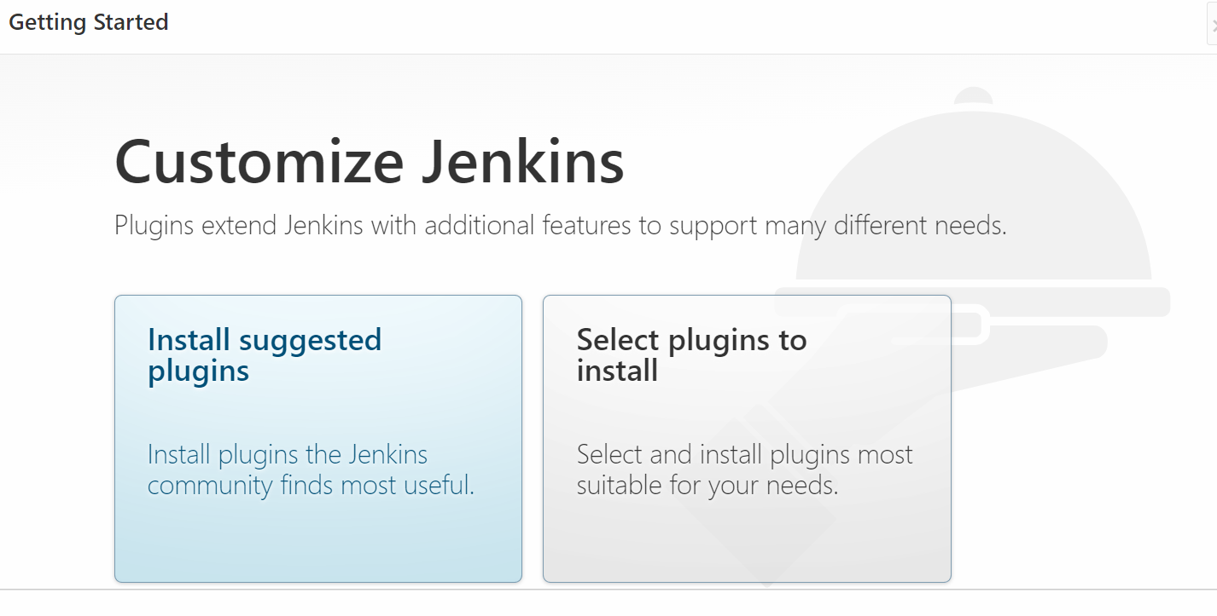
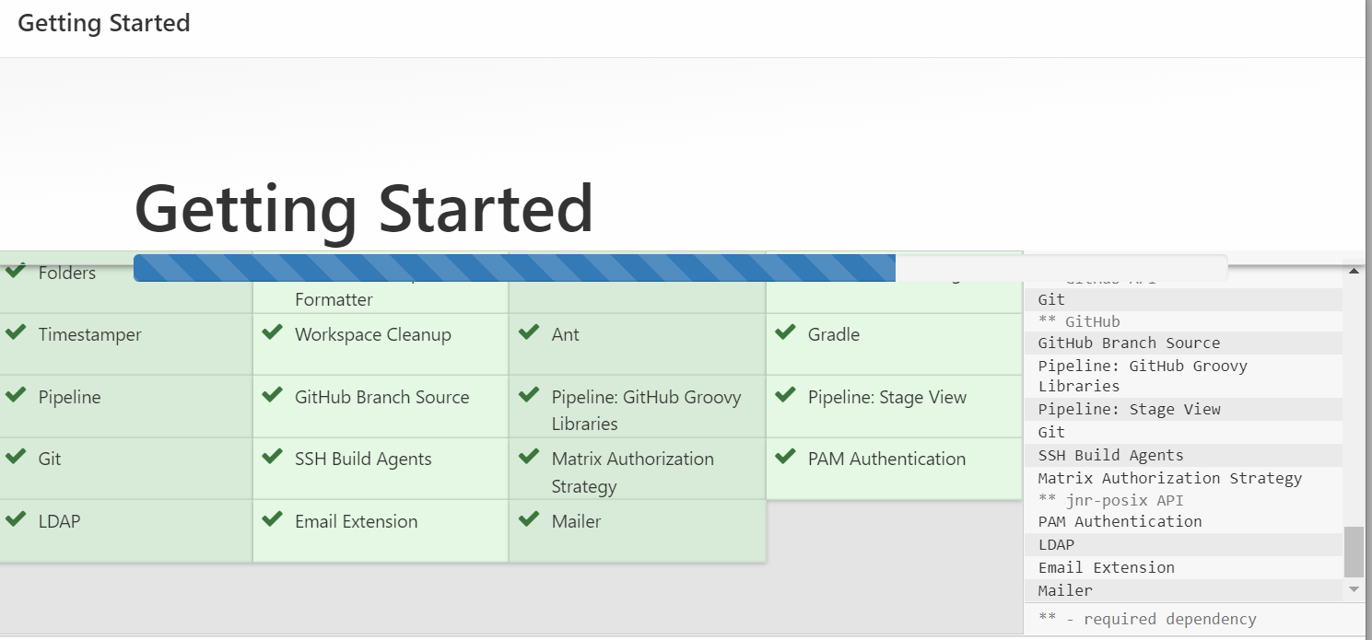
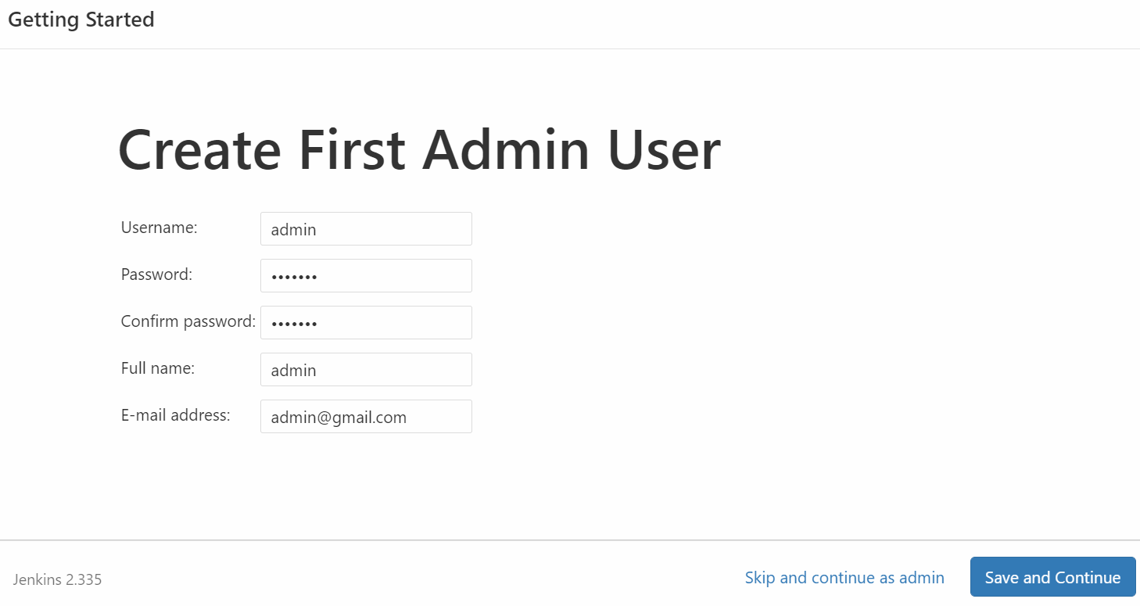
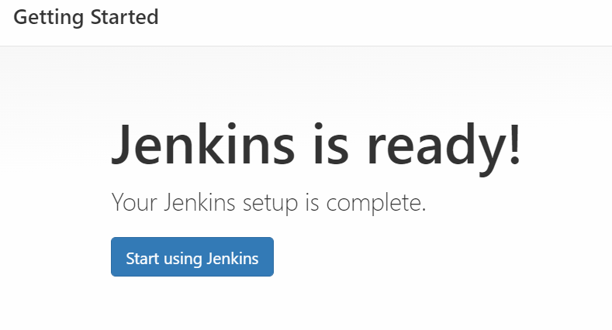

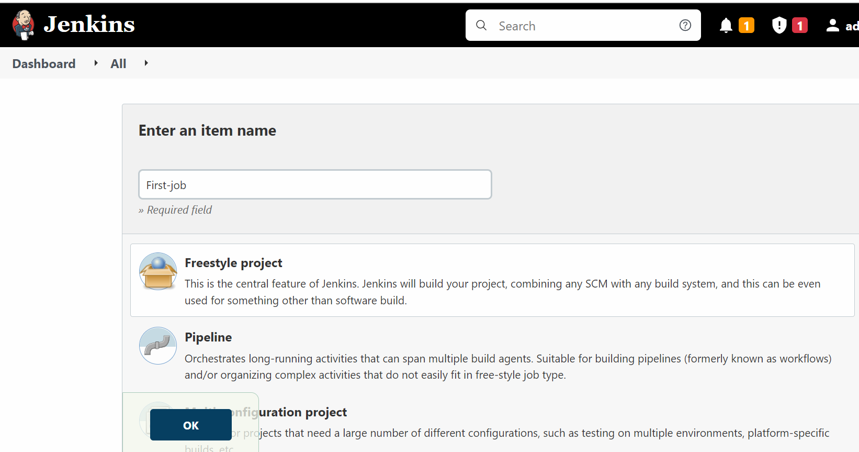

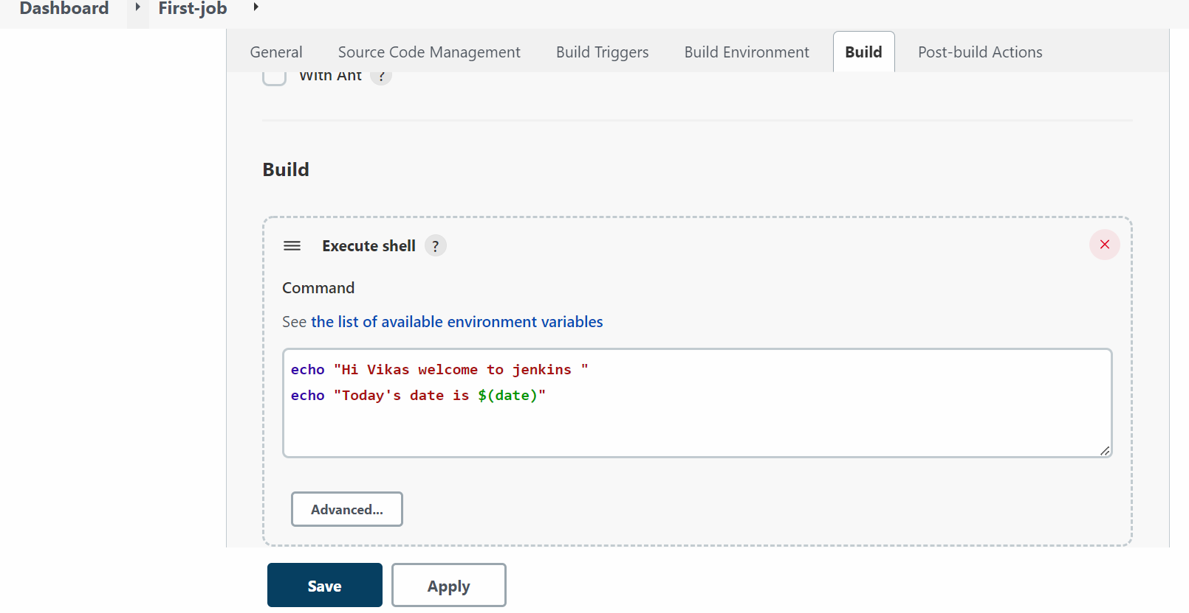
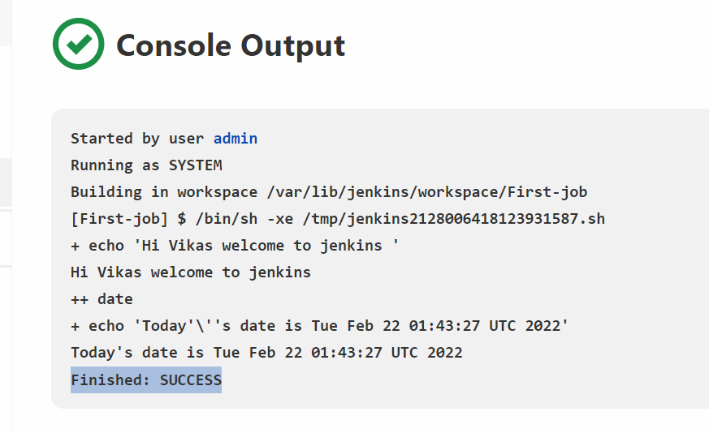

Installation
Send Email Notification:
https://support.google.com/accounts/answer/6010255?hl=en#zippy=%2Cif-less-secure-app-access-is-on-for-your-account

