- A small-scale (individual or small team) instance of the SonarQube server requires at least 2GB of RAM to run efficiently and 1GB of free RAM for the OS.
- 20 GB Storage.

Run as ec2-user and not as root user.
- 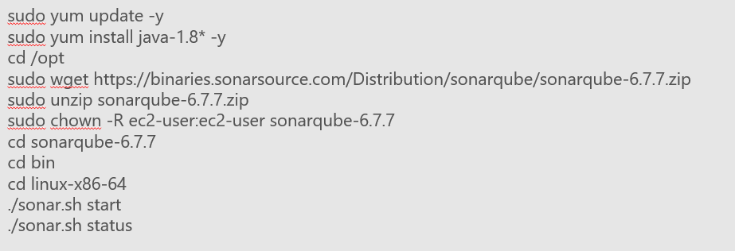

- 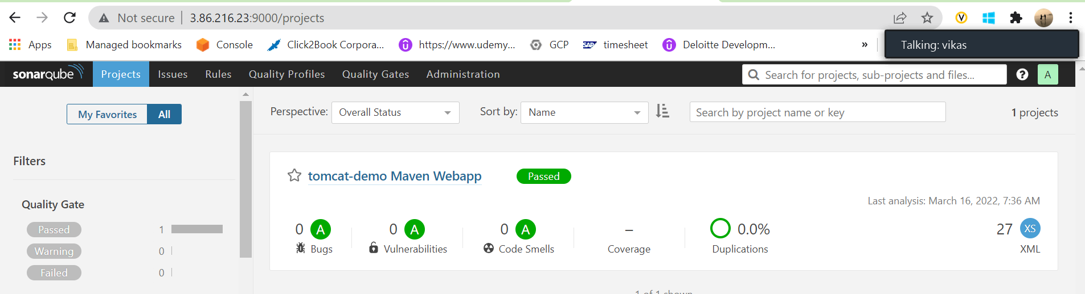

- 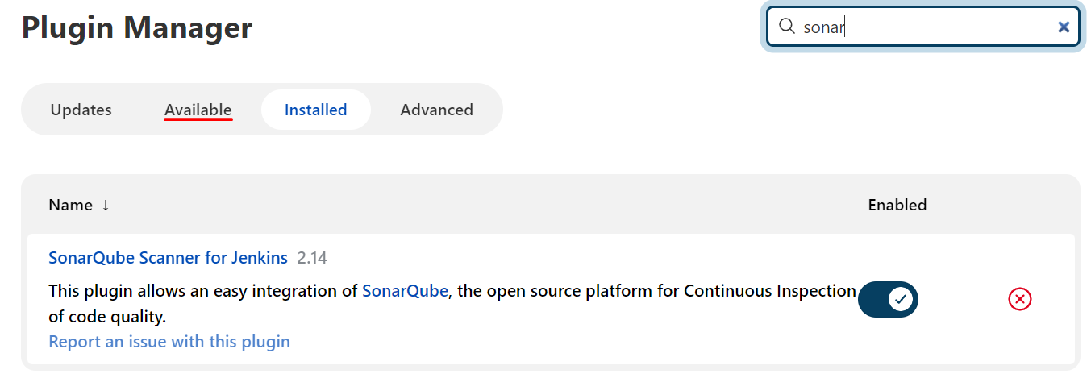

- 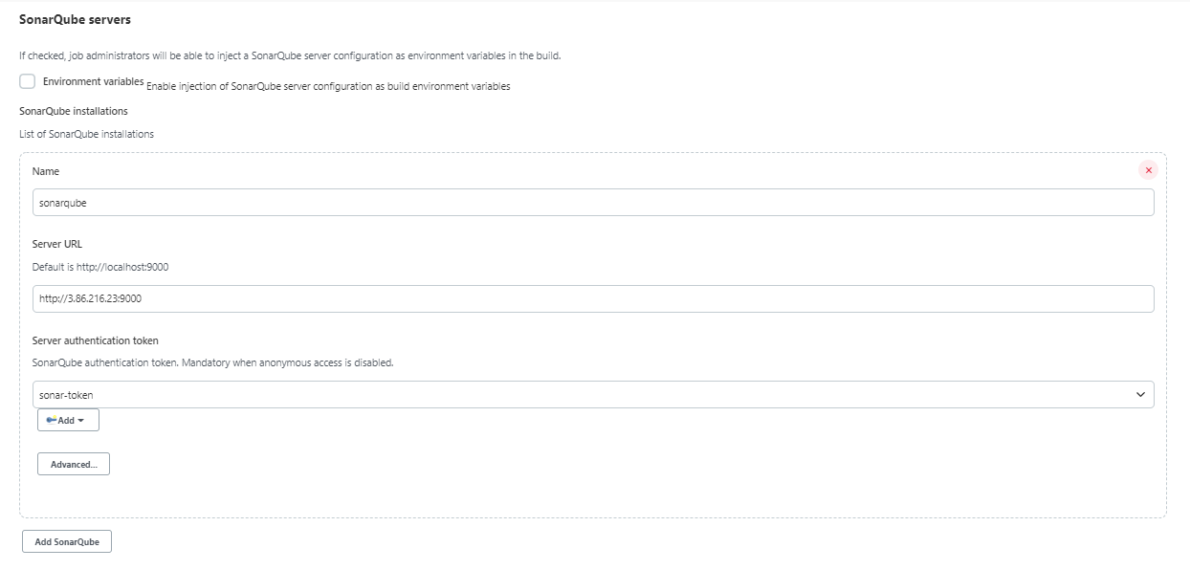

- Create a Jenkins pipeline job using: https://github.com/vikas99341/tomcat-demo/blob/main/Jenkinsfile2

- 

 