- Create an ec2 instance and install Terraform.

- sudo yum install -y yum-utils shadow-utils
- sudo yum-config-manager --add-repo https://rpm.releases.hashicorp.com/AmazonLinux/hashicorp.repo
- sudo yum -y install terraform
- Make sure the terraform is installed.

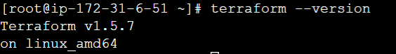

- Clone the git repo to find the latest code and execute it to get the Jenkins server up and running with Ansible and git installed.
- https://github.com/vikas99341/Terraform-codes/tree/8dc06ac0822ae6abf352cd1f8870c9dd1b922dd1/tf-jenkins
- Check if Jenkins and Ansible are installed. Run command “service Jenkins status”, If Jenkins is up and running start Jenkins we @ <public-ip>:8080.
- Do the initial set for Jenkins and install the Ansible and Terraform plugins. Once the plugin is installed check for global tool configuration.

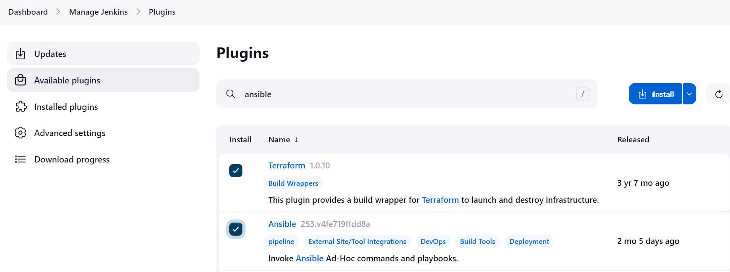
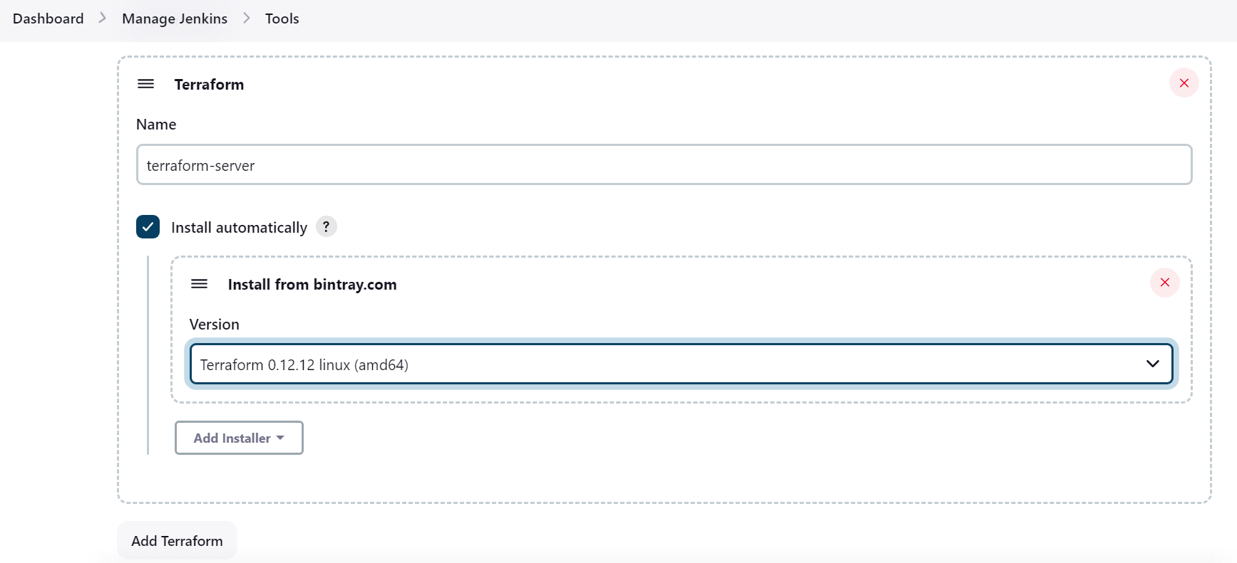

- Create a new pipeline job.
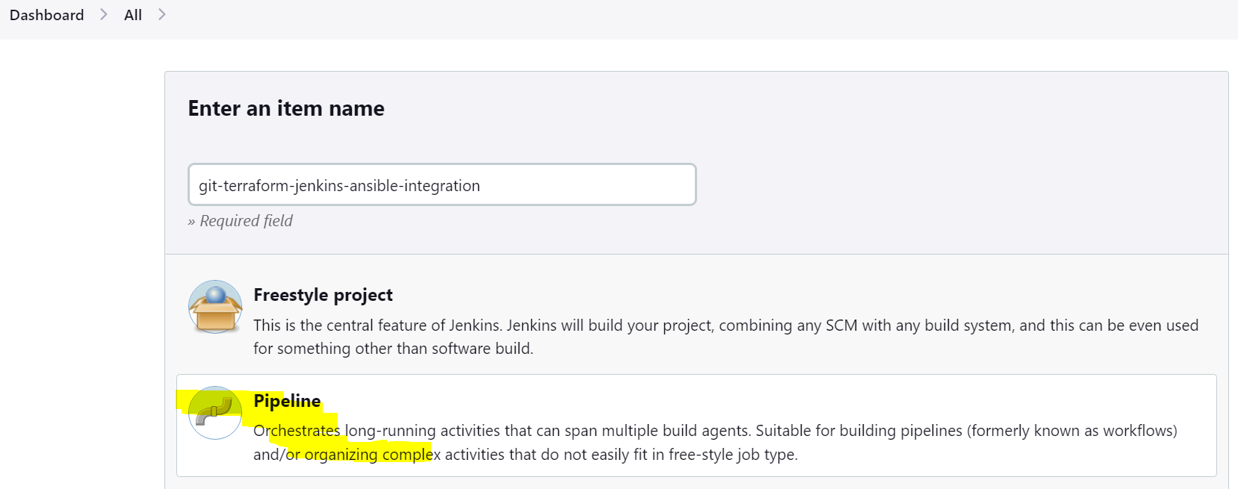
- Take the code from the git repo and configure the Jenkins job.
- https://github.com/vikas99341/jenkins-terraform-ansible-integration.git
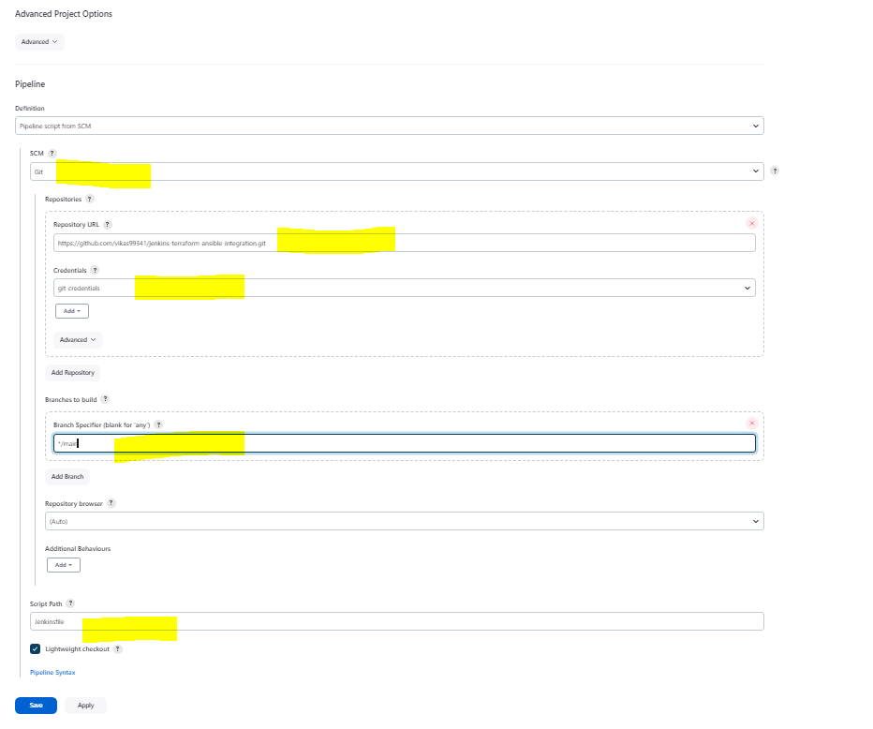
- Execute the job and check console output.

